**Finnish Recovery Boiler Committee**

**Guidelines on burning non-condensable gases**

**30 May 2002**

**16 December 2005, rev A.**

**29 October 2013, rev B.**

**21 December 2021, rev C.**

**Recommendation 1**

**Should use previously accepted terms:**

**British English in spelling!**

Boiler air duct instead of boiler air channel

boiler bank instead of digesting surface

dissolving tank instead of dissolver

flare instead of torch

furnace wall openings instead of furnace wall injectors

furnace instead of fire chamber

figure instead of image

kraft mill instead of sulphate process

liquor guns instead of liquor injectors

mixing tank instead of mixer

presteaming of chips instead of calcining of chips

purge instead of blast

smelt instead of melt

shut-off valve instead of shutter valve

steam instead of vapour

vent instead of vent gas

Not translated

Figure 2-2

Figure 2-3

~~Figure 3-1~~ korjattu

Figure 5-1

Figure 7-2

Figure 11-1

Figure 11-2

Figure 11-3

typo also in finnish version “Kuvassa 7-3 on esimerkki”

Questions

quick closing or trip valves or fast acting shut-off valves.

INTRODUCTION

These guidelines by the Finnish Recovery Boiler Committee are the third update to the guidelines originally published on 30 May 2002. The guidelines have been updated based on the experiences implemented in the past few years. The work on the update started in late 2018 and was finished in December 2021.

Revision C was prepared by the working group comprising Esa Vakkilainen and Kirsi Hovikorpi from LUT University, Risto Honkanen and Petri Pynnönen from Andritz Oy, Tero Juutilainen, Kari Haaga and Joni Niskavaara from Valmet Technologies Oy, Lauri Mattila from the UPM Pietarsaari mill, Kimmo Pakkanen from the Metsä Fibre Joutseno mill, and Teppo Pakarinen from the Stora Enso Varkaus mill. The secretaries of this separate working group on non-condensable gases were Antti Tikkanen and Markus Nieminen from the Committee.

Revision B was prepared by a working group founded by the Finnish Recovery Boiler Committee, the group members being Marja Heinola and Risto Honkanen from Andritz Oy, Kari Haaga and Tuomo Hilli from Metso Power Oy, Ismo Tapalinen from the UPM-Kymmene Kaukas mill, Lauri Mattila from the UPM-Kymmene Pietarsaari mill, Raine Rantanen from the UPM-Kymmene Kymi mill, Esa Vakkilainen from Lappeenranta University of Technology, and Markus Nieminen from Pöyry Finland Oy as the secretary.

Revision A was prepared by the Environmental Working Group of the Finnish Recovery Boiler Committee, with Pekka Posti from Oy Metsä-Botnia Ab as the chair, Jens Kohlmann from Jaakko Pöyry Oy as the secretary, and Hanna Anttila from Andritz Oy, Jouni Hiltunen from Stora Enso Fine Paper Oy, Mikko Anttila from Kvaerner Power Oy, Kari Parviainen from Helsinki University of Technology, Harri Jussila from UPM-Kymmene Oyj, Kymi, Jorma Torniainen from Oy Keskuslaboratorio-Centrallaboratorium AB, and Juha Tolvanen from Alstom Power Finland Oy as the members, and Esa Vakkilainen from Jaakko Pöyry Oy as the expert.

The original guidelines were prepared by the Environmental Working Group of the Finnish Recovery Boiler Committee, with Pekka Posti from Oy Metsä-Botnia Ab as the chair, Sebastian Kankkonen from Jaakko Pöyry Oy as the secretary, and Aimo Hakkarainen from Andritz-Ahlstrom Oy, Jouni Hiltunen from Stora Enso Fine Paper Oy, Markku Isoniemi from Kvaerner Pulping Oy, Kari Parviainen from Jaakko Pöyry Oy, Matti Tikka from Kymi Paper Oy, Esko Talka from Oy Keskuslaboratorio-Centrallaboratorium AB and Juha Tolvanen from Alstom Power Finland Oy as the members, and Esa Vakkilainen from Jaakko Pöyry Oy as the expert.

The working group would like to thank everyone who commented on the guidelines.

These guidelines do not attempt to make the structures of the non-condensable gas systems uniform or force users or manufacturers to only use identical systems or process solutions. The guidelines provide basic knowledge that can be used to support design, manufacturing and use.

Our goal is to develop the guidelines even further, which is why we ask that readers inform the secretaries of the Finnish Recovery Boiler Committee of any errors, improvement ideas and experiences. You can find our contact information on the Committee’s website: <http://www.soodakattilayhdistys.fi>

The Committee will not be liable for any errors in these guidelines or any problems that arise from such errors. The potential updated version will be available to Committee members on the Committee website or via the secretaries.

Finnish Recovery Boiler Committee

CONTENTS

1 GENERAL INFORMATION 1

2 DEFINITIONS AND ABBREVIATIONS 3

2.1 Concentrated non-condensable gases 3

2.2 Diluted non-condensable gases 5

2.3 Vent gas from the dissolving tank and mixing tank 5

2.4 Systems with separate collection that require special attention 6

2.4.1 Tall oil plant 6

2.4.2 Potassium and chlorine removal plant 6

2.4.3 Sulphuric acid plant 6

2.4.4 Lignin separation plant 7

2.4.5 Biochar plant 7

2.5 Hydrogen sulphide 7

2.6 Methyl mercaptan 8

2.7 Dimethyl sulphide and dimethyl disulphide 8

2.8 Methanol 8

2.9 Turpentine 9

2.10 Explosive limits 10

2.10.1 Calculation formulas for explosive limits 13

2.11 Abbreviations 14

3 IMPACT ON RECOVERY BOILER EMISSIONS 15

3.1 Effects on the recovery boiler’s sulphur emissions 15

3.2 Effects on the recovery boiler’s TRS emissions 15

3.3 Effects on the recovery boiler becoming blocked 16

3.4 Effects on the recovery boiler’s NOx emissions 16

3.4.1 Effect of diluted non-condensable gases 17

3.4.2 Effect of the dissolving tank vent gases 17

3.4.3 Effect of concentrated non-condensable gases 18

3.4.4 Effect of methanol 18

3.5 Effects on the recovery boiler’s other functions 18

4 RISKS AND CORROSION OF NCG SYSTEMS 20

4.1 Non-condensable gases leaking into the working space 20

4.1.1 Odour 21

4.1.2 Personal protection 21

4.2 Problems with condensate removal 22

4.2.1 Draining pocket becoming full 22

4.2.2 Water trap drying 22

4.2.3 Water trap becoming blocked 22

4.3 Explosion hazards in NCG lines 22

4.3.1 Shutdowns and startups 23

4.3.2 Back fire 23

4.4 Gas explosion in a boiler 23

4.5 Smeltwater explosion in a boiler 24

4.6 Problems with corrosion 24

4.7 Sparking and static electricity 24

5 SYSTEMS FOR DILUTED NON-CONDENSABLE GASES 25

5.1 Typical collection locations at a pulp mill 25

5.1.1 Fibre line 26

5.1.2 Evaporator 27

5.1.3 White liquor plant 28

5.1.4 Other locations 29

5.2 Composition and volume 29

5.3 Cooling and heating 31

5.4 Logic for burning DNCG 32

5.4.1 Preconditions for the supply of DNCG 32

5.4.2 Interrupting the burning of DNCG 33

5.4.3 Flow 33

5.4.4 Equipotential bonding 33

5.5 Valves and dampers 34

5.6 Fan 34

5.7 Extra air inlet 34

5.8 Scrubbers and condensers 35

5.9 Droplet separator 35

5.10 Condensate removal 35

5.10.1 Size of the condensate removal lines 35

5.10.2 Duct slopes and placement of the condensate removal devices 36

5.10.3 Water traps 36

5.11 Flame arrester 37

5.12 Bypassing 37

5.13 Low-pressure safeguards 37

5.14 High-pressure safeguards 37

5.14.1 Explosion and bursting discs 37

5.15 Concentration measurement 38

6 Burning the dissolving tank vent gases at the recovery boiler 39

6.1 Composition and volume 39

6.2 Vent from the mixing tank 40

6.3 Cooling and heating 41

6.4 Logic for burning dissolving tank vent gases 41

6.4.1 Preconditions for the supply of dissolving tank vent gases 41

6.4.2 Interrupting the supply of dissolving tank vent gases 42

6.5 Ducts 42

6.5.1 Flow 43

6.5.2 Equipotential bonding 43

6.6 Valves and dampers 43

6.7 Fan 43

6.8 Scrubber 44

6.9 Droplet separator 44

6.10 Cleaning the droplet separators and the heating battery 44

6.11 Condensate removal 44

6.11.1 Size of the condensate removal lines 44

6.11.2 Duct slopes and placement of the condensate removal devices 45

6.11.3 Water traps 45

6.12 Flame arrester 46

6.13 Bypassing 46

6.14 High-pressure safeguards 46

6.14.1 Explosion disc 46

6.15 Concentration measurement 47

7 Systems for concentrated non-condensable gases 48

7.1 Typical collection locations at a pulp mill 49

7.1.1 Fibre line 49

7.1.2 Evaporator 50

7.2 Composition and volume 50

7.3 Logic for burning CNCG 52

7.3.1 Preconditions for starting a CNCG burner 52

7.3.2 Interrupting the burning of concentrated gases 54

7.3.3 Capacity limitation 54

7.3.4 The burner and use of the support flame 55

7.4 Pipelines 57

7.4.1 Pipeline steaming 57

7.4.2 Pressure measurements on the pipeline 57

7.4.3 Equipotential bonding 57

7.5 Transfer of concentrated gases 58

7.5.1 Pressure containment vapour 58

7.5.2 Valves 58

7.5.3 Cooling and heating 59

7.5.4 Alkaline scrubber 59

7.5.5 Droplet separator 59

7.5.6 Flame arrester 59

7.5.7 Low-pressure safeguards 60

7.5.8 High-pressure safeguards 60

7.6 Condensate removal 60

7.6.1 Size of the condensate removal lines 61

7.6.2 Pipe slopes and placement of the condensate removal devices 61

7.6.3 Water traps 62

7.7 Alternative location 62

7.8 Concentration measurement 62

8 BURNING METHANOL AND TURPENTINE IN A RECOVERY BOILER 64

8.1 The logic for burning methanol or turpentine 64

8.1.1 Preconditions for starting a methanol or turpentine burner 65

8.1.2 Events that interrupt the burning of methanol or turpentine 65

8.2 Electrical and automated systems for the burner 66

8.3 Valves 66

9 ACTIONS IN SPECIAL SITUATIONS 68

9.1 Actions during a disruption 68

9.2 Actions during a shutdown 68

9.3 Actions during startup 69

9.4 Operations during shutdown 70

9.4.1 Instructions for preparing the NCG system for shutdown or maintenance 70

9.4.2 Instructions for maintenance work during shutdown 70

10 MATTERS TO CONSIDER IN THE DESIGN OF NCG LINES 71

10.1 Classification 71

10.2 Signs 72

10.3 Condensate removal 72

10.4 Materials for ducts and pipelines 72

10.5 Insulation of pipes, ducts and devices 73

10.6 Slopes in pipes and ducts 73

10.7 Valves and dampers 73

10.8 Flanges and connections 74

10.9 Fans 74

10.10 Ejectors and liquid mechanical compressor 74

10.11 Alkaline scrubber in the ducts 75

10.12 Dimensioning of ducts and pipelines 75

10.13 Flame arrester placement 76

10.14 Placement of explosion and bursting discs 76

10.15 Bypass placement 76

10.16 Facility classifications 77

10.17 Production permits 77

11 OTHER BURNING LOCATIONS AND COOPERATION 79

11.1 Secondary burning locations 79

11.2 Flare 80

11.2.1 Flare placement 80

11.2.2 Condensate removal at the flare 81

11.3 NCG boiler 82

11.3.1 Alkaline scrubber 82

11.3.2 Production of sodium bisulphite, NaHSO3 82

11.3.3 Production of sulphuric acid, H2SO4 83

11.4 Lime kiln 84

11.5 Power boiler 84

11.6 Selection of the burning location and bypass line 84

11.7 Bottling of non-condensable gases 86

12 MATTERS TO CONSIDER IN HAZARD ASSESSMENTS 87

12.1 Hazard assessment in DNCG systems 87

12.1.1 Vent gas from the chip bin 87

12.1.2 Condensate collection in tank areas 88

12.1.3 Low-pressure and high-pressure safeguards and condensate removal implemented with water columns 89

12.1.4 Liquor expansion in the evaporator area 89

12.1.5 Vent gas from the tall oil digester 90

12.1.6 Scrubbers for diluted non-condensable gases 90

12.1.7 Use of DNCG as combustion air for recovery boilers 91

12.1.8 Vent gases from the recovery boiler dissolving and mixing tank 92

12.1.9 Condensate leaks into the recovery boiler 92

12.1.10 Diluted non-condensable gases from the causticizing plant 93

12.1.11 Pre-heating of non-condensable gases 93

12.1.12 Condensates of diluted non-condensable gases 93

12.2 Hazard assessment for concentrated non-condensable gases 94

12.2.1 Digester 94

12.2.2 Strong liquor tank and strong black liquor tank 94

12.2.3 Evaporator vacuum system for concentrated non-condensable gases 95

12.2.4 Processing of foul condensates 96

12.2.5 Evaporator’s foul condensate tank 96

12.2.6 Problems in the recovery boiler burner for concentrated non-condensable gases 97

12.2.7 Condensate leaks into the recovery boiler 97

12.3 Turpentine 98

12.4 Methanol 99

12.5 Startup of the evaporator 100

12.6 Flame arresters 100

12.7 Flame controllers 101

12.8 Matters to consider in secondary burning locations 101

12.9 Changes to the NCG system 102

13 OTHER GUIDELINES AND REGULATIONS THAT INFLUENCE THE DESIGN 103

13.1 Finnish legislation 103

13.1.1 Hazard and operability study (HAZOP) 103

13.1.2 Pipeline classification 103

13.1.3 Classification of explosive atmospheres 104

13.2 European standards 104

13.3 Binding conclusions in EU BAT BREF 104

13.4 Notes about the process-specific BAT conclusions 105

13.5 Existing guidelines 109

13.5.1 Sodahuskommittén 109

13.5.2 BLRBAC 109

14 DIFFERENCES FROM OTHER GUIDELINES 113

14.1 Differences compared to the BLRBAC guidelines 113

14.2 Differences compared to the EN standard 114

15 EXAMPLES OF DAMAGE 115

15.1 Example 1: 115

15.2 Example 2: 118

15.3 Example 3: 119

15.4 Example 4: 121

15.5 Example 5: 122

15.6 Example 6: 125

15.7 Example 7: 126

15.8 Example 8: 126

15.9 Example 9: 127

15.10 Example 10: 127

15.11 Example 11: 130

16 CONCLUSION 133

17 LITERATURE 134

APPENDIX 1 137

Example of calculating fire power 137

APPENDIX 2 139

Balance graph for alpha pinene in air 139

APPENDIX 3 141

Partial pressure of turpentine components 141

APPENDIX 4 143

Balance graph for methanol in air 143

APPENDICES:

Appendix 1 An example of calculating the base load

Appendix 2 Balance graph for alpha-pinene

Appendix 3 Balance graph for the components of turpentine

Appendix 4 Balance graph for methanol

# GENERAL INFORMATION

These guidelines provide instructions for processing and burning non-condensable gases in recovery boilers in pulp mills. The need for these guidelines arises from concerns about safety and the overall functionality of the processes in the field. Burning non-condensable gases in a recovery boiler increases the risk of accident, and processing the gases may pose problems for occupational safety.

The guidelines focus on the burning of non-condensable gases in a recovery boiler. They also touch on the collection systems for non-condensable gases and the related equipment. The processing of non-condensable gases must be designed thoroughly. These guidelines do not attempt to unify the structures or process solutions of the non-condensable gas systems. Instead, the guidelines provide basic knowledge that should be used to support design, manufacturing and use.

As an operating environment, a recovery boiler requires highly reliable and safe systems. In a pulp mill, even short interruptions due to incidents often end up costing more than the investment in preventing them.

These guidelines do not include views on the content of the user training required for collecting non-condensable gases and for using the burning systems. Before users start operating new equipment or new employees start working on the systems for burning non-condensable gases, appropriate training and induction must be provided to them.

The guidelines do not include views on the mechanical maintenance operations on the non-condensable gas systems, or inspection intervals or methods.

The views of mill and plant operators, system providers and insurance institutions have been heard in the preparation of these guidelines. The guidelines are built on the assumption that the equipment included in the non-condensable gas system are primarily compliant with the requirements governed by Finnish law and regulations, including the Occupational Safety and Health Act and the laws and regulations on flammable liquids and gases, or the requirements set by the supervisory authorities. It is also assumed that the non-condensable gas systems are professionally designed, top-grade, appropriate, reliable and structurally sound, and also that the materials used and the work carried out are of premium quality.

The system designers are responsible for the functionality and process solutions of the non-condensable gas system. The plant operators are responsible for the correct and careful use of the plant. The Finnish Recovery Boiler Committee recommends that, prior to purchasing a system, the supplier and the end user carry out a hazard and operability study (HAZOP) on the mill and go through the information required for a hazard assessment. In its series of reports, the Finnish Recovery Boiler Committee has published a report on the hazard assessment of a recovery boiler plant, 16A0913-E0032.

Regardless of the recommendations in these guidelines, operators must primarily comply with laws, decrees and the regulations and instructions provided by the authorities.

# DEFINITIONS AND ABBREVIATIONS

Non-condensable gases contain gases that are released during pulp production, volatile compounds from wood, steam and air. Gases and reaction products released during the digesting, processing of black liquor and causticizing – hydrogen sulphide, methyl mercaptan, dimethyl sulphide, dimethyl disulphide, methanol and turpentine – are flammable, explosive and highly odorous compounds which give non-condensable gases their characteristic aroma. Volatile compounds included in wood – turpentine and methanol – do not smell if they are pure, but in a pulp mill, they also contain, as impurities, components that do smell.

In these guidelines, non-condensable gases are classified as the following:

* concentrated non-condensable gases
* diluted non-condensable gases
* systems with separate collection that require special attention
* vent gas from the dissolving and mixing tank
* liquid methanol
* liquid turpentine

## Concentrated non-condensable gases

Concentrated non-condensable gases mainly come from the evaporator, the stripping process, the methanol plant, or the concentrated or strong black liquor tank. The gases may also be produced at the digester’s expansion tanks, the reboiler, the turpentine decanting, or the gassing of the digester and impregnation vessel.

Concentrated non-condensable gases contain flammable gaseous compounds that involve an explosion hazard during processing. Total reduced sulphur (TRS) gases and turpentine, in particular, are highly explosive in high concentrations. The explosion hazard can be removed by preventing the air leaks into the system and eliminating the sources of ignition energy.

The abbreviations used for concentrated non-condensable gases include CNCG and LVHC (Low Volume High Concentration).

Stripper off gases (SOG) refer to concentrated non-condensable gases that contain methanol (30–50% weight), total reduced sulphur compounds (TRS) and terpenes. Stripper off gases are processed similarly to concentrated non-condensable gases. Stripper off gases can be led, at their own processing pressure and via their own separate line and combustion nozzle, directly to the burner for concentrated substances or to be liquefied at the methanol plant.

If the liquification of methanol is carried out for stripper off gases, the process of burning non-condensable gases becomes more consistent and reliable, even during disruptions at the evaporator or stripper. The non-condensable gases created in the liquification of methanol are directed to the collection system for concentrated non-condensable gases.

Figure 2-1 shows two examples of a CNCG burner. Pictured here are the non-condensable gas supply pipe, the pipeline for liquid methanol, the flame controllers, the flame arrester and the auxiliary burner.

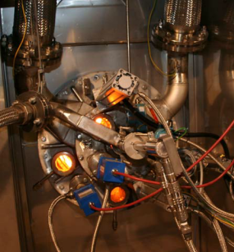

Figure 2‑1. Burner for concentrated non-condensable gas

## Diluted non-condensable gases

Diluted non-condensable gases are collected from unpressurised tanks and equipment at the fibre line, the evaporator, the tall oil digester and the causticizing plant. Gases from pressured black liquor tanks must be directed to the system for concentrated non-condensable gases. For non-condensable gases from unpressurised concentrated black liquor tanks, it is recommended that the gases be collected into the system for diluted non-condensable gases so that their dilution is verified.

Diluted non-condensable gases contain same components as concentrated non-condensable gases. Diluted non-condensable gases contain such a high amount of infiltrated air that they are below the explosive limit. The processing solutions for diluted non-condensable gases must always ensure that the gases stay diluted in all conditions.

The abbreviation HVLC (High Volume Low Concentration) also refers to diluted non-condensable gases. The guidelines by the BLRBAC use the American term DNCG (Diluted Non-Condensible Gas).

The EU BAT BREF refers to uncollected diluted non-condensable gases as ‘residual weak gases.’ The BREF also mentions ‘diffuse emissions,’ which refers to odorous emission sources that are not classified as non-condensable gases and that are generally not collected. These include odour emissions from sewage treatment.

## Vent gas from the dissolving tank and mixing tank

The vent gas from the dissolving tank contains inorganic dust, ammonia and odorous sulphur compounds, in addition to air and steam. Conventionally, the vent gas is not classified as a non-condensable gas. However, if the vent gas is led to the recovery boiler furnace, its processing must follow the guidelines for diluted non-condensable gases.

The mixing tank for ash and black liquor can be connected to diluted non-condensable gases or the vent gas from the dissolving tank. When collecting the vent from the mixing tank, the processing solution must be such that the gases remain diluted in all conditions.

## Systems with separate collection that require special attention

Systems with separate collection may include tall oil plants, potassium and chlorine removal plants, sulphuric acid plants, lignin separation plants and biochar plants.

### Tall oil plant

Mills for softwood have a tall oil plant. The soap forming out of the wood extractives rises to the top of the liquor tanks at the evaporator, from where it will be collected. At the tall oil digester, the soap is cooked by adding sulphuric acid to it, heating it and stirring the reaction mixture. The reaction releases gases that contain hydrogen sulphide (H2S), which is led via a gas scrubber to the collection system for diluted non-condensable gases. The gases can be led to the H2S scrubber of the tall oil plant, or to the system for cleaning diluted non-condensable gases at the evaporator that is equipped with pH adjustment for cleaning H2S.

### Potassium and chlorine removal plant

The closed cycle of a pulp mill causes chlorine and potassium to concentrate in the chemical circulation. The concentration of foreign substances hinders the operability of the recovery boiler and increases corrosion in the boiler. To control the foreign substance balance in the chemical circulation, the salt separated by the recovery boiler’s electrostatic precipitator is processed. There are various methods being used, the most common ones being extraction and evaporation crystallisation.

The non-condensable gases produced in the process at the vacuum pumps, tanks and filters are led into the diluted non-condensable gas system.

### Sulphuric acid plant

To control the sulphur balance, it is possible to make sulphuric acid out of concentrated non-condensable gases. The SO2 created in the NCG boiler is catalytically oxidised into SO3, which is then absorbed into water to form sulphuric acid. The remaining gases are led to the system for diluted non-condensable gases.

### Lignin separation plant

Some of the lignin contained by black liquor can be separated before being burned in the recovery boiler. The separation is done through precipitation, in which the pH is reduced by using acid or carbon dioxide. The precipitated lignin is filtered and scrubbed with acid to minimise sodium loss. The washing water is led back to the evaporator.

This process produces both concentrated and diluted non-condensable gases.

### Biochar plant

Biochar, also called ‘black pellets,’ is produced by thermally treating the wood pulp before pelletising. Two methods are used for the thermal treatment: steam explosion and torrefaction. In steam explosion, the biomass is heated with steam in a pressurised reactor, and the released biomass is pressed into pellets. The steam released in the process is condensed, and the foul condensate produced is led to the evaporator. The vent from the condenser is led to the collection system for concentrated non-condensable gases. The diluted non-condensable gases produced in the process are led to the collection system for diluted non-condensable gases.

## Hydrogen sulphide

Hydrogen sulphide is a colourless, toxic and highly flammable gas that is heavier than air. It typically gives out a strong odour of rotten eggs, but when the concentrations are close to 100 ppm (140 mg/m3), the hydrogen sulphide numbs the sense of smell, which is why the person exposed to it can no longer recognise the smell even when the concentration subsequently grows. A hydrogen sulphide concentration of 500 ppm (750 mg/m3) results in unconsciousness within five minutes. A concentration of over 1,000 ppm (1,400 mg/m3) causes a person to immediately fall unconscious and die as their breathing is paralysed.

A hydrogen sulphide leak may cause a fire hazard outdoors and an explosion hazard indoors.

Hydrogen sulphide is a reducing agent, which is why it may react powerfully with oxidising agents. The substance corrodes metals and plastics. In a water solution, hydrogen sulphide is acidic. Hydrogen sulphide is heavier than air (density of 1.19 compared to air), so it may accumulate in tanks and ducts, only releasing when the tank is full or through air flows. Hydrogen sulphide is formed when solutions containing sulphide, such as sodium sulphide, are mixed with acids, and it may be present in the whole plant area. Through sewers and ducts, it may spread a long distance. This is why pulp mills have gas detectors installed in areas where hydrogen sulphide may be present. When the detectors observe concentrations of hazardous gas above the threshold (typically 5 or 10 ppm), the alarm lights connected to the system and installed close to the measurement points light up.

## Methyl mercaptan

Methyl mercaptan is a colourless, highly flammable, volatile and toxic gas that is heavier than air. The health hazards of methyl mercaptan are very similar to those of hydrogen sulphide.

## Dimethyl sulphide and dimethyl disulphide

In normal conditions, dimethyl sulphide and dimethyl disulphide are colourless liquids with a characteristic unpleasant odour. Both compounds are flammable, and also explosive when mixed with air.

## Methanol

Pure methanol (CH3OH) is a colourless, nearly odourless, flammable and toxic gas/liquid. However, methanol is mixed with numerous odorous compounds at a kraft mill. The volume of methanol generated during digesting is influenced by the number of methoxy groups in the wood, the digesting time, the kappa number of digesting, the pH and the digesting temperature. Appendix 3 details the lower explosive limit for methanol as a function of temperature.

At an evaporator plant, methanol is released from liquor and ends up in the foul condensate. The methanol is separated from the foul condensate in the stripping column. The stripper off gas (SOG) from the column, which contains 30–35% of methanol vapour, is led directly for firing or to the methanol column where the methanol is liquefied and pumped for firing via the tank. The liquefied methanol can be stored in tanks before firing.

## Turpentine

Crude turpentine is a mix of C10H16 terpene isomers (such as alpha pinene), which is produced as a by-product of pulp digesting from the softwood extractives, the volatile components of resin. The turpentine yield depends on the wood’s habitat, the method and duration of storage, and the temperature and duration of steaming. Turpentine is separated and, in some cases, fired. Distilled turpentine is a colourless gas/liquid with a light scent. However, at a kraft mill, turpentine is mixed with odorous organic sulphur compounds, such as methyl mercaptan.

The vapour pressure of turpentine is 0.5 kPa in normal conditions, and its boiling range is 150–170°C, which is why it is classified as a volatile organic compound (VOC). The composition of crude turpentine varies widely. The most typical compositions are presented in table 2-1. Turpentine distilled from crude turpentine mostly consists of alpha pinene and delta-3 carene.

Table 2‑1. Typical compositions of crude turpentine. [OVA guidelines]

|  |  |
| --- | --- |
| **Compound** | **Concentration, %** |
| Alpha pinene | 50 – 80 |
| Beta pinene | 2 – 7 |
| Delta-3 carene | 10 – 30 |
| Other C10H16 compounds | 7 – 16 |
| Methyl mercaptan | 0 – 5 |
| Dimethyl sulphide | 0 – 12 |
| Dimethyl disulphide | 0 – 1 |

Turpentine should be removed from among non-condensable gases as carefully as possible, since it is explosive even in small concentrations with a lower explosive limit of 0.8%, approximately.

At collection points that may include terpenes, high concentrations are limited by condensing the gases. Turpentine is separated from non-condensable gases by condensing it with cold water in a scrubber. The scrubber comes after the turpentine condenser in the non-condensable gas line. Separated crude turpentine is stored in a turpentine tank.

Collection points that may contain terpenes include the chip supply bins, foul condensate tanks, and collection and weak liquor tanks, if condensates containing turpentine are led to them, even occasionally.

During shutdown and startup situations, condensed turpentine may vaporise among the non-condensable gases from the surface or ducts of the condensate tanks.

In addition to being separated from non-condensable gases, turpentine can also be separated using a turpentine decanter from the bottom condensate generated during methanol distillation. In the decanter, turpentine rises to the water surface as it is lighter than water and non-soluble. It can be separated from the water surface through overflow. The gases collected are directed to the collection system for concentrated non-condensable gases.

## Explosive limits

Non-condensable gases only explode if the mix of NCGs and oxygen is between its explosive limits and there is contact with an ignition source (figure 2-2). Ignition sources include e.g. hot surfaces, sparks generated mechanically, electrical devices, static electricity, electromagnetic radiation, shockwaves and chemical reactions.

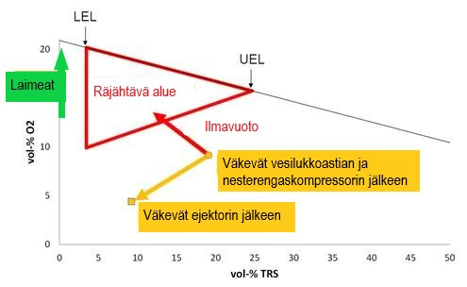

Figure 2‑2. Explosive concentration of NCGs.

These limits are called the lower explosive limit and upper explosive limit, figure 2-3. Often, the abbreviations LEL and UEL are used.

Lower explosive limit, LEL The lower limit for concentrations of flammable substances at which explosion is possible (the substance is too diluted; insufficient fuel).

Upper explosive limit, UEL The upper limit for concentrations of flammable substances at which explosion is still possible (too concentrated; insufficient oxygen).

Explosion range The range between the LEL and UEL (above LEL where there is a sufficient amount of flammable gas to cause an explosion; and below UEL where there is a sufficient amount of air to cause an explosion).

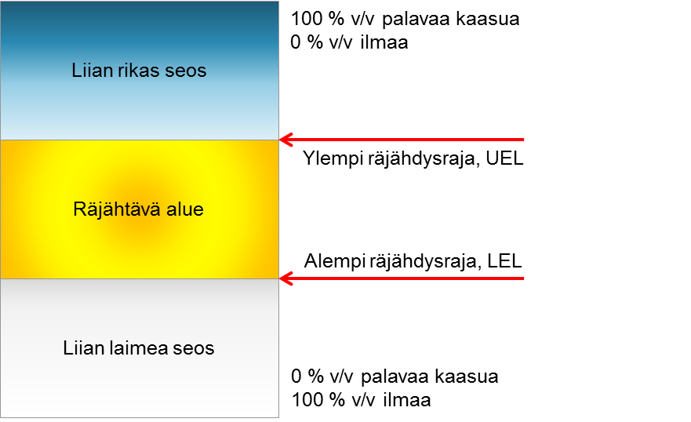

Figure ‑. Explosive limits

### Calculation formulas for explosive limits

The explosive limit is typically calculated based on the components in a mix.

In the decision on the classification grounds and labelling for chemicals of the Finnish Ministry of Social Affairs and Health (807/2001), Section 7.7.1 of Appendix 1 includes a formula for determining flammability. The decision is based on the standard ISO 10156, *Gases and gas mixtures — Determination of fire potential and oxidizing ability for the selection of cylinder valve outlets*, and its tables 1 and 2 that provide calculation constants for various flammable and inert gases. Table 2-2 presents the qualities of various NCG components in air.

Table 2‑2. Qualities of NCG components in air (Burgess & Young, 1992; Lautkaski, 2010)

|  |  |  |  |  |  |  |  |
| --- | --- | --- | --- | --- | --- | --- | --- |
|  |  | **Hydrogen**  **sulphide** | **Methyl**  **mercaptan** | **Dimethyl**  **sulphide** | **Dimethyl**  **disulphide** | **Turpentine**  **(α-pinene)** | **Methanol** |
| Formula |  | H2S | CH3SH | (CH3)2S | (CH3)2S2 | C10H16 | CH3OH |
| Molecular weight |  | 34 | 48 | 62 | 94 | 132 | 32 |
| Lower explosive limit | %, v/v | 4.3 | 3.9 | 2.2 | 1.1 | 0.8 | 5.5 |
| Upper explosive limit | %, v/v | 45.0 | 21.8 | 19.7 | 16.1 | 6.0 | 36.5 |
| Flame speed | m/s | 0.46 | 0.55 | 0.55 |  | 0.62 | 0.5 |
| Auto-ignition temperature | °C | 260 | 197 | 206 | 300 | 255 | 385 |
| Flashpoint | °C | -82 | -18 | -49 | 24 | 34 | 11 |
| Boiling point | °C | -60 | 6 | 38 | 110 | 150 | 65 |
| High heat value, HHV | MJ/kg | 15 | 22 | 31 | 23 | 41 | 22 |
| Gas volume weight compared to air |  | 1.19 | 1.66 | 2.14 | 3.24 | 4.7 | 1.11 |
| Odour threshold | ppm | 0.008 | 0.0004–0.003 | 0.001–0.01 | 0.003–0.011 | 100 | 100 |
| Heat value | kJ/mol | 518 | 1,249 | 1,908 | 2,213 | 3,947 | 543 |
| Soluble in water |  | Yes | No | No | Poorly | No | Yes |

When defining the combustion limits, or explosive limits, a method that is guaranteed to provide safe limits should be used. The explosive limits can be calculated using various methods. For gas mixtures, the calculation method presented in Section 5.2 of the standard [ISO 10156 /2010](http://sales.sfs.fi/servlets/ProductServlet?action=showproduct&productid=237500) may be used.

Another method is looking at the problem from the perspective of thermodynamics (Hokynar, 1999). The difference is practically indistinguishable in terms of the lower explosive limit, but the definition of the upper explosive limit is different since the impact of inert gas is different in the two methods.

## Abbreviations

|  |  |  |
| --- | --- | --- |
| **Abbreviation** | **Finnish definition** | **English definition** |
| ATEX | Räjähdysvaarallisten tilojen turvallisuus | Atmosphères Explosibles (explosive atmospheres) |
| BLRBAC |  | Black Liquor Recovery Boiler Advisory Committee |
| CH3SH | metyylimerkaptaani | methyl mercaptan |
| MM | metyylimerkaptaani | methyl mercaptan |
| (CH3)2S | dimetyylisulfidi | dimethyl sulphide |
| DMS | dimetyylisulfidi | dimethyl sulphide |
| (CH3)2S2 | dimetyylidisulfidi | dimethyl disulphide |
| DMDS | dimetyylidisulfidi | dimethyl disulphide |
| C10H16 | tärpätti | turpentine |
| CH3OH | metanoli | methanol |
| MeOH | metanoli | methanol |
| C2H5OH | etanoli | ethanol |
| H2S | rikkivety | hydrogen sulphide |
| SO2 | rikkidioksidi | sulphur dioxide |
| O2 | happi | oxygen |
| NH3 | ammoniakki | ammonia |
| H2O | vesi | water |
| CO2 | hiilidioksidi | carbon dioxide |
| CO | hiilimonoksidi | carbon monoxide |
| NO | typpioksidi | nitric oxide |
| CNCG | väkevät hajukaasut | concentrated non-condensable gases |
| DNCG | laimeat hajukaasut | diluted non-condensable gases |
| HEL | ylempi räjähdysraja | higher explosive limit |
| HVLC | laimeat hajukaasut | high volume low concentration |
| LEL | alempi räjähdysraja | lower explosive limit |
| LVHC | väkevät hajukaasut | low volume high concentration |
| NCG | hajukaasu | non-condensable gases |
| SHK | Sodahuskommittén | Swedish Recovery Boiler Committee |
| SOG | stripperin kaasut | stripper off gases |
| TRS | pelkistyneet rikkiyhdisteet | total reduced sulphur compounds |
| UEL | ylempi räjähdysraja | upper explosive limit |
| HAZOP | poikkeamatarkastelu | hazard and operability study |
| HTP (TLV) | haitalliseksi tunnettu pitoisuus | threshold limit value |

# IMPACT ON RECOVERY BOILER EMISSIONS

Burning non-condensable gases in a recovery boiler may affect the emissions from the recovery boiler. Burning non-condensable gases may reduce the carbonate content and pH value of the precipitator ash in the recovery boiler. The extra sulphur supplied to the furnace along with the non-condensable gases can first be seen in the ash salts entering the electrostatic precipitators with the flue gases as carbonate is replaced by sulphate. When the carbonate is used up, the surplus sulphide forms SO2.

## Effects on the recovery boiler’s sulphur emissions

The extra sulphur contained by non-condensable gases always increases the sulphate content in the recovery boiler ash, and as such may reduce its pH value. If the carbonate buffer is insufficient, the SO2 emissions of the boiler may increase. The boiler’s SO2 emissions are affected by the high sulphidity level of the mill, low dry solids and heat value levels of black liquor, and low boiler load.

Non-condensable gases should not be burned using a recovery boiler that already contains significant sulphide emissions. In such cases, a separate burning location with sulphur collection, e.g. a separate boiler, is recommended for the non-condensable gases.

## Effects on the recovery boiler’s TRS emissions

In modern boilers with effective mixing of fuel and air and an NCG system that works as intended, the TRS emissions of the boiler will not increase significantly as long as the non-condensable gases are directed to a zone with a minimum temperature of 900°C. In practice, the effect measured is a few tenths of ppm.

However, TRS and SO2 emissions are possible if the burning of concentrated non-condensable gases begins at a low boiler load. If diluted non-condensable gases are supplied above the liquor guns, it is possible that some non-condensable gases will travel along the cold walls without reacting.

## Effects on the recovery boiler becoming blocked

See Section 3.1. Effects on the recovery boiler’s sulphur emissions

If the conditions for burning non-condensable gases in the recovery boiler are not optimal and SO2 emissions are produced, the boiler bank, economisers and electrostatic precipitators may become blocked. The system also becomes more susceptible to corrosion if the ash remains at a low pH value for a long time.

## Effects on the recovery boiler’s NOx emissions

Liquid methanol and stripper off gases, in particular, contain nitrogenous compounds. The nitrogen is mostly present as ammonia. The diluted non-condensable gases in a causticizing plant contain ammonia.

In practice, the nitrogenous compounds in wood dissolve into the alkaline liquor almost completely in normal digestion. As such, they move to the evaporator via black liquor and further into the recovery boiler. In a recovery boiler, about a third of the nitrogen in black liquor typically turns into nitric oxide and forms NOx emissions in flue gases.

The other significant part of the organic nitrogen in black liquor is formed in the bottom smelt of the recovery boiler as sodium cyanate, NaOCN. The cyanate nitrogen in the smelt moves into green liquor, along with other salts in the smelt, in which the cyanate nitrogen transforms into ammonia as a result of alkaline hydrolysis.

The ammonia in green liquor, and moving forward, white liquor, partially evaporates into diluted non-condensable gases. However, most of the ammonia travels back to the digestion with white liquor. From the digestion, the ammonia moves to the black liquor along with organic nitrogenous compounds. In the evaporator, the ammonia is finally separated from the liquor and moves into concentrated non-condensable gases and methanol.

According to Conclusion 22 in the EU BAT, the NOx emission level of a recovery boiler increases as flows containing nitrogen are burned, such as non-condensable gases, turpentine and methanol, in which case the emission levels will be closer to the upper limit specified in the BAT.

### Effect of diluted non-condensable gases

The proportion of diluted non-condensable gases of the total air supplied into a recovery boiler is typically 10–30% of the total volume of air. The nitrogen in diluted non-condensable gases is mostly ammonia. The ammonia content of dry gases can be expected to be at the level of 10 ppm. It can be assumed that about 30% of ammonia converts into NO. If the boiler’s NO− level is at 100 ppm, the increase in nitric oxide emissions will be:

A measurable effect has not been detected in practice if diluted non-condensable gases are directed to the correct temperature range in the furnace.

### Effect of the dissolving tank vent gases

The proportion of air transferred via the dissolving tank vent gases of the total air volume supplied in the recovery boiler is typically 2−5% of the total air volume. The nitrogen in the dissolving tank vent gases comes from the secondary condensates from the evaporator, or from the smelt running into the dissolving tank reacting and turning into ammonia. The ammonia content of dry gases can be expected to be at the level of 100 ppm. It can be assumed that about 30% of ammonia converts into NO. If the boiler’s NO level is at 100 ppm, the increase in nitric oxide emissions will be:

A measurable effect has not been detected in practice if diluted non-condensable gases are directed to the correct temperature range in the furnace. In some boilers, an increase in NOx emissions has been detected when dissolving tank vent gases have been led into the tertiary air.

### Effect of concentrated non-condensable gases

The proportion of concentrated non-condensable gases of the total air supplied into a recovery boiler is typically 0.2−3% of the total volume of air. The nitrogen in concentrated non-condensable gases is mostly ammonia. The ammonia content of dry gases can be expected to be at the level of 2,000 ppm. It can be assumed that about 30% of ammonia converts into NO. If the boiler’s NO level is at 100 ppm, the increase in nitric oxide emissions may be:

$${NO}_{x}= \frac{100+0.3*0.01*2,000}{100}-1≈6\%$$

### Effect of methanol

About 10 kg/ADt of methanol is usually generated, depending on the raw wood material used. Liquid methanol may contain about 2% of ammonia. The ammonia content of methanol can be expected to be around 0.2 kg/ADt. It can be assumed that about 30% of ammonia converts into NO. If the NO level in the boiler is at 200 mg/Nm3, 3.5 Nm3 per kg of solids of flue gases are produced, and the amount of dry liquor is 1,600 kg of dry solids per ADt, the increase in the boiler’s nitric oxide emissions may be:

$${NO}_{x}= \frac{200*3.5*\frac{1,600}{1,000,000}+0.3*0.2}{200*3.5*1,600/1,000,000}-1≈5\%$$

## Effects on the recovery boiler’s other functions

In modern boilers that mix fuel and air effectively and have a sufficient base load, and when the NCG system is working as intended, no effects on the recovery boiler operation parameters have been detected. For example, no changes to the reduction have been reported.

Starting to burn non-condensable gases usually reduces the total sulphur emissions of a mill. However, it also affects the chemical balance in the mill and tends to increase sulphidity. The sulphur balance of a mill should always be reviewed on a case-by-case basis.

Along with the dissolving tank vent gases and diluted non-condensable gases, steam will enter the boiler, which may reduce the boiler’s capacity somewhat, depending on the steam content. Figure 3-1 shows the maximum amount of steam contained in dry air at a specific temperature. Warm air can absorb more water than cold air. The burning of concentrated non-condensable gases, methanol and turpentine increases evaporation in the boiler. In this case, the design of the water and steam sides of the boiler should be inspected before the burning starts, especially when using an existing recovery boiler.

Figure 3‑1. Steam content in saturated air as a function of temperature

# RISKS AND CORROSION OF NCG SYSTEMS

Typical risks involved in an NCG system include explosion hazards (the gases concentrating and being ignited by a spark, hot surface or back fire), toxic hazards, problems with condensate removal (water entering the furnace), and corrosion or erosion.

The Finnish Recovery Boiler Committee recommends that, before new collection sources are added or changes (dimensioning, running method, etc.) are made, a risk assessment (e.g. HAZOP) is made on the NCG system.

The burning of non-condensable gases may cause problems in the process, such as sulphur emissions from the boiler, the economisers and boiler bank becoming blocked, and disruptions in the furnace.

## Non-condensable gases leaking into the working space

Non-condensable gases may leak outside the system through joints, valves, drains or damaged parts. Non-condensable gases have a high concentration of sulphur compounds and methanol, which pose a toxic hazard. When a leak occurs in the boiler room or another space, the entire room or space must be evacuated and ventilated thoroughly, and its suitability for working must be ensured with measurements.

Non-condensable gases typically leak to the working space through condensates during maintenance. During maintenance, potential leaks come from the water traps and safety devices in the NCG system. Special care is required when handling methanol or turpentine burners. Even the smallest leaks cause significant odour nuisance.

Since the lines for concentrated non-condensable gases coming after the ejector in a recovery boiler building are over-pressurised, they may pose a risk of gas poisoning in the recovery boiler building if the lines leak. A poorly ventilated area may also involve a gas explosion hazard.

The permitted hydrogen sulphide content is 5 ppm (7 mg/m3) per 8 h and 10 ppm (14 mg/m3) per 15 min indoors, according to the TLV guidelines (threshold limit values) published by the Finnish Ministry of Social Affairs and Health, [*HTP-ARVOT 2020: Haitallisiksi tunnetut pitoisuudet*](http://urn.fi/URN:ISBN:978-952-00-5658-2). These TLVs are the lowest concentrations that are believed to harm workers.

Mills have both fixed and mobile meters for hydrogen sulphide and VOC. The fixed meters start the alarm lights and sounds if the content of hydrogen sulphide or VOC in the air is too high. The alarms should be visible both locally and in the control room. When placing the meters, the air flow and working areas should be taken into consideration. The operation of both fixed and mobile meters should be tested regularly, the mills’ quality systems should include instructions on them, and the tests made should be documented.

The Finnish Recovery Boiler Committee recommends that fixed hydrogen sulphide alarms are installed at the locations where non-condensable gases are burned. The separate burning locations may also experience flue gas leaks, which is why a fixed SO2 alarm is equally necessary.

When repairs or maintenance are carried out on the NCG lines or equipment, the workers must obtain a special permit to carry out the work.

### Odour

Sulphur compounds numb the sense of smell, which is why you should never trust your nose. The situation may become lethal if the appropriate precautions are not taken. Everyone working with equipment that contain non-condensable gases should read the safety data sheets for diluted and concentrated non-condensable gases.

### Personal protection

When working, only pneumatic devices should be used to protect against non-condensable gases. Gas masks and respirator protectors are only intended for exiting the danger zone. The filter on the protectors should protect against the compounds that are present in non-condensable gases. It is also recommended that workers wear personal meters that indicate the levels of hydrogen sulphide (H2S), at the very least.

## Problems with condensate removal

If the steam in an NCG line condensates, the risk of smeltwater explosion exists if this water ends up in the recovery boiler.

Special attention should be paid to the draining, and it should be arranged extensively throughout the lines.

### Draining pocket becoming full

A common problem present in NCG systems is the occasionally excessive volume of condensate. The draining pockets closest to the recovery boiler should be equipped with alarms for the upper-level and with an interlocking system, if necessary, to turn the non-condensable gases away from the burning location.

### Water trap drying

The water trap can dry if the non-condensable gases are heated above the condensation temperature. To prevent drying, a sufficient flow of fresh water should always be led to the water traps, and they should be equipped with flow guards, at the minimum.

The water traps must also be stopped from drying during shutdowns.

### Water trap becoming blocked

Small amounts of liquor foam/soap end up in the non-condensable gases and may accumulate in the lowest points of the line, such as the drains. If the draining pipe does not have a sufficient diameter, the pipeline may become fully blocked.

## Explosion hazards in NCG lines

Concentrated non-condensable gases are moved and burned so that the gas remains non-explosive at all times. An explosion hazard is present if air leaks into the concentrated non-condensable gases, e.g. via the water traps or tanks’ safety valves. The concentration of CNCGs can be kept above the upper explosive limit by ensuring the system’s tightness.

Diluted non-condensable gases are moved and burned so that the gas concentration remains below the lower explosive limit. The concentration of DNCGs is kept below the explosive limit by ensuring air dilution, for example. In some cases, the explosion hazard may be created when the steam in the non-condensable gases is condensed away, which is when the gas concentration will rise closer to the lower explosive limit.

Ignition requires ignition energy. Sparks can be prevented as far as possible through grounding, structures and choices of equipment.

### Shutdowns and startups

Special attention should be paid to the concentrations of diluted non-condensable gases during shutdowns and startups. Often, the NCG explosions at recovery boilers have occurred in the systems for diluted NCGs where the concentration has increased excessively during a shutdown or disruption. One of the typical problems is that the explosive gases are accumulated in the pipeline during the shutdown and then volatilize at startup.

### Back fire

The flame travels against the gas flow in the pipeline typically because the flow speed is too low. This is why flame arresters are used in the pipelines for concentrated non-condensable gases.

## Gas explosion in a boiler

Non-condensable gases are mixtures of flammable components, oxygen and inert gases (nitrogen, steam). As always, flammable gases pose a danger of gas explosion in the furnace. A gas explosion occurs if fuel is run to the furnace without it burning immediately. After this, the mixture will provide high levels of energy when it ignites.

## Smeltwater explosion in a boiler

If water that has condensed in the NCG pipeline ends up in the furnace, it will cause a smeltwater explosion. To prevent the water supply, diluted non-condensable gases and the vent from the dissolving tank are heated sufficiently so that most of the water is steam, and the NCG lines are constructed so that they have sufficient condensate removal systems and slopes. When designing the drain system, aspects such as the size, number and location should be considered.

‘Smeltwater explosion’ refers to the rapid vaporisation of water that ends up in contact with a hot mix of chemicals. The shockwave caused by the vaporisation may damage the furnace and cause a leak of flue gas/water/steam in the boiler room.

## Problems with corrosion

When designing NCG systems, the danger of furnace corrosion should be taken into consideration. Corrosion has also been detected in the air vents close to a burner for concentrated non-condensable gases.

The material recommended for each NCG type should be used. When designing NCG burners, potential problems caused by the flame should be taken into account.

## Sparking and static electricity

An explosion requires ignition energy from a spark or hot surface. To ensure safety, equipotential bonding should be carried out on the NCG lines, starting from the collection point. The purpose of equipotential bonding is to prevent dangerous simultaneous differences in voltage between conductive parts that are being touched. For example, flanges, hatches and connections that may form galvanic differences due to their seal materials must undergo equipotential bonding. The equipotential bonding is carried out according to regulations and verified with measurement records.

# SYSTEMS FOR DILUTED NON-CONDENSABLE GASES

Diluted non-condensable gases are not fuel. They mainly consist of air and steam. According to the Chemicals Act of Finland, diluted non-condensable gases are classified as generally harmful, which is why the systems for them must be purchased, designed, installed and used accordingly.

To ensure the safe use of the recovery boiler, water leaks into the boiler must be prevented when burning diluted non-condensable gases. Diluted non-condensable gases are cooled (some of the water in the gas will condensate), moved with a fan and heated to vaporise any drops before the burning. The NCG lines are equipped with condensate removal so that water does not accumulate in the NCG line and end up in the boiler.

## Typical collection locations at a pulp mill

The locations where non-condensable gases are collected vary by mill because of different process solutions. As such, not all mills have the collection locations presented in this section of the guidelines.



Figure 5‑1. Example of a DNCG collection system (based on document PSAVI/7988/2019).

### Fibre line

Typical collection locations in a fibre line are described below. The vent gas from the bleaching process is not collected along with the diluted non-condensable gases, but processed separately.

Tanks: brown stock blow tank, oxygen stage blow tank, filtered liquor tanks, reject tanks and leak collection tank.

Process equipment: chip bin, brown stock scrubbers, knot scrubbers, reject scrubbers, white liquor oxidisation system, scrubbers beyond the oxygen stage, pumps for medium consistency pulp, and vacuum pumps.

Other process locations: floor drains in the digesting and scrubbing areas, floor ducts and underground collection tanks.

Notes about the collection locations in the fibre line:

* Regardless of the process solution, the chip bin may generate non-condensable gases that may concentrate to the point that they exceed the lower explosive limit for diluted non-condensable gases. Attention must be paid to various operation and disruption situations when assessing the risks.
* Using secondary condensate from the evaporator in the fibre line may increase the amount of vent gas that contains RTS fractions.
* The vent gas from bleaching should not be collected in the DNCG system since these fractions do not contain odorous sulphur compounds. The bleaching vent gas can be led to the sky via a dedicated scrubber.

The drying system does not form a significant amount of odorous compounds, and the discharge amounts are substantial, which is why they should not be led to the DNCG collection.

### Evaporator

Typical collection locations in an evaporator are described below.

Tanks: liquor tanks operating at air pressure, such as the tanks for feed liquor, weak black liquor, semi-thick liquor, leak liquor and strong black liquor, secondary condensate tanks, and soap tanks.

Process equipment: sampling points.

Other process locations: floor channels and underground collection tanks.

Notes about the collection locations in the evaporator:

* The vent gas from pressurised liquor tanks must not be led to the DNCG collection system. In pressurised liquor tanks, concentrated non-condensable gases are formed even during shutdowns, and these must be treated appropriately.
* The expansion of hot liquor must not be carried out in storage tanks; instead, the vent gas must be collected into the evaporation sequence.
* Only vent gas from clean secondary condensate tanks can be collected to the DNCG system. The vent gas from the foul condensate tank should be collected into the CNCG system.
* If the quality of the stripped condensate is weakened, the condensate can be temporarily led into the leak liquor tank. Sufficient dilution of the tank vent gas must be ensured. Ensuring the condensate quality must be a priority.
* Overflow from the foul condensate tank is typically led to the floor drain, the vent gas from which is collected into the DNCG system. In this case, the sufficient dilution of the vent gas from the floor drain must be ensured. However, overflow should be prevented in the first place to avoid risk.
* The vent gas from the processing of methanol and separation of turpentine must be led into the CNCG system.

### White liquor plant

Typical collection locations in a white liquor plant are described below:

Tanks: storage tanks for raw or filtrated green liquor, green liquor clarifiers, dregs tanks, white liquor filters, storage tanks for white liquor, storage tanks for weak white liquor, storage tanks for lime mud, washwater tanks, acid tanks, and dilution tanks.

Process equipment: green liquor filtering equipment, dregs processing, slaker and causticizing vessels, white liquor filters, lime mud filters, vacuum pumps, and white liquor oxidisation system.

Other process locations: floor channels and underground collection tanks.

Notes about the collection locations in a white liquor plant:

* When designing the NCG system of a white liquor plant, the processes that generate dust should be taken into consideration. These processes pose a risk of blocking the collection system.

### Other locations

Sewage treatment in the mill area: mixing chamber for acidic and alkaline sewage; bio sludge processing.

Other collection locations: Vent gas from a tall oil plant after the alkaline scrubber, vent gas from the lignin separator, chloride removal system, and sulphuric acid production.

The vent gas from oil tanks, such as tanks for fuel oil, tall oil or tar oil, are typically not collected into the NCG system as such vent gas is not odorous.

## Composition and volume

Diluted non-condensable gases consist of the vent gas from the tanks and equipment in a pulp mill’s fibre line, from the evaporator tank area or from the causticizing plant, etc. The amount of diluted non-condensable gases is about 300–400 m3n/ADt, and their sulphur concentration is about 0.1–0.5 kgS/ADt. Generally, diluted non-condensable gases are processed by using a scrubber-type vent gas cooler, which reduces the amount of non-condensable gases to be processed. Table 5-1 shows the typical amounts of diluted non-condensable gases in different parts of the mill.

TABLE 5‑1. Amounts of DNCG in different parts of the mill at 40 °C.

|  |  |  |
| --- | --- | --- |
| **Section** | **kg S / ADt** | **m3n / ADt** |
| Vent gas from continuous digesting | 0.1 – 0.5 | 100 – 400 |
| Vent gas from batch digesting  (evacuation air, vent gas from non-pressurised tanks) | 0.1 – 0.5 | 150 – 300 |
| Vent gas from the scrubber | 0.05 – 0.1 | 100 – 200 |
| Vent gas from the tall oil plant | 0.05 – 0.2 | 2 – 3 |
| Tank vent gas, evaporator (tanks at air pressure) | 0.1 – 0.4 | 20 – 30 |
| Causticizing and lime kiln plant | 0.01 – 0.1 | 5 – 10 |
| Total | 0.1 – 0.5 | 300 – 400 |

The concentration of diluted non-condensable gases must always be kept below the explosive limit, and the concentration must be prevented from rising. As long as the concentration and humidity are kept low, diluted non-condensable gases can be processed at a boiler plant like other combustion air. When the system for burning diluted non-condensable gases is first commissioned in a mill, or the process is changed, the concentrations in the lines and at the different collection locations must be measured to determine the DNCG content at different locations. Table 5-2 shows examples of analyses on diluted non-condensable gases. The content of the NCG components varies greatly by mill and measurement point.

Table 5‑2. Examples of DNCG analyses at the point of origin.

|  |  |  |  |  |  |  |
| --- | --- | --- | --- | --- | --- | --- |
|  | **Plant A** | **Plant B** | **Plant C** | **Plant D** | **Plant E** | **Plant F** |
| **Component** | **ppm** | **ppm** | **ppm** | **ppm** | **ppm** | **ppm** |
| H2S | * | * | 1 | 0 | 725 | 1 |
| MM, CH3SH | 200 | 40 | 70 | 2 | 14 | 2 |
| DMS, (CH3)2S | 1,000 | 60 | 160 | 643 | 1,530 | 784 |
| DMDS, (CH3)2S2 | 90 | * | 270 | 1 | 10 | 365 |
| Turpentine, C10H16 | 1,500 | 15 | * | 69 | 470 | 12,400 |
| MeOH, CH3OH | 900 | 150 | * | 834 | 6,943 | 2,046 |
| Ethanol, C2H5OH | 80 | * | * | * | * | * |
| Oxygen, O2 | * | * | * | * | * | * |
| Ammonia, NH3 | 200 | * | * | * | * | * |
| Water, H2O | 70,000 | 50,000 | * | * | * | * |
| Carbon dioxide, CO2 | * | 300 | * | * | * | * |

*) not analysed or below the observation threshold

Special attention should be paid to ensuring that the NCG concentration in the chip bin vent gas does not rise too high when there is a disruption. In the event of a disruption at the chip bin, the vent gas must not be led to the DNCG collection system. In addition to this, it must be determined where condensate containing turpentine is led during a disruption in the digesting. There have been cases where, during a digesting disruption, the condensate’s turpentine content has increased substantially due to an unsuitable connection.

Table 5-3 shows the recommended maximum content of DNCG components prior to burning. Typically, diluted non-condensable gases are at less than 10% from the lower explosive limit.

Table 5‑3. Recommended maximum content of DNCG components prior to burning.

|  |  |  |
| --- | --- | --- |
| **Quality** | **Limit** | **Notes** |
| Air content, vol-% | > 90 |  |
| Water content, vol-% | <7 | 40°C (after condenser) |
| Water content, vol-% | <12 | 50°C (after condenser) |
| Sulphur content, TRS, ppm | <200 |  |
| Turpentine content, ppm | <1,000 |  |
| Methanol content, ppm | <1,000 |  |

Diluted non-condensable gases are typically fed into the recovery boiler as a part of the boiler’s combustion air. Due to the risk of smeltwater explosion caused by the rush of condensate, feeding non-condensable gases into primary air is not recommended.

## Cooling and heating

The condensate from diluted non-condensable gases must not enter the recovery boiler’s furnace. The amount of steam among diluted non-condensable gases running into the furnace must be as low as possible. It is recommended that the temperature of the diluted non-condensable gases be 40–50°C after the condenser.

It is recommended that diluted non-condensable gases be heated above the condensation temperature of 30°C to minimise the water drops’ entry into the furnace. When diluted non-condensable gases are mixed with combustion air, the temperature after the mixing must fulfil the criterion specified above.

## Logic for burning DNCG

This text aims to present the process requirements for the logic for burning diluted non-condensable gases. This document aims to present a set of conditions required of safe automation. The operating logic of an individual recovery boiler also includes other variables due to its equipment, process connections or realisation.

These guidelines do not apply to the interlocking for starting and running the DNCG collection, although they are often implemented in the same system as the interlocks for the burning. Such interlocks must be defined separately on a case-by-case basis.

The Finnish Recovery Boiler Committee recommends that the NCG system be used for sufficiently long (e.g. over an hour) before the supply is started so that the flammable NCG components that have condensed in the ducts can be vaporised and vented out. If possible, the collection of diluted non-condensable gases should stay on during a shutdown. The purpose is to avoid the concentration of diluted gases into concentrated gases.

It must be possible to monitor the burning of diluted non-condensable gases in a recovery boiler, and starting and stopping must be possible via the same control room where all other monitoring on the recovery boiler takes place.

### Preconditions for the supply of DNCG

Diluted non-condensable gases can be fed to the boiler’s furnace when e.g. the following conditions are met. **NOTE: The operating logic of an individual recovery boiler may also include other conditions due to its year of commissioning, equipment, process connections or realisation.**

Table 5‑4. Preconditions for the supply of DNCG

|  |  |  |
| --- | --- | --- |
|  | **Condition** | **Purpose of the condition** |
| 1. | Fire status in the boiler: e.g. at least one startup burner is running and/or liquor burning is on. | To ensure the burning conditions. |
| 2. | The boiler’s fire power is greater than 0.3 MW/m2, which can be verified by the steam load or supply water flow. This limit equals about 15% of the boiler’s nominal steam load, but **the specific limit should be defined on a case-by-case basis**. | To ensure that the conditions in the furnace are sufficiently stable for non-condensable gases to oxidise (temperature, delay). |
| 3. | The fan into the DNCG furnace is on. | To ensure that non-condensable gases flow into the furnace and stop them from flowing into the boiler room. |
| 4. | The temperature after the cooling (before the heating battery) is below the temperature limit. | To reduce the gas volume and amount of steam. |
| 5. | The temperature before feeding into the boiler is above the temperature limit. | To prevent water drops from entering the boiler. |
| 6. | The surface of the potential water pocket in the NCG system is below the upper limit. | To prevent condensate from leaking into the boiler. |

### Interrupting the burning of DNCG

The supply of diluted non-condensable gases must be stopped if some of the following conditions are met. **NOTE: The operating logic of an individual recovery boiler may also include other conditions due to its year of commissioning, equipment, process connections or realisation.**

Table 5‑5. Interrupting the burning of DNCG

|  |  |  |
| --- | --- | --- |
|  | **Condition** | **Purpose of the condition** |
| 1. | The boiler’s fire status is lost. | To ensure the burning conditions. |
| 2. | The boiler’s fire power is lower than 0.3 MW/m2, which can be verified by the steam load or supply water flow. This limit equals about 15% of the boiler’s nominal steam load, but **the specific limit should be defined on a case-by-case basis**. | To ensure that the conditions in the furnace are sufficiently stable for non-condensable gases to oxidise (temperature, delay). |
| 3. | Quick stop is initiated. | To prevent the supply of non-condensable gases when the boiler is no longer being used. |
| 4. | The fan feeding diluted non-condensable gases into the furnace stops. | To ensure that non-condensable gases flow into the furnace and stop them from flowing into the boiler room. |
| 5. | The temperature after the cooling (before the heating battery) rises above the temperature limit. | Gas moisture content is too high. |
| 6. | The temperature before feeding into the boiler is below the temperature limit. | The amount of water drops grows too high. |
| 7. | The surface of the water pocket in the NCG system is above the upper limit. | To prevent condensate from leaking into the boiler. |

### Flow

It is recommended that the flow of diluted non-condensable gases fed for burning be measured.

### Equipotential bonding

Equipotential bonding is not required for diluted non-condensable gases.

## Valves and dampers

The valves and dampers for the burning of diluted non-condensable gas must be selected carefully. Special attention must be paid to the valve tightness. Normally, tight flap valves or dampers are used in large pipes.

The automatic shut-off valve of the DNCG line must close when auxiliary energy stops. At the same time, the valve of the bypass duct or alternative burning location must open. Limit data of the shut-off valve being opened and closed must be entered into the automation system.

The recommended construction material for the valves is EN 1.4301 (AISI 304) or similar.

## Fan

The fan structure must be sufficiently tight so that the non-condensable gases do not leak into the environment. The condensate removal pipe must be sized DN50, at the minimum.

## Extra air inlet

An extra air inlet (additional air inlet) can be used as a part of the DNCG system to add outdoor air into the non-condensable gases. If the safety of the diluted non-condensable gases depends on the operation of the extra air inlet, special attention should be paid to preventing the extra air supply from stopping for any reason.

For the reasons mentioned above, the extra air supply must be monitored and measured sufficiently, e.g. through flow measurements. Insufficient supply of extra air must trigger necessary locking.

## Scrubbers and condensers

In a DNCG system, a required number of scrubbers or condensers should be present to remove the steam and VOC (e.g. turpentine) contained in the gases and thus reduce the amount of gas collected.

## Droplet separator

In the droplet separator, any condensate is removed from the gas. It is recommended that a droplet separator be used afterwards whenever diluted non-condensable gases have been cooled or handled at the scrubber. In addition to this, it is also recommended that drop separating be used before the gases are heated close to the burning location.

## Condensate removal

The DNCG lines should be equipped with condensate removal devices. Primarily, the condensate should be fed to the foul condensate processing in a dedicated system.

When designing the condensate removal, special attention should be paid to the size, number and location of the devices. The last removal should be equipped with surface switches and placed as close to the recovery boiler as possible so that the duct from the removal to the furnace is as short as possible.

### Size of the condensate removal lines

In condensate removal devices and the lines starting from them, the recommended pipe diameter is DN50, at the minimum, due to the risk of blocking. Combining the condensate removal lines to each other should be avoided to ensure sufficient capacity. The pipe diameter in the devices and line for condensate removal close to the recovery boiler must be DN100, at the minimum. The size of the condensate removal devices and lines must be increased if it is possible that extra water, such as washing water, will end up in the line.

### Duct slopes and placement of the condensate removal devices

The ducts and pipes must slope towards the condensate removal. Removing condensate to any other direction than the direction of flow is difficult. The recommended slope for ducts in places other than the recovery boiler plant is 1:100 to the direction of the gas flow and 1:25 against the gas flow.

Due to the danger of water ending up in the furnace, recovery boiler plants should aim to have ducts where the slope is 1:100 in the direction of the gas flow and 1:1 against the direction of the gas flow. Condensate removal must always be carried out before a steep upward slope. If the recommended slopes cannot be reached at some section of the duct, the condensate removal for such a section must be designed with special care.

When designing the size and flow speed of the NCG pipeline, it must be considered that the gas flow may catch condensate at high flow speeds.

When large duct sizes are being used (over DN300), a condensate pocket, via which the condensate will be removed, is recommended.

### Water traps

The condensate removal lines must be equipped with water traps or a shared water trap tank (condensate collection tank). This way, NCG leaks via the condensate removal devices can be prevented.

To prevent the water traps from drying, they must be equipped with surface level measurements or with a continuous or timed water flow verified through flow measurements.

For the pressure in the DNCG duct to stay sufficiently low to not empty the water trap, the difference in the trap’s water surface levels should be able to fluctuate by 10 kPa, at the minimum, or by an amount that corresponds to the structural pressure of the duct. 10 kPa corresponds to 1 m of surface level fluctuation in the water trap.

If the condensate is collected in a pumping vessel, the difference between the vessel’s surface levels must be able to fluctuate by 10 kPa, at the minimum, or by an amount that corresponds to the duct’s structural pressure.

It is recommended that the facility placed before the burning location have a condensate removal that is able to receive a larger amount of condensate generated e.g. during a shutdown.

## Flame arrester

DNCG ducts do not require flame arresters.

## Bypassing

The DNCG bypass duct should be led to a place that is as high as possible. It is recommended that the bypass duct be led to the roof or chimney of the recovery boiler plant in its dedicated line. The bypass can also be implemented by leading the diluted non-condensable gases to the same bypass ducts as the dissolving tank vent gases. In this case, attention should be paid to the joint operation and the sealing of the entire system.

## Low-pressure safeguards

A low-pressure safeguard can be used for diluted non-condensable gases if the pipeline’s structural pressure and fan suction so require.

## High-pressure safeguards

DNCG systems do not require a high-pressure safeguard.

### Explosion and bursting discs

DNCG ducts do not require explosion discs. If bursting discs are used for pressure protecting in the systems, the condition of the discs must be monitored in the automation system by triggering an alarm. The outlet of such a bursting disc must be turned to a safe direction.

## Concentration measurement

DNCG systems do not require continuous content measuring.

The Finnish Recovery Boiler Committee recommends that DNCG concentrations at the starting point be measured if changes to the devices or connections are made there. This way, it can be ensured that the DNCG concentration does not exceed the lower explosive limit.

The Committee also recommends that the sulphur and oxygen content of the diluted non-condensable gases be measured at least once a year.

# Burning the dissolving tank vent gases at the recovery boiler

At a recovery boiler, vent gases are mostly formed when smelt is dissolved. In addition to this, when ash from the electrostatic precipitator is mixed with black liquor, vent gas is formed. This also happens in potassium and chloride separation plants. In addition to these, typical collection locations include the drain collector tank and a well or tank intended for collecting liquor leaks.

The qualities of the dissolving tank vent gases correspond to those of diluted non-condensable gases. The vent gas mainly contains air, steam and small amounts of odorous sulphur compounds and salt particles. To recover the odorous sulphur contained in the dissolving tank vent gases and to reduce dust emissions, mills have started to burn these in recovery boilers. The Finnish Recovery Boiler Committee recommends that dissolving tank vent gases be burned in a recovery boiler plant.

Other substances, such as vent gases from the mixing tank or the ash processing and diluted non-condensable gases from elsewhere in the mill, can be fed to the dissolving tank vent gases system.

To ensure the safe use of the recovery boiler, water leaks into the boiler must be prevented when burning dissolving tank vent gases.

Dissolving tank vent gases is scrubbed, cooled, moved with a fan and heated to vaporise any drops before the burning. The vent gas lines are equipped with condensate removal so that water does not accumulate in the vent gas line and end up in the boiler.

## Composition and volume

The dissolving tank vent gases come mainly from the leaked air, steam produced by the smelt’s heat (green liquor boiling in the dissolving tank) and the steam from the smelt shattering. The most problematic elements for the processing are the small drops of green liquor included in the dissolving tank vent gases that tend to contaminate/block the vent gas system when they dry.

The amounts and compositions of the dissolving tank vent gases in a pulp mill are presented in Table 6‑1. However, the amount of vent gas varies by boiler, and the process influences the composition extensively.

TABLE 6‑1. Amounts and compositions of dissolving tank vent gases; Rantanen, 1987

|  |  |  |
| --- | --- | --- |
| Amount of vent gases from the dissolving tank | m3n / kg dry solids | 0.4 – 0.8 |
| Temperature of vent gases from the dissolving tank | °C | 85 – 95 |
| Humidity of vent gases from the dissolving tank | vol-% | 40 – 80 |
| Total dust level of vent gases from the dissolving tank | mg/m3n (dry) | 1,000 – 5,000 |
| TRS in vent gases from the dissolving tank | mg/m3n (dry) | 150 – 700 |
| Total sulphur in vent gases after scrubber | kg S / ADt | 0.01 – 0.1 |
| Total dust in vent gases after scrubber | mg/m3n (dry) | 100 – 200 |
| TRS in vent gases after scrubber | mg/m3n (dry) | 1 – 10 |

The dissolving tank vent gases are fed to the recovery boiler mixed with air or other diluted non-condensable gases led to the boiler. Another option is feeding the dissolving tank vent gases via dedicated openings.

## Vent from the mixing tank

The TRS content of the vent gas from the mixing tank may be high, but the amount is still low compared to the amount of vent gas from the dissolving tank, which is why it can be mixed with the dissolving tank vent gases. When leading mixing tank vent gas to the dissolving tank vent gas system, their contaminating effect must be taken into consideration. In this case, a dedicated scrubber can be added to the mixing tank’s vent gas system.

When leading the mixing tank vent gas to the furnace in a dedicated system, the recommendations and locking systems for the burning of dissolving tank vent gases must be taken into consideration.

## Cooling and heating

The condensate from dissolving tank vent gases must not enter the recovery boiler’s furnace. The dissolving tank vent gases system may include a cooler that removes steam and thus reduces the amount of gas entering the boiler. Attention should be paid to the option of washing the cooler during operation. It is recommended that the temperature of the dissolving tank vent gases be 40–50°C after the condenser.

Typically, a separate heating system is not used for the vent due to the risk of contamination; instead, the vent gas is heated by mixing it into the hot gas flow.

## Logic for burning dissolving tank vent gases

This text aims to present the process requirements for the logic for dissolving tank vent gases. This document aims to present a set of conditions required of safe automation. The operating logic of an individual recovery boiler also includes other variables due to its equipment, process connections or realisation.

It must be possible to monitor the burning of dissolving tank vent gases in a recovery boiler, and starting and stopping must be possible via the same control room where all other monitoring on the recovery boiler takes place.

### Preconditions for the supply of dissolving tank vent gases

Dissolving tank vent gases can be fed to the boiler’s furnace when the following conditions are met. **NOTE: The operating logic of an individual recovery boiler may also include other conditions due to its year of commissioning, equipment, process connections or realisation.**

Table 6‑2. Preconditions for the supply of dissolving tank vent gases

|  |  |  |
| --- | --- | --- |
|  | **Condition** | **Purpose of the condition** |
| 1. | Fire status in the boiler: e.g. at least one startup burner is running and/or liquor burning is on. | To ensure the burning conditions. |
| 2. | The boiler’s fire power is greater than 0.3 MW/m2, which can be verified by the steam load or supply water flow. This limit equals about 15% of the boiler’s nominal steam load, but **the specific limit should be defined on a case-by-case basis**. | To ensure that the conditions in the furnace are sufficiently stable for non-condensable gases to oxidise (temperature, delay). |
| 3. | The dissolving tank vent gas fan and the fan for the combustion air level in question are on. | To ensure that the vent gases flow into the furnace and stop them from flowing into the boiler room. |
| 5. | The temperature after the cooling (before the heating battery) is below the temperature limit. | To reduce the gas volume and amount of steam. |
| 6. | The temperature before feeding into the boiler is below the temperature limit. | To prevent condensate from leaking into the boiler. |
| 7. | The surface of the potential water pocket in the dissolving tank vent gas system is below the upper limit. | To prevent condensate from leaking into the boiler. |

### Interrupting the supply of dissolving tank vent gases

The supply of dissolving tank vent gases must be stopped if some of the following conditions are met. **NOTE: The operating logic of an individual recovery boiler may also include other conditions due to its year of commissioning, equipment, process connections or realisation.**

Table 6‑3. Interrupting the supply of dissolving tank vent gases

|  |  |  |
| --- | --- | --- |
|  | **Condition** | **Purpose of the condition** |
| 1. | The boiler’s fire status is lost. | To ensure the burning conditions. |
| 2. | The boiler’s fire power is lower than 0.3 MW/m2, which can be verified by the steam load or supply water flow. This limit equals about 15% of the boiler’s nominal steam load, but **the specific limit should be defined on a case-by-case basis**. | To ensure that the conditions in furnace are sufficiently stable for non-condensable gases to oxidise (temperature, delay). |
| 3. | Quick stop is initiated. | To prevent the supply of non-condensable gases when the boiler is no longer being used. |
| 4. | The dissolving tank vent gas fan and the fan for the combustion air level in question stop. | To ensure that the vent gases flow into the furnace and stop them from flowing into the boiler room. |
| 5. | The temperature after the cooling rises above the temperature limit. | Gas moisture content is too high. |
| 6. | The temperature before feeding into the boiler is below the temperature limit. | The amount of water drops grows too high. |
| 7. | The surface of the water pocket in the dissolving tank vent gas system is above the upper limit. | To prevent condensate from leaking into the boiler. |

## Ducts

The dissolving tank vent gases must be prevented from leaking into the boiler room, and the duct length in the boiler room must be minimised.

Due to the risk of corrosion, the ducts and openings for burning the dissolving tank vent gases must be made of stainless steel EN 1.4301 (AISI 304) or a similar material.

### Flow

It is recommended that the flow rate of the dissolving tank vent gases be measured.

### Equipotential bonding

Equipotential bonding is not necessary for the dissolving tank vent gases duct.

## Valves and dampers

The valves and dampers for the burning of dissolving tank vent gases must be selected carefully. Special attention must be paid to the valve tightness. Normally, tight flap valves or dampers are used in large pipes.

The automatic shut-off valve of the dissolving tank vent gases line must close when auxiliary energy stops. At the same time, the valve of the bypass duct or alternative burning location must open. Limit data of the shut-off valve being opened and closed must be entered into the automation system.

The recommended construction material for the valves is EN 1.4301 (AISI 304) or similar.

## Fan

The fan structure must be sufficiently tight so that the non-condensable gases do not leak into the environment. The condensate removal pipe must be sized DN50, at the minimum.

## Scrubber

The dissolving tank vent gases system must include a scrubber to remove dust and steam. The option to clean the scrubber and the main devices while the recovery boiler is in operation must be taken into consideration.

## Droplet separator

In the droplet separator, any condensate is removed from the gas. It is recommended that a droplet separator be used afterwards whenever vent gas has been cooled or handled at the scrubber.

## Cleaning the droplet separators and the heating battery

The dissolving tank vent gases contains small drops of green liquor, which tend to contaminate or block the droplet separator, heating battery and duct. When the devices mentioned above are scrubbed with water, special attention should be paid to proper condensate removal. The scrubbing must be stopped immediately if the surface switch for the condensate removal is raising an alarm.

## Condensate removal

The dissolving tank vent gases lines should be equipped with condensate removal devices. The condensate should primarily be led to the dissolving tank.

When designing the condensate removal, special attention should be paid to the size, number and location of the devices. The last removal should be equipped with limit switches and placed as close to the recovery boiler as possible so that the duct from the removal to the chamber is as short as possible.

### Size of the condensate removal lines

In condensate removal devices and the lines starting from them, the recommended pipe diameter is DN50, at the minimum, due to the risk of blocking. Combining the condensate removal lines to each other should be avoided to ensure sufficient capacity. The pipe diameter in the device and line for condensate removal close to the recovery boiler must be DN100, at the minimum. The size of the condensate removal device and lines must be increased if it is possible that extra water, such as washing water, will end up in the line.

### Duct slopes and placement of the condensate removal devices

The ducts and pipes must slope towards the condensate removal. Removing condensate to any other direction than the direction of flow is difficult. The recommended slope for ducts in places other than the recovery boiler plant is 1:100 to the direction of the gas flow and 1:25 against the gas flow.

Due to the danger of water ending up in the furnace, recovery boiler plants should aim to have ducts where the slope is 1:100 in the direction of the gas flow and 1:1 against the direction of the gas flow. Condensate removal must always be carried out before a steep upward slope. If the recommended slopes cannot be reached at some section of the duct, the condensate removal for such a section must be designed with special care.

When designing the size and flow speed of the NCG pipeline, it must be considered that the gas flow may catch condensate at high flow speeds.

When large duct sizes are being used (over DN300), a condensate pocket, via which the condensate will be removed, is recommended.

### Water traps

The condensate removal lines must be equipped with water traps or a shared water trap tank (condensate collection tank). This way, NCG leaks via the condensate removal devices can be prevented.

To prevent the water traps from drying, they must be equipped with surface level measurements or with a continuous or timed water flow verified through flow measurements.

For the pressure in the vent gas duct to stay sufficiently low to not empty the water trap, the difference in the trap’s water surface levels should be able to fluctuate by 10 kPa, at the minimum, or by an amount that corresponds to the structural pressure of the duct. 10 kPa corresponds to 1 m of surface level fluctuation in the water trap.

If the condensate is collected in a pumping vessel, the difference between the vessel’s surface levels must be able to fluctuate by 10 kPa, at the minimum, or by an amount that corresponds to the duct’s structural pressure.

It is recommended that the trap placed before the burning location have a condensate removal that is able to receive a larger amount of condensate generated e.g. during a shutdown.

## Flame arrester

Dissolving tank vent gas ducts do not require flame arresters.

## Bypassing

Similarly to diluted non-condensable gases, the bypass duct for the dissolving tank vent gases must be led to a location that is as high as possible. It is recommended that the bypass duct be led to the roof or stack of the recovery boiler plant in its dedicated line. The bypass can also be implemented by leading the dissolving tank vent gases to the same bypass ducts as diluted non-condensable gases. In this case, attention should be paid to the joint operation and the sealing of the entire system.

## High-pressure safeguards

The dissolving tank vent gas system must withstand the overpressure caused by the fan. The dissolving tank also has a separate duct leading out of the boiler building that opens in the event of overpressure in the dissolving tank.

### Explosion disc

Using an explosion disc is not necessary for the dissolving tank vent gas ducts.

## Concentration measurement

Continuous content measuring is not necessary for the dissolving tank vent gases.

# Systems for concentrated non-condensable gases

Concentrated non-condensable gases are fuels with low heat value by nature, and the safety rules and logic in their burning system should follow the recommendations and regulations regarding the burning of explosive atmospheres.

The CNCG collection receives e.g. non-condensable gases from the evaporator, stripper off gases and methanol distillation gases, vent gas from the foul condensate tank, gases from the digester condensers, gases from the turpentine system, and gases from pressurised liquor tanks.

Concentrated non-condensable gases are moved with an ejector or a liquid mechanical compressor. After these devices, the NCG system has a droplet separator, flame arrester and explosion disc before the burning. Concentrated non-condensable gases are generally not heated prior to burning, unlike diluted non-condensable gases. The bypasses and turns required and the related devices are described in Section 11.

When designing CNCG systems, the ATEX regulations must be taken into account.

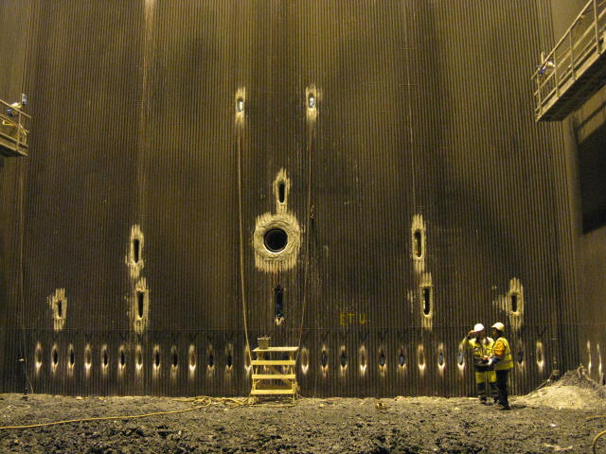

Figure 7‑1. The lower part of a recovery boiler’s furnace with a dedicated burner for CNCG in the middle.

## Typical collection locations at a pulp mill

The locations where non-condensable gases are collected vary by mill because of different process solutions. As such, not all mills have the collection locations presented in this section of the guidelines. Examples of collection locations are provided in Figure 7‑2



Figure 7‑2. Example of a CNCG collection system (document PSAVI/7988/2019).

### Fibre line

Typical CNCG collection locations in a fibre line include the following:

Tanks: turpentine storage tank, foul condensate tanks, pressurised liquor tanks.

Process devices: digester gassing, reboiler, vent gas condenser for liquor expansion, turpentine separation system.

Notes about the collection locations in the fibre line:

* Regardless of the process solution, the chip bin may generate non-condensable gases that may concentrate to the point that they exceed the lower explosive limit for diluted non-condensable gases. Regardless of this, the vent gas from the chip bin must not be connected to the CNCG system.
* When transferring turpentine to a tanker lorry, air flow into the NCG system and the non-condensable gases’ release to the environment should be prevented.

### Evaporator

Tanks: pressurised liquor tanks, foul condensate tanks, turpentine tanks, methanol tank.

Process devices: evaporator’s vacuum drain, turpentine separator system, methanol plant.

Other notes about the collection locations in the evaporator:

* The vent gas from pressurised liquor tanks and thermal treatment of liquor must not be led to the DNCG system.
* Air should be prevented from entering the CNCG collection system via the foul condensate tank.
* The gases formed in the steam stripper for foul condensate are typically directed to the methanol plant.

## Composition and volume

The total amount of concentrated non-condensable gases is 2–4 kg S/ADt in a modern pulp mill. The amount increases significantly if black liquor is evaporated to a high level of dry solids (over 80%). The sulphur content and thermal power of concentrated non-condensable gases depends on the sulphidity of the chemical cycle, which means that the amount of concentrated non-condensable gases may vary widely at different times. Typical amounts in the CNCG collection locations of a pulp mill are presented in table 7-1.

TABLE 7‑1. Typical amounts of CNCG at different departments

|  |  |  |
| --- | --- | --- |
| **Section** | **kg S / ADt** | **m3n / ADt** |
| Batch digesting blow | 0.4 – 0.8 | 5 – 15 |
| Batch digesting gassing | 0.1 – 0.2 | 1.0 – 3.0 |
| Continuous digestion | 0.1 – 0.4 | 1.0 – 4.5 |
| Stripper | 0.5 – 1.0 | 15 – 25 |
| Evaporator | 0.4 – 0.8 | 1 – 10 |
| Methanol processing | 0.5 – 1.0 | 1.0 – 2.0 |
| Thermal treatment of black liquor | 2 – 3 | 1.5 – 3.0 |
| Concentrator | 2 – 5 | 1.5 – 6.0 |

Concentrated non-condensable gases contain substantial amounts of sulphur compounds and ammonia. Table 7-2 shows examples of analyses on concentrated non-condensable gases. Concentrated non-condensable gases are classified as highly toxic, toxic or flammable by their content. Heat values of NCG components are presented in table 7-3.

TABLE 7‑2. Examples of analyses on CNCG.

|  |  |  |  |  |
| --- | --- | --- | --- | --- |
|  | **Plant A** | **Plant B** | **Plant C** | **Plant D** |
| **Component** | **ppm** | **ppm** | **ppm** | **vol-%** |
| H2S | * | 50,000 | 81,300 | 1.5 |
| CH3SH | 80,900 | 110,000 | 188,300 | 2.0 |
| (CH3)2S | 22,000 | 50,000 | 116,000 | 2.0 |
| (CH3)2S2 | 800 | 30,000 | 3,000 | 1.5 |
| C10H16 (turpentine) | 1,900 | * | * | 0.1 |
| CH3OH | * | * | * | 0.2 |
| O2 | * | * | * | 9.0 |
| NH3 | * | * | * | * |
| H2O | 20,000 | 330,000 | * | 6.0 |
| CO2 | * | * | * | * |

*) not analysed or below the observation threshold

TABLE 7‑3. Heat values of CNCG components, BLRBAC.

|  |  |
| --- | --- |
| **Component** | **kJ/kg (dry**) |
| H2S | 15,280 |
| CH3SH | 26,100 |
| (CH3)2S | 30,890 |
| (CH3)2S2 | 23,630 |
| Turpentine | 41,560 |
| Methanol (gas) | 22,720 |

It is required of the CNCG burning and collection system that leaks from the lines to the working spaces are prevented, that water cannot enter the furnace along with the gases, and that the risk of explosion is minimised. Air leaks into the CNCG system must be prevented so that explosive gas mixtures are not created.

## Logic for burning CNCG

It must be possible to monitor the burning of concentrated non-condensable gases in a recovery boiler, and starting and stopping must be possible via the same control room where all other monitoring on the recovery boiler takes place.

This text aims to present the process requirements for the logic for burning concentrated non-condensable gases. This document aims to present a set of conditions required of safe automation. The operating logic of an individual recovery boiler also includes other variables due to its equipment, process connections or realisation.

These guidelines do not apply to the interlocks for the CNCG collection locations, although they are often implemented in the same system as the interlocks for the burning.

### Preconditions for starting a CNCG burner

The burning of concentrated non-condensable gases may start when e.g. the following conditions are met. **NOTE: The operating logic of an individual recovery boiler may also include other conditions due to its year of commissioning, equipment, process connections or realisation.**

Table 7‑4. Preconditions for starting the burning of CNCG

|  |  |  |
| --- | --- | --- |
|  | **Condition** | **Purpose of the condition** |
| 1. | The boiler’s fire power is greater than 0.7 MW/m2, which can be verified by the steam load or supply water flow. This limit equals about 30% of the boiler’s nominal steam load, but **the specific limit should be defined on a case-by-case basis**. | To ensure that the conditions in the furnace are sufficiently stable for non-condensable gases to oxidise (temperature, delay). |
| 2. | The support flame for the burner is on. | To ensure sufficient burning conditions at the burner. |
| 3. | The inlet pressure or flow of the burner’s combustion air is above the minimum value. | To ensure a sufficient air flow for the burner. |
| 4. | The CNCG lines before the quick-closing valves are open. | To ensure the flow of non-condensable gases into the furnace. |
| 5. | The quick-closing valves and vent valves are working without interruptions. | To ensure that the valves work safely. |
| 6. | The surfaces of the foul condensate collection tank and the droplet separator in the recovery boiler burner are not high. | To prevent condensate from leaking into the furnace. |
| 7. | The explosion disc or the squib valve are intact. | To prevent non-condensable gases from leaking into the environment. |
| 8. | The CNCG line must have sufficient pressure before the quick-closing valve. | To ensure the flow of non-condensable gases into the furnace. |
| 9. | The CNCG pipeline is in the burning position. | To ensure the burner’s safe operation and direct non-condensable gases into the furnace. |

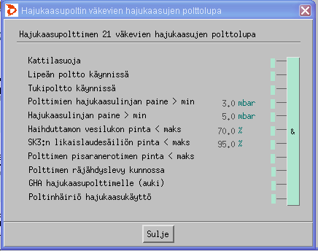

Figure 7‑3. An example of the CNCG burning permission view used in a mill. The figure also includes additional permission conditions.

### Interrupting the burning of concentrated gases

The burning of concentrated non-condensable gases is interrupted if e.g. some of the following conditions are in effect. **NOTE: The operating logic of an individual recovery boiler may also include other conditions due to its year of commissioning, equipment, process connections or realisation.**

Table 7‑5. Interrupting the burning of concentrated non-condensable gases

|  |  |  |
| --- | --- | --- |
|  | **Condition** | **Purpose of the condition** |
| 1. | The boiler’s fire power is lower than 0.7 MW/m2, which can be verified by the steam load or supply water flow. This limit equals about 30% of the boiler’s nominal steam load, but **the specific limit should be defined on a case-by-case basis**. | To ensure that the conditions in the furnace are sufficiently stable for non-condensable gases to oxidise (temperature, delay). |
| 2. | The burner’s support flame is not on while the boiler’s fire power is at 1.5 MW/m2. | To ensure sufficient burning conditions at the burner. |
| 3. | The flow of combustion air is above the lower limit, or the pressure is above the lower limit, and the combustion air damper is in the burning position. | To ensure a sufficient air flow for the burner. |
| 4. | Quick stop is initiated. | To prevent the supply of non-condensable gases and pressure containment steam when the boiler is no longer being used. |
| 5. | The CNCG lines before the quick-closing valves are not open. | To ensure the flow of non-condensable gases into the furnace. |
| 6. | There is a disruption in the quick-closing valves or purge valves. | To ensure that the valves work safely. |
| 7. | The surface level of the foul condensate collection tank or droplet separator in the recovery boiler burner is high. | To prevent condensate from leaking into the furnace. |
| 8. | The explosion disc or squib valve is not intact. | To prevent non-condensable gases from leaking into the environment. |
| 9. | The CNCG supply pressure to the burner is below the minimum level or above the maximum level. | To ensure the flow of non-condensable gases into the furnace and the effective operation of the burner. |
| 10. | The CNCG pipeline is not in the burning position. | To ensure the burner’s safe operation and direct non-condensable gases into the furnace. |

### Capacity limitation

The burning of concentrated non-condensable gases requires that the temperature and delay in the furnace are sufficient for the non-condensable gases to burn into carbon dioxide, steam and sulphur dioxide. The sufficient temperature can be achieved when the boiler load is increased sufficiently. The minimum capacity as steam flow is defined by the system provider. Since the definition of the nominal load is often slightly vague, it is recommended that the capacity meet the fire power of 0.7 MW per m2 of base area. An example of calculating fire power is presented in Appendix 1.

It is **recommended** that the burning of concentrated non-condensable gases **be interrupted** if e.g. one of the following alarms is activated.

Table 7‑6. Alarms for the burning of concentrated non-condensable gases

|  |  |  |
| --- | --- | --- |
|  | **Alarm** | **Purpose of the alarm** |
| 1. | The sulphur content (H2S) alarm for the boiler room is activated. | To prevent hydrogen sulphide poisoning. |
| 2. | The pressure difference in the flame arrester is above the upper limit. | The flame arrester is blocked or about to be blocked. |

### The burner and use of the support flame

Concentrated non-condensable gases may only be burned with a dedicated burner that is suitable for this purpose. The burner should be equipped with a separate air register and a separate pipeline for the support/pilot fuel, which may be oil, gas, methanol, turpentine or tall oil pitch. Using diluted non-condensable gases (incl. dissolving tank vent gases) as the burner air for concentrated non-condensable gases is not recommended due to their humidity and impurities.

At small loads, the support flame is intended to ensure the ignition and burning of non-condensable gases. The fuel power of the support flame should be at least 10% of the burner’s NCG’s fuel power. The support flame must be monitored with a flame controller.

When the burning of concentrated non-condensable gases starts, a support flame is always required. The first ignition of the support flame should be done through local control. After this, the NCG burning can be initiated from the control room. A support flame is constantly required for burning concentrated non-condensable gases when the boiler’s fire power is between 0.7 and 1.5 MW/m2. When the boiler is operating at the fire power range >1.5 MW/m2, a support flame is not needed. In this case, the support flame can be extinguished when three minutes have passed from initiating the burning of concentrated non-condensable gases.

When the boiler is operating at the fire power range of 0.7–1.5 MW/m2 and the support flame is lost, the ignition of the support flame can be attempted in the control room no more than twice in three minutes, at which point the burning of concentrated non-condensable gases may continue without the support flame.

Both the support flame and the burning of concentrated non-condensable gases can be stopped via the control room or local control.

The burning of concentrated non-condensable gases requires a sufficient temperature in the burning zone; generally, the sufficient temperature is considered to be 900°C. The temperature requirement is met if non-condensable gases are led below the liquor guns while the boiler is functioning stably and at a sufficient load. If concentrated non-condensable gases are led above the liquor guns, it must be ensured that they are led to a part of the boiler where this temperature is exceeded.

Figure 7-4 shows an example of a CNCG burner, photographed from both outside and inside. The photo shows e.g. the NCG burner, methanol pipeline, flame controllers, flame arrester and auxiliary burner.

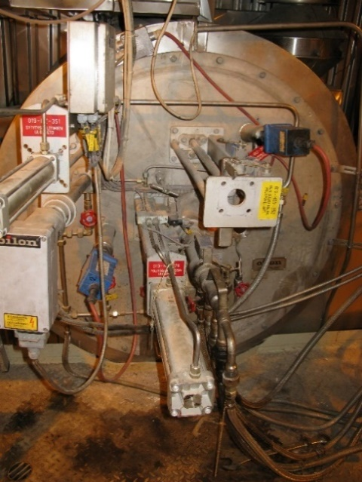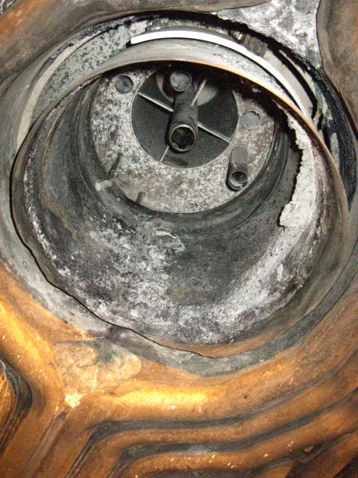

Figure -7‑4. A CNCG burner photographed from inside and outside the boiler.

The electrical and automatic systems of the CNCG burner must fulfil the requirements for the electrical and automatic systems for burning oil and gas.

## Pipelines

The length of the CNCG lines in the recovery boiler room should be kept as short as possible. The pipeline should be placed so that potentially problematic places, such as the dissolving tank and its vicinity, weak corners and passageways, are avoided. The pipeline construction must comply with the laws on pressurised vessels and chemicals. When preparing the placement plan, attention should be paid to the safe routing of the pipeline.

The recommended construction material for the pipeline is EN 1.4436 (AISI 316) acid-proof steel or similar. Some compounds in non-condensable gases, such as turpentine and methanol, are strong solvents, which is why parts made of glass fibre or plastic are not permitted.

### Pipeline steaming

Once the burning stops, the CNCG lines can be blown clean by using an inert medium. In practice, the lines are always steamed by using low-pressure steam. Blowing the lines with air is not recommended as an explosive mix will form on the limit zone of the air and the concentrated non-condensable gas being removed.

When steaming the line, there is a risk that the water that has condensed in the line enters the furnace and causes a hazard.

### Pressure measurements on the pipeline

The CNCG pipeline should be equipped with pressure measurement after the ejector or liquid ring compressor and as close as possible before the CNCG burner. The system should feature overpressure and minimum pressure alarms for the pipeline pressure.

The potential blocking of the pipeline can be monitored based on both the flow rate and pressure measurements.

### Equipotential bonding

Equipotential bonding should be carried out for CNCG lines. For example, flanges, hatches and devices that may form galvanic differences due to their seal materials must undergo equipotential bonding. The equipotential bonding is carried out according to regulations and verified with measurement records.

## Transfer of concentrated gases

A fan must not be used to move concentrated gases. It is recommended that concentrated gases be moved with an ejector or a liquid ring compressor. It is recommended that low-pressure steam be used in the steam ejector. The steam temperature can be 200°C, at the maximum (which corresponds to the pressure of 12 bar overpressure for saturated steam), due to the autoignition temperature of the gas components.

The ejector/liquid mechanical compressor for concentrated gases can be placed in the recovery boiler plant, if necessary.

### Pressure containment steam

Low-pressure steam is used as the pressure containment steam. It should be ensured that the draining of the steam lines works in all conditions; this prevents water from entering the boiler.

### Valves

The valves for CNCG burning should be selected carefully. Special attention should also be paid to the valve tightness.

In the CNCG supply line towards the burner, there should be two quick-closing valves and a ventilation pipeline with valves in-between. The shut-off valves should be equipped with limit data. The shut-off valves should close without external operating energy. The ventilation line valve between the shut-off valves should also open at the same time.

It is recommended that the CNCG lines running into the boiler room be equipped with ‘fire safety valves’ that can be shut from outside the boiler room. The recommendation for shutting the valves from the outside is based on the fact that shutting the NCG lines through the boiler room cannot be required in an emergency. Furthermore, the aim is to prevent the flow of non-condensable gases into the boiler room in a situation where a valve in the boiler room is leaking, for example.

When choosing the valves, attention should be paid to the requirements set for flammable gases, such as fire endurance. The recommended construction material for the valves is EN 1.4436 (AISI 316) acid-proof steel or similar.

### Cooling and heating

Concentrated non-condensable gases are generally not heated or cooled in connection with burning.

### Alkaline scrubber

The amount of sulphur that ends up in the incineration can be reduced by using an alkaline scrubber for concentrated non-condensable gases. The typical sulphur recovery rate of an alkaline scrubber is 50–60%. The alkaline used is typically sodium hydroxide (NaOH) or white liquor.

### Droplet separator

The NCG line running to the incineration after the steam ejector and liquid mechanical compressor should include a droplet separator and condensate removal. In the droplet separator, any condensate is removed from the gas.

### Flame arrester

A flame arrester should be used for concentrated non-condensable gases. The purpose of the flame arrester is to extinguish a combustion wave that proceeds via the pipeline from the furnace to the NCG supply. The flame arrester should be located as close to the CNCG burner as possible.

When choosing the flame arrester, it should be remembered that non-condensable gases are a mix of multiple gases. As such, no specific definitions have been given for them in the IEC standard, for example. It is recommended that flame arresters of explosion class IIA, at the minimum, be installed in the NCG line.

If a scrubber option is organised for the flame arrester, the scrubber lines must not be installed permanently. The pressure difference in the flame arrester must be measured, and an alarm must be set for high pressure difference.

### Low-pressure safeguards

A low-pressure safeguard that uses air as replacement gas must not be used for concentrated non-condensable gases. It is recommended that the pipelines and equipment be dimensioned as sufficiently durable so that low-pressure safeguards are not necessary.

### High-pressure safeguards

In the boiler building, a high-pressure safeguard (e.g. a safety valve) that opens directly to the boiler room must not be used for concentrated non-condensable gases. The CNCG flow caused by the high-pressure safeguard being triggered must be led to a place where the gas does not pose a danger and that is as harmless as possible. In the pipes of high-pressure safeguards leading outdoors, attention must be paid to draining to prevent freezing. The high-pressure safeguard being triggered must activate an alarm.

Explosion discs are typical high-pressure safeguards. The explosion discs must be equipped with an indicator that activates an alarm when the explosion disc is working. Alternatively, temperature measurement can be used as an indicator of functionality.

The material recommended for the explosion disc is acid-proof steel or graphite.

The explosion discs must be placed so that the people working at the normal working levels are not endangered when the discs are functioning.

## Condensate removal

The CNCG lines must be equipped with condensate removal devices. The condensate contains plenty of odorous compounds. The condensate is collected in the pump tank and pumped via the tank to the foul condensate tank in the evaporator.

The CNCG lines at different process pressures, such as the CNCG line for continuous digesting, the CNCG line for batch digesting, or the stripper off gas line, should not be drained into the same condensate collection pipes.

### Size of the condensate removal lines

In condensate removal devices and the lines starting from them, the recommended pipe diameter is DN50, at the minimum, due to the risk of condensation and blocking. Devices and condensate pipes located outdoors should be equipped with electric trace heating due to their risk of freezing. The electric trace heating cable should take the ATEX requirements into account.

### Pipe slopes and placement of the condensate removal devices

The pipes must slope towards the condensate removal. The recommended slope for pipes in places other than the recovery boiler plant is 1:100 if the condensate is running to the direction of the gas flow, and 1:25 if the condensate is running against the gas flow. The pipes must be dimensioned to be sufficiently large to prevent the condensate from flooding the pipeline.

Due to the danger of water ending up in the furnace, recovery boiler plants should aim to have pipes where the slope is 1:100 in the direction of the gas flow and 1:1 against the direction of the gas flow, or steeper. If the recommended slopes cannot be reached at some section of the pipeline, the condensate removal for such a section must be designed with special care.

When designing the condensate removal system, aspects such as the size, number and location of the devices should be considered. The last removal should be placed as close to the recovery boiler as possible so that the pipeline from the removal to the furnace is as short as possible. Special attention should be paid to the condensate removal in the steam lines for burning concentrated non-condensable gases.

When large pipe sizes are being used (over DN200), a condensate pocket, via which the condensate will be removed, is recommended.

### Water traps

In order to prevent NCG leaks through the condensate removal devices, the condensate removal lines must be equipped with water traps and pumping tanks or shared water trap tanks.

In order to keep the pressure generated by the ejector in the CNCG pipeline from emptying the water trap, the ejector’s dimensioning values (over-pressure and under-pressure) and the process requirements (such as bottling in the system) must be taken into consideration in the water trap’s dimensions.

The water trap tank must be dimensioned to be sufficiently wide so that the ejector’s suction does not catch the drops.

To prevent the water traps from drying, they must be equipped with surface-level measurements or with a continuous or timed water flow verified through flow measurements.

## Alternative location

The precondition for burning concentrated non-condensable gases in a recovery boiler is that the system includes an alternative location where the gases can be directed automatically in situations where the burning at the recovery boiler is interrupted. There may be multiple alternative locations, such as the power boiler, secondary boiler, flare, lime kiln and smokestack. Alternative burning locations and the steering logic are described further in Section 11.

## Concentration measurement

CNCG systems do not require continuous content measuring.

The Finnish Recovery Boiler Committee recommends that CNCG concentrations at the starting point be measured if changes to the devices are made there.

The Committee also recommends that the sulphur and, potentially, oxygen content of the concentrated non-condensable gases be measured at least once a year.

# BURNING METHANOL AND TURPENTINE IN A RECOVERY BOILER

Liquid methanol and turpentine are burned at pulp mills in lime kilns, dedicated NCG boilers, power boilers and the flare, in addition to recovery boilers.

In the joint burning of a methanol and turpentine mixture, the turpentine is led to the suction side of the methanol pump in the desired proportion to the methanol being burned. In the joint burning, turpentine’s higher heat value and tendency to rise to the tank surface (poor solubility) should be taken into account. Turpentine’s heat value is ~40 MJ/kg, and methanol’s is ~20 MJ/kg.

When burning methanol, the problems caused by its water content should be taken into account. For example, the water may be separated into ‘pearls’ in long transfer lines.

If an alternative burning location is unavailable, it must be possible to store an amount of methanol/turpentine that matches the production of 24 hours, for example. When placing the methanol and turpentine tank, attention must be paid to the legislation on chemicals and regulations on the storage of flammable liquids. The chemicals must not be placed in the boiler room.

## The logic for burning methanol or turpentine

This text aims to present the process requirements for the logic of the methanol and turpentine burner, in addition to a gas and oil burner. This document aims to present a set of conditions required of safe automation. The operating logic of an individual recovery boiler also includes other variables due to its equipment, process connections or realisation.

Both methanol and turpentine can be used as auxiliary fuels in a CNCG burner in a recovery boiler and as fuels for the starting burner. When using methanol or turpentine as fuel for the starting burner, the sufficient temperature in the furnace must be taken into consideration. The burning can start sooner than the burning of non-condensable gases. In this case, the locking conditions must be defined on a case-by-case basis.

Due to the flame possibly being blown off or extinguished, the quality (e.g. water content) of the methanol and turpentine to be burned must be verified by measuring the density, for example. Turpentine’s normal density is c. 0.85 kg/dm3, and methanol’s is c. 0.80 kg/dm3.

It must be possible to monitor the burning of methanol and turpentine in a recovery boiler, and starting and stopping must be possible via the same control room where all other monitoring on the recovery boiler takes place.

### Preconditions for starting a methanol or turpentine burner

The burning of methanol/turpentine can start in the recovery boiler when the following conditions are met. **NOTE: The operating logic of an individual recovery boiler may also include other conditions due to its year of commissioning, equipment, process connections or realisation.**

Table 8‑1. Preconditions for starting a methanol or turpentine burner

|  |  |  |
| --- | --- | --- |
|  | **Condition** | **Purpose of the condition** |
| 1. | Fire status in the boiler: e.g. at least one startup burner is running or liquor burning is on. | To ensure the burning conditions. |
| 2. | The pipeline for methanol or turpentine is in place and connected. | To ensure that the methanol or turpentine pipelines are placed correctly. |
| 3. | The pressure of methanol or turpentine is above the minimum pressure and below the maximum pressure (delay). | To ensure the stable burning of methanol or turpentine. |
| 4. | The flow of combustion air is above the lower limit, or the pressure is above the lower limit, and the combustion air damper is in the burning position. | To ensure a sufficient combustion air supply  to the burner. |
| 5. | The pressure of the disperser is above the minimum pressure. | To ensure that methanol and turpentine burn evenly. |
| 6. | The flame controller is displaying a flame (ignition delay). | To verify the flame status. |
| 7. | The density of methanol/turpentine is below the upper limit. | To ensure that the fuel’s thermal value does not drop too low (too much water). |
| 8. | There are no disruptions in the quick-closing valves. | To ensure that the valves work safely. |

### Events that interrupt the burning of methanol or turpentine

The burning of methanol and turpentine is interrupted if some of the following conditions are in effect. **NOTE: The operating logic of an individual recovery boiler may also include other conditions due to its year of commissioning, equipment, process connections or realisation.**

Table 8‑2. Events that interrupt the burning of methanol or turpentine

|  |  |  |
| --- | --- | --- |
|  | **Condition** | **Purpose of the condition** |
| 1. | The fire status of the boiler is lost: no starting burners or auxiliary burners are running and liquor burning is not on. | To ensure the burning conditions. |
| 2. | The pipeline for methanol or turpentine is not in place or connected. | To ensure that the methanol or turpentine pipelines are placed correctly. |
| 3. | The pressure of methanol or turpentine is below  the minimum pressure or above the maximum pressure (delay). | To ensure the stable burning of methanol or turpentine. |
| 4. | The flow of combustion air is below the lower limit, or the pressure is below the lower limit, or the combustion air damper is not in the burning position. | To ensure a sufficient combustion air supply  to the burner. |
| 5. | The pressure of the disperser is below the minimum pressure. | To ensure that methanol and turpentine burn evenly. |
| 6. | The flame controller is not displaying a flame. | To verify the flame status. |
| 7. | The density of methanol or turpentine is above the upper limit. | To ensure that the fuel’s thermal value does not drop too low (too much water). |
| 8. | There is a disruption in the quick-closing valves. | To ensure that the valves work safely. |

## Electrical and automated systems for the burner

The electrical and automatic systems of the methanol and turpentine burner must fulfil the requirements for the electrical and automatic systems for burning oil and gas.

The methanol and turpentine pipelines are purged with steam or air. In this case, the boiler’s fire status must be valid (starting burners are on).

## Valves

The valves for burning methanol and turpentine must be selected carefully. The automatic shut-off valves for burning methanol and turpentine must close without external operating energy. Limit data from the shut-off valve being closed must be entered into the automation system.

When choosing the valves, attention should be paid to the requirements set for flammable liquids, such as fire endurance. The recommended construction material for the valves is EN 1.4436 (AISI 316) acid-proof steel or similar. The valve sealing materials must be insoluble (as methanol and turpentine are solvents). Special attention must be paid to the choice of sealing materials. More information is available in the Finnish PSK standards, for example.

# ACTIONS IN SPECIAL SITUATIONS

This section is about the measures that should be taken in the situations where the recovery boiler is not run at the standard load.

## Actions during a disruption

The Finnish Recovery Boiler Committee recommends that the burning of concentrated and diluted non-condensable gases, dissolving tank vent gas, methanol and turpentine be interrupted in the recovery boiler and the gases be directed to a secondary burning location in the event of a disruption.

If the boiler safety device is triggered, the burning of methanol, turpentine, vent gas from the dissolving and mixing tank, and concentrated and diluted non-condensable gases must stop in the recovery boiler.

If the emergency shutdown procedure is triggered, the burning of methanol, turpentine, vent gas from the dissolving and mixing tank, and concentrated and diluted non-condensable gases must stop in the recovery boiler.

## Actions during a shutdown

In the event of a shutdown, it is recommended that the burning of non-condensable gases stop in the recovery boiler as the locking thresholds are approached, see Table 5‑5, Table 6‑3 and Table 7‑5, and the gases are directed to a secondary burning location or bypass line. If possible, the collection of diluted non-condensable gases should stay on during a shutdown since the gases easily concentrate in the tanks and pipelines.

When NCG lines are undergoing maintenance, being inspected from the inside, or being prepared for a longer shutdown, the lines should be blown with steamr during the shutdown.

## Actions during startup

If the burning of non-condensable gases has been shut down in the recovery boiler, the following must be ensured before the NCG system is restarted:

* the maintenance and repairs carried out during the shutdown are completed and shutdown work is no longer performed on the NCG devices
* the devices and pipelines subject to maintenance or repairs have been properly installed, inspected and cleaned of installation waste
* the equipotential bonding has been returned to appropriate condition once the maintenance has ended
* the valves connected to the devices subject to maintenance or repairs are in the condition and position required by the startup
* the devices and pipelines subject to maintenance or repairs are ready for use and tight. Their tightness must be verified with test rotations.

Before startup, all CNCG lines that were non-pressurised during shutdown must be steamed and inertized with nitrogen. Similarly, DNCG lines that were out of operation must be ventilated. Furthermore, the Finnish Recovery Boiler Committee also recommends that the NCG system be operated for sufficiently long (e.g. over an hour) before the burning begins in the recovery boiler to ensure that any flammable NCG components that have leaked or condensed into the ducts or other devices will not pose any harm or hazard.

Before startup, all condensate tanks must be inspected to detect overflow or drying.

Before startup, all extra waterflows in the water traps must be inspected and activated.

## Operations during shutdown

During a shutdown, non-condensable gases must be prevented from leaking into the boiler building, e.g. by blinding. The purpose of separating NCG lines is to prevent non-condensable gases from leaking or concentrating in the inner ducts and pipes in the boiler building during the shutdown.

### Instructions for preparing the NCG system for shutdown or maintenance

NCG lines, much like other lines in the liquor department, must be made safe before they can be worked on. The DNCG lines should be ventilated carefully. The CNCG lines require steaming and, if necessary, nitrification. After the NCG system is stopped and the necessary system components are separated, all separated devices must be ventilated effectively at the start of the shutdown. The ventilation should be carried out to the flow direction and led outdoors. The lines for concentrated and diluted non-condensable gases also require that the lower explosive limit and the content of sulphuric gases be measured before the work is started.

It is recommended that the CNCG pipeline be flushed 24 hours before measuring the content and starting the maintenance work in the CNCG pipes.

When the burning of diluted non-condensable gases stops, the ducts must be flushed with air. It is recommended that the flushing of the DNCG duct be done eight hours before measuring the content and starting the maintenance work on the DNCG ducts.

Before the work is started, a risk assessment must be carried out, especially on all pipelines in the working area. It is recommended that working permits be issued in writing before the work is started. For example, working inside the devices in the NCG system always requires a written tank work permit.

### Instructions for maintenance work during shutdown

Welding generates sparks and heat in the NCG system, which is why it poses an explosion hazard. Maintenance work in the NCG systems and pipelines always requires a special permit. During a shutdown, the workers participating in the maintenance during shutdown must be made aware of which lines are NCG lines and how the repairs and maintenance should be carried out.

# MATTERS TO CONSIDER IN THE DESIGN OF NCG LINES

Regarding the design and choices of materials for NCG lines, special guidelines must be followed in addition to general design guidelines for ordinary pipes and ducts, since NCG lines contain explosive, solvent and corrosive compounds.

NCG lines must withstand the mechanical, chemical and thermal impact caused by their content and environment (snow, ice, hot and cold surfaces, vibration). The joining method must be suitable for the chosen material.

## Classification

The legislation on chemicals must be complied with when classifying NCG lines. More information is available in the guide published by the Finnish Safety and Chemicals Agency (Tukes): [Safety requirements for chemical piping 2017](https://tukes.fi/documents/5470659/6410920/Kemikaaliputkistojen+turvallisuusvaatimukset.pdf/bb410ce1-baeb-4a0d-8086-f881d8f13b2b/Kemikaaliputkistojen+turvallisuusvaatimukset.pdf?t=1516698242000). According to the guide, “*vent gas is a mixture formed by vapours, fumes and gases that are classified as hazardous, and air and potential inert gases. An vent gas pipe is a pipeline intended for moving such hazardous substances and/or mixtures.*” According to the guide, the lines for concentrated non-condensable gases are classified as pipelines subject to the Chemicals Act. Diluted non-condensable gases do not typically contain concentrations at hazardous levels.

Dividing the non-condensable gases into diluted and concentrated ones and dissolving tank vent gas is not sufficient to characterise the hazard level of the content. Gas mixtures must be classified based on [the Decree of the Ministry of Social Affairs and Health on the grounds for classifying and labelling chemicals 26.9.2001/807](https://www.finlex.fi/fi/laki/alkup/2001/20010807) and with regard to [the amendments made on 11 January 2010](https://www.finlex.fi/fi/laki/alkup/2010/20100006). As such, each NCG line must be classified based on the specific content of the gases contained in the line.

If not otherwise specified, the lines for concentrated non-condensable gases, methanol and turpentine can be pre-designed based on the classes *toxic* and *flammable*.

If not otherwise specified, the lines for diluted non-condensable gases can be pre-designed based on the class *harmful*.

However, the classification must be verified from the valid legislation and regulations.

## Signs

NCG fuels, pipes and ducts must be labelled appropriately. At the minimum, the labels must include the texts “Concentrated non-condensable gases”, ”Turpentine”, ”Methanol” and ”Diluted non-condensable gases”, and, whenever necessary, ”Flammable”, ”Toxic” and ”No welding or cutting without supervision” and ”The devices must not be opened without a written work permit”. The pipes and ducts must also be equipped with labels that indicate the flow direction.

Smoking and making any kind of open fire is forbidden in the area where non-condensable gases are processed. Appropriate signs must be installed in the area.

## Condensate removal

When designing the condensate removal system, aspects such as the size, number and location of the devices, in particular, should be considered. See sections 5.10, 6.11 and 7.6.

## Materials for ducts and pipelines

The recommended construction material for the DNCG ducts is EN 1.4301 (AISI 304) stainless steel or similar.

For concentrated non-condensable gases, the guidelines of TUKES must be followed (Safety requirements for chemical piping 2017) when designing vent gas pipes. The recommended construction material for the pipeline is EN 1.4436 (AISI 316) acid-proof steel or similar.

The recommended construction material for the pipelines for burning methanol and turpentine is EN 1.4436 (AISI 316) or similar.

Some compounds in non-condensable gases, such as turpentine and methanol, are strong solvents, which is why parts made of glass fibre or plastic are not permitted.

## Insulation of pipes, ducts and devices

Non-condensable gases contain plenty of water and other condensable substances. Like other pipelines, the NCG lines must be insulated to avoid personal injuries and in places where the aim is to avoid condensation.

The ATEX regulations, regarding e.g. the classification of electric trace heating cables, must be taken into account when designing CNCG lines and their condensation lines, and methanol and turpentine pipelines. The drains must be insulated, and if necessary, trace heating must be arranged for drains located outdoors.

## Slopes in pipes and ducts

Non-condensable gases almost always contain large amounts of steam. Even if the pipelines and ducts are carefully insulated and electrically trace heated, condensation should always be prepared for. The instructions for sloping pipelines and ducts and placing the condensate removal devices are described in more detail in the sections: 5.10 Condensate removal for diluted non-condensable gases, 6.11 Condensate removal for dissolving tank vent gases and 7.6 Condensate removal for concentrated non-condensable gases.

## Valves and dampers

When burning non-condensable gases, valves and dampers must be chosen according to the qualities of the non-condensable gas to be processed. More information is available in the Finnish PSK standards, for example.

The recommended construction material for the DNCG valves and dampers is EN 1.4301 (AISI 304) or similar.

The recommended construction material for the CNCG valves is EN 1.4436 (AISI 316) or similar.

The recommended construction material for the valves for methanol and turpentine is EN 1.4436 (AISI 316) or similar. The valve sealing materials must be such that they can withstand solvents.

## Flanges and connections

Special attention must be paid to the tightness of flanges and connections in all conditions. When selecting the seals, special attention must also be paid to the choice of correct sealing materials. Non-condensable gases contain solvent and corrosive compounds.

The joints should remain sealed even during use (oxidisation, reactions with the sulphur compounds contained by the non-condensable gases, freezing, warping, etc.). Whenever a flange of an NCG line is opened, the seals should be replaced.

## Fans

It is recommended that diluted non-condensable gases be moved with fans. It is recommended that a drain device sized at least DN50 and draining lines sized at least DN50 with flexible connection be installed in the DNCG fans.

## Ejectors and liquid mechanical compressor

A fan must not be used to move concentrated non-condensable gases. They can be moved with a steam ejector or a liquid mechanical compressor. It is recommended that low-pressure steam be used in the steam ejector. The steam temperature can be 200°C, at the maximum, due to the autoignition temperature of the gas components. In connection with a disruption or startup, the concentrated non-condensable gases may contain so much oxygen that the gas mixture becomes flammable.

## Alkaline scrubber in the ducts

Often, the respective ducts for concentrated and diluted non-condensable gases both use a scrubber. The scrubber cools the non-condensable gases and removes humidity from them. Similarly, the scrubber also separates e.g. turpentine and methanol. The scrubbers always produce foul condensate that must be processed appropriately.

The use of an alkaline scrubber is recommended for a DNCG system when the concentrations need to be reduced to ensure personnel safety.

The alkaline scrubber must not be used to turn concentrated non-condensable gases into diluted ones.

## Dimensioning of ducts and pipelines

When burning non-condensable gases, the duct and pipeline speeds must be kept above the flame’s propagation velocity in all operating conditions.

The Finnish Safety and Chemicals Agency (Tukes) has published a guide titled [Safety requirements for chemical piping 2017](https://tukes.fi/documents/5470659/6410920/Kemikaaliputkistojen+turvallisuusvaatimukset.pdf/bb410ce1-baeb-4a0d-8086-f881d8f13b2b/Kemikaaliputkistojen+turvallisuusvaatimukset.pdf?t=1516698242000) which details the requirements set for safe chemical piping as specified in the regulations in terms of design, manufacturing, use, maintenance and documentation. The guide presents the obligations defined by the legislation on chemical safety and pressurised devices.

Concentrated non-condensable gases are typically classified as toxic or highly toxic and highly flammable. The operating pressure of the CNCG lines is -10 … +10 kPa. The CNCG lines must withstand full negative pressure (100 kPa). In addition to the design principles presented by TUKES, it is recommended that the pipelines for concentrated non-condensable gases be designed based on the steam pressure and temperature to be used; in any case, 4 bar (overpressure) at the minimum.

Diluted non-condensable gases are typically classified as harmful. The operating pressure of the DNCG lines is -5 … +10 kPa. The DNCG collection and transfer lines must withstand a negative pressure of 10 kPa.

## Flame arrester placement

The flame arrester must be placed as close to the burning device as possible. A flame arrester where the bottom is not lower than the line base must be selected, as this will prevent the creation of a water pocket.

## Placement of explosion and bursting discs

The explosion and bursting discs must be placed so that the people working at the normal working levels are not endangered when the discs are functioning. Their condition must be monitored through an alarm in the automation system.

The explosion discs must be placed as a direct extension of the pipe section, without bends. The pipe proper continues forward with a T branch.

## Bypass placement

The bypass lines should be led to a place that is as high as possible. It is recommended that the bypass be led to the smokestack or the roof of the recovery boiler plant via its dedicated line.

The bypass spot should be located as close to the boiler as possible for the line between the bypass and the recovery boiler to be as short as possible. For practical reasons, the bypass location should be located close to the recovery boiler.

The automatic shut-off device for the bypass must open when auxiliary energy is cut off. Limit data from the shut-off valve opening must be entered into the automation system.

Since the fire shut-off valve for concentrated non-condensable gases is located outside the recovery boiler building, the bypass line should also be outside the recovery boiler building, before the fire shut-off valve.

## Facility classifications

The facility classifications must follow the instructions and regulations of the chemical legislation.

The classification of explosive atmospheres often needs to be applied to concentrated non-condensable gases and foul condensate containing turpentine. Turpentine is volatile and poorly soluble in water, which is why it rises to the top and evaporates in air during leaks.

The atmosphere classifications and their impact zones are also defined for potential leak locations. The systems built in the impact zone of a classified atmosphere must have components that comply with the classification. Class 1 means that the explosive gas is present occasionally, and class 2 means that the gas is not expected to be present in the space during normal use.

If a space is seen as risky in terms of potential leaks, it can be equipped with automatic effective ventilation if the H2S content rises too high.

The boiler room and the potential vicinity zone of the burner for concentrated non-condensable gases and methanol and turpentine must be equipped with an alarm and meter that shows the hydrogen sulphide and VOC content, if the line containing non-condensable gases runs via a working space.

## Production permits

When designing, making and supervising the installation of NCG lines, attention must be paid to the requirements of the Pressure Equipment Act.

For concentrated non-condensable gases, pipeline manufacturers are typically required to have a design permit and manufacturing supervisor, as detailed in the Pressure Equipment Act.

The manufacturers of DNCG pipelines or ducts are not generally required to have a design permit or manufacturing supervisor detailed in the Pressure Equipment Act.

In the installation of methanol and turpentine lines, the applicable regulations must be followed (gas installations, oil installations and construction of pressurised vessels). In practice, the principles for installing oil and gas pipes for starting burners should be followed.

It is recommended that only authorised companies be used for all construction and installation work.

Only a company with installation permits for the systems in question may install the burner and auxiliary fuel pipeline.

# OTHER BURNING LOCATIONS AND COOPERATION

The non-condensable gases from a pulp mill are typically processed in more than one burning location. The EU BAT BREF document requires multiple processing locations to minimise the odour and environmental impact. As such, it is important to plan the cooperation in the NCG system.

In the BAT, a secondary burning location is required for concentrated non-condensable gases. A secondary burning location is not required for diluted non-condensable gases. The document also requires that disruptions and the amount of emissions during disruptions be recorded for concentrated non-condensable gases. However, the local authorities always determine the final requirements and operating methods.

## Secondary burning locations

Typically, the recovery boiler is the primary burning location for non-condensable gases. Secondary burning locations may be a flare, a dedicated NCG boiler, a lime kiln or a power boiler.

The design of the burning system for the secondary burning site must follow the same principles as the ones for the burning of concentrated non-condensable gases in a recovery boiler, including condensate removal, quick-stopping valves, flame arresters and explosion protectors. Furthermore, the automation system of the secondary burning location must have conditions for the safe processing of non-condensable gases.

If the primary location for burning non-condensable gases is not a recovery boiler, the recovery boiler can be used as a secondary burning location. However, the Finnish Recovery Boiler Committee does not recommend that concentrated non-condensable gases be automatically turned into the recovery boiler.

## Flare

The flare can be used as a secondary burning location for both concentrated and diluted non-condensable gases. The high volume flow of diluted non-condensable gases must be taken into account if the plan is to use the flare as a secondary burning location.

Typically, the flare is not kept continuously hot by burning auxiliary fuel. The flare’s ignition can be accelerated e.g. by

* keeping the flare’s combustion air fan running all the time, ensuring sufficient ventilation and preventing humidity, snow and ice from accumulating in the system
* keeping auxiliary fuel lines pressurised up to the quick-closing valves
* keeping the NCG lines pressurised with non-condensable gases up to the quick-closing valves
* designing and equipping the flare so that it can be heated as quickly as possible
* ensuring the defrosting in the flare and the connected systems.

It should be noted that the flare will oxidise the sulphur in non-condensable gases into sulphur dioxide (SO2) and there is no sulphur recovery. The sulphur dioxide emissions can be reduced by adding an alkaline scrubber to the gas line running to the burning.

### Flare placement

A flare is typically located on the roof of the recovery boiler building, in which case a separate smokestack does not need to be built. The flare can be placed fully on the roof or partially inside the roof, in which case the burner part and valve units are inside the building. Depending on the placement, the combustion and cooling air for the flare can be taken from inside the recovery boiler building. In this case, sufficient air supply must be ensured.

It is recommended that the NCG and fuel lines running to the flare, along with their valves, are placed outside the recovery boiler building. This way, it can be ensured that the flare will function independently without disruptions, even when there is a disruption in the recovery boiler and fuel cannot be supplied to the recovery boiler building. When designing the lines, devices and instrumentation, the requirements of the ATEX classifications must be taken into consideration.

### Condensate removal at the flare

The condensate removal lines for the CNCG lines and burner structures leading to the flare are run to the foul condensate collection system for the recovery boiler or to a separate foul condensate pumping tank. If multiple dedicated CNCG lines are leading to the flare, each of them should have their separate condensate collection system with regard to different process pressures.

In condensate removal devices and the lines starting from them, the recommended pipe diameter is DN50, at the minimum, due to the risk of condensation and blocking. Devices and condensate pipes located outdoors should be equipped with electric trace heating due to their risk of freezing. The electric trace heating cable should take the ATEX requirements into account.

The condensate lines can be led to a joint collection system with a sufficiently high water trap. This way, the non-condensable gases are stopped from entering the flare’s combustion space via the collection system. As for the level of the water trap, the pressure caused by potential bottling, must be taken into account.

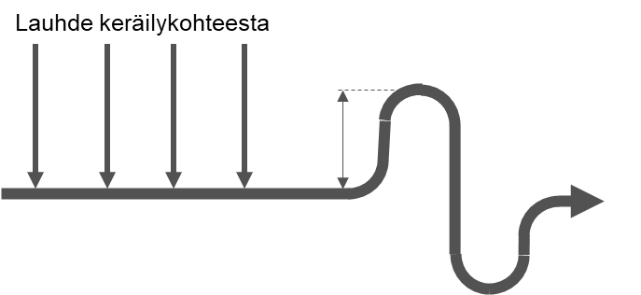

Figure 11‑1 Leading CNCG condensates that are fed to the flare to a collection system.

## NCG boiler

It is typical of modern mills that they have a dedicated boiler for non-condensable gases which features a system for sulphur recovery. The NCG boiler functions as a secondary burning location for concentrated non-condensable gases, but also in the continuous production of chemicals, which is presented in the sections below, 11.3.1–11.3.3

Diluted non-condensable gases can also be burned in an NCG boiler. When using the boiler, its long start time should be taken into account, this requires that the boiler be constantly kept hot. Similarly, attention should be paid to its limited processing capacity for diluted non-condensable gases.

### Alkaline scrubber

The alkaline scrubber can remove sulphur compounds in gas phase directly from the non-condensable gases or from the flue gases formed when non-condensable gases are burned.

When non-condensable gases are processed in the alkaline scrubber, the washing water’s pH is turned alkaline e.g. by adding NaOH, thanks to which a significant proportion of the hydrogen sulphide, methyl mercaptan and dimethyl sulphide (DMS) moves from gas to liquid. However, scrubbing dimethyl disulphide (DMDS) in an alkaline scrubber yields poor results. If the alkaline scrubber uses secondary condensate as a scrubbing liquid, the TRS components within will be released when the temperature rises.

Another application for the alkaline scrubber is removing SO2 from the non-condensable gases in an NCG boiler or another device that uses fuel with sulphur content. In this case, the sulphur recovered can be returned to the chemical cycle or utilised otherwise.

### Production of sodium bisulphite, NaHSO3

Sodium bisulphite can be produced in an alkaline scrubber when processing the flue gases from burning non-condensable gases. Sodium bisulphite can be used for adjusting the pH level at the bleaching plant or for scrubbing vent gas, or refined into a cooking chemical.

If fuels that have impurities, such as heavy fuel oil, are used as auxiliary fuel for the NCG boiler, the sodium bisulphite must be filtered to remove the impurities.

### Production of sulphuric acid, H2SO4

Sulphuric acid can be produced out of concentrated non-condensable gases. In the production of sulphuric acid, concentrated non-condensable gases are burned in a dedicated NCG boiler in which sulphur dioxide is formed among the flue gases. The temperature of the flue gases is adjusted at a suitable level, and the sulphur dioxide is converted into sulphur trioxide by using a catalyst. The sulphur trioxide is allowed to react with water to form sulphuric acid. However, not all of the sulphur dioxide is converted into sulphur trioxide, which is why the flue gases are still scrubbed to recover any remaining sulphur. The Na/S balance of a mill can be adjusted if sulphuric acid made of the mill’s concentrated non-condensable gases is used instead of purchased sulphuric acid.

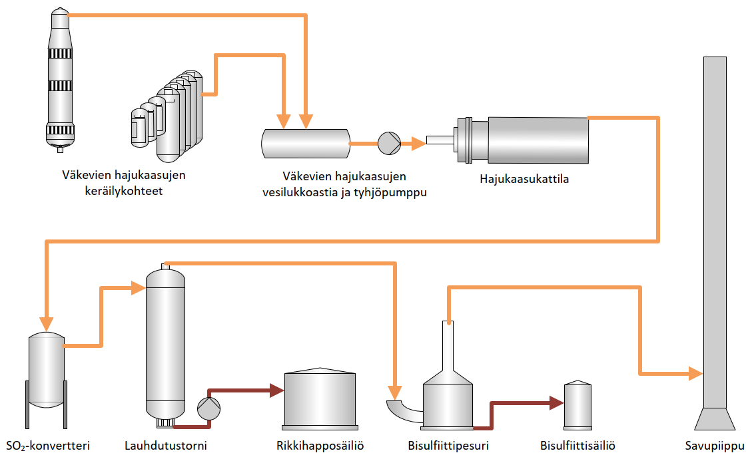

Figure 11‑2. Production of sulphuric acid out of CNCG.

## Lime kiln

In modern mills, lime kilns are no longer used as the primary burning locations for concentrated non-condensable gases, and their use as secondary burning locations is also waning. Not all sulphur among the flue gases is absorbed into the lime in the kiln, which may cause sulphur emissions. It has been observed that the fluctuation of the fuel power of concentrated non-condensable gases causes problems with using lime kilns. The diluted non-condensable gases from the causticizing plant can be led into the secondary air in the lime kiln. Normally, the capacity of the lime kiln is not sufficient to process all diluted non-condensable gases in the mill.

## Power boiler

The power boiler can function as a secondary burning location for both concentrated and diluted non-condensable gases. In this case, concentrated non-condensable gases are led to a dedicated NCG burner, and diluted non-condensable gases are led into the combustion air. The burning requirements must be defined on a case-by-case basis.

The processing of non-condensable gases in a power boiler is limited by the sulphur and NOx emissions in the flue gases.

## Selection of the burning location and bypass line

When selecting the burning location, the conditions for starting burning must be met. If a secondary burning location is unavailable, the non-condensable gases will be directed to the bypass line, or the bottling process will be launched, see Section 11.7. Directing the non-condensable gases to the secondary burning location should be possible without opening the bypass line to avoid odour nuisance. The turning of non-condensable gases to the secondary burning locations can be designed as automatic, with regard to the safe operation of each burning location. However, the operator must always approve the starting of NCG burning in a recovery boiler.

When using turning valves to select the burning location for concentrated non-condensable gases, the non-condensable gases are directed to an alternative burning location or bypass line. The valves must also work automatically even when external operating energy is cut off. Limit data from all turning and shut-off valves in the NCG system must enter the automation system. The purpose of the bypass line is to prevent the release of the non-condensable gases from the collection locations, e.g. if operating energy is cut off, and direct them in a controlled manner through the bypass line to a place that is as safe as possible.

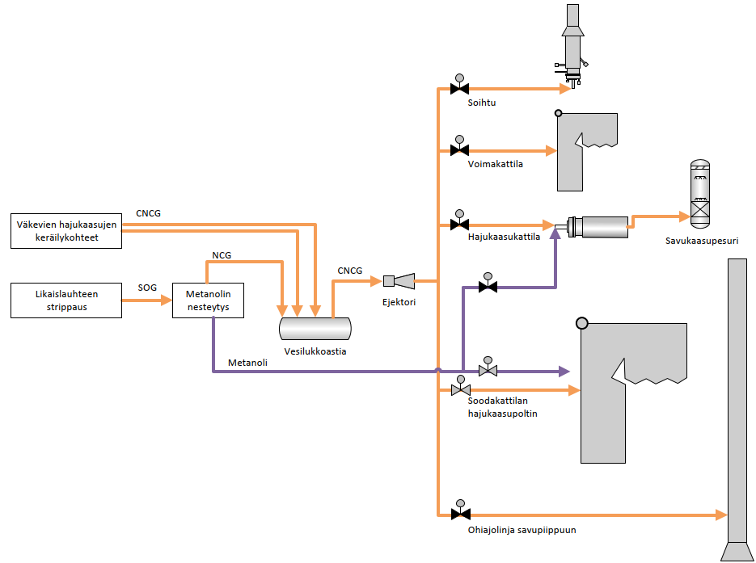

Figure 11‑3. An example of a CNCG collection and burning system with the various burning locations illustrated.

If the mill aims to remain odour-free even during disruptions, such as an extensive power outage, the energy supply into the entire NCG system must be ensured e.g. through verified supply of electricity.

## Bottling of non-condensable gases

To prevent odour nuisance during disruptions at the burning locations, concentrated non-condensable gases can be held in the pipeline until a secondary burning location is activated. Bottling is activated automatically, and the automation system must be designed for this purpose.

When the non-condensable gases are not burned anywhere or released to the environment via a bypass line, the NCG system starts to develop pressure. The NCG collection and transfer system in its entirety must be designed to prepare for the increased pressure during NCG bottling. The rise in pressure can be slowed down by shutting all steam supply, such as ejector steam and pressure adjustment steam. To avoid the use of the CNCG bypass line if the bottling is prolonged, the system must be implemented so that the processes that produce concentrated non-condensable gases are automatically shut down in stages.

# MATTERS TO CONSIDER IN HAZARD ASSESSMENTS

Due to the nature of non-condensable gases, the systems for collecting, processing and burning them involve a risk of hazards and accidents. As such, identifying the types of hazards and situations is especially important.

The system designers are responsible for the functionality and process solutions of the non-condensable gas system. The plant operators are responsible for the correct and careful use of the plant. The Finnish Recovery Boiler Committee recommends that, prior to purchasing a system, the supplier and the end user carry out a hazard and operability study (e.g. HAZOP) on the mill and go through the hazard assessment. In its series of reports, the Finnish Recovery Boiler Committee has published a report on the hazard assessment for recovery boiler plants (11/2001, 16A0913-E0032). Section 8 of the report details the hazard assessment on non-condensable gases.

To facilitate hazard assessments, the Finnish Recovery Boiler Committee has collected a list of hazardous situations that have occurred in Finnish mills. When auditing NCG systems, the potential hazards, their probabilities and potential consequences (such as danger to persons, material or the environment) must be identified. It must also be studied how the hazards have been prepared for.

## Hazard assessment in DNCG systems

### Vent gas from the chip bin

Designing and assessing the safety of vent gas collection from the chip bin should start by determining the type and operating principles of the chip bin. Solutions from different eras and different technology providers may vary significantly, which is why a universal principle on vent gas collection cannot be provided.

Typically, vent gas from the chip bin are collected into the DNCG collection system. In some process solutions, the presteaming of chips in the chip bin makes use of the vent gas containing TRS from the expansion of black liquor in the digester. A safer option is using clean steam to presteam the chips. The steam can be live steam or steam produced with reboilers of various types (vapour-liquid, liquid-liquid).

Leading the liquor expansion steam directly to the chip bin for presteaming has been the main cause of several NCG explosions both in Finland and elsewhere in the world. The DNCG contents have exceeded the lower explosive limit e.g. during disruptions at the chip bin.

Matters to inspect:

1. Locking systems for the chip bin and vent gas system to ensure safe operation.
2. How does the chip bin work when the chip level is low?
3. Can the TRS, methanol or turpentine content in the chip bin vent gas exceed the LEL during operation or a shutdown?

### Condensate collection in tank areas

In the DNCG collection system for tank areas, a sufficient supply of dilution air must be ensured. The dilution air is led to the entire tank or directly to the collection line. The amount of air can be limited by using a hand valve or low-pressure/high-pressure safeguards. When limiting the supply of dilution air, it must be ensured that the tank does not release vent gas into the environment. It must also be ensured that an excessive negative pressure is not created in the tank as the tank may be damaged by it.

The use of measurement, maintenance and scrubbing devices the NCG system and the connected tanks must be implemented so that the operation of the collection system is not disrupted due to excessive air infiltration.

Matters to inspect:

1. The quality of the non-condensable gases introduced to the collection can be ensured through measurements. Special attention should be paid to that the non-condensable gases of the strong black liquor tank and the recovery boiler’s ash mixing tank in the evaporator area always remain under the LEL.
2. The duration of the tanks connected to the NCG system and the supply of replacement air during rapid pressure fluctuations.
3. If the extra air inlet is connected to the suction hole of the fan, the mill must prepare for potential NCG emissions via the extra air inlet when the fan stops.

### Low-pressure and high-pressure safeguards and condensate removal implemented with water columns

The liquid-charged protectors of the low-pressure and high-pressure safeguards are based on the pressure protection formed by hydrostatic pressure. This protection is achieved at the height of the water column. The heights of the water columns between the mill departments may vary greatly between different high-pressure and low-pressure safeguards.

The latest pulp mill solutions aim to design and implement the DNCG collection systems so that they are as closed as possible. This way, unnecessary infiltration air that increases duct and device sizes and odorous vent gass to the sky can be minimised. When changes are made to the DNCG system, attention must be paid to the high-pressure and low-pressure safeguards so that the new or existing process does not form an excessive vacuum that may damage the tanks.

Matters to inspect:

1. The water columns must not dry up during use.
2. The height of the water column must correspond to the most extensive high or low pressure possible.

### Liquor expansion in the evaporator area

Black liquor tanks (30–75% dry solids) have a tendency to vent to the sky in evaporator areas. One of the reasons for the excessive vent gas has been the insufficient expansion of the liquor before it is pumped to the strong black liquor tank. For one reason or another, the liquor cannot expand in the expansion tanks in the evaporator sequences, which is why it is too hot when it enters the strong liquor tank. The hot liquor expands in the tank, causing odour nuisance and increased TRS content to the environment if the DNCG collection capacity is not sufficient to cover the expansion vapour formed. Furthermore, the amount of expansion vapour may overload the condensation of diluted non-condensable gases, which will further reduce the total capacity of the collection system.

Matters to inspect:

1. The operation of the evaporator expansion.
2. The temperature of the liquor fed into the tank.

### Vent gas from the tall oil acidulation

The acid treatment of soap in the tall oil plant releases hydrogen sulphide (H2S), a toxic and even lethal non-condensable gas. Because of this, it must be ensured that the non-condensable gases from the acid treatment cannot spread to the working spaces. The content of non-condensable gases in the tall oil plant can be reduced before the connection to the DNCG collection system, e.g. through an alkaline scrubber or by adding dilution air. This way, it can be ensured that the diluted non-condensable gases do not need to be classified as toxic.

The choice of piping material in the vent gas lines of the tall oil plant should be verified so that the gas pipelines will not corrode and cause leaking hazards in the indoor spaces, in particular, before the alkaline gas scrubber.

Matters to inspect:

1. Choices of materials and tightness in the tall oil plant’s NCG system.
2. Needs for alkaline scrubbing or dilution for non-condensable gases.
3. Safe gas flow in all conditions, even during potential shutdowns.

### Scrubbers for diluted non-condensable gases

The NCG scrubbers aim to remove solids, such as dust or fibres, from the DNCG collection and to condensate the water contained in the non-condensable gases. The foul condensate formed in the scrubber may include concentrated sulphur compounds or turpentine which may form an explosive gas mixture when vaporised. The hazard typically occurs after a shutdown when a scrubber is restarted. During a shutdown, it must be ensured that the system is ventilated sufficiently and the foul condensate accumulated in the scrubber is diluted and removed.

During operation, it is especially important for the scrubber’s functionality that its contamination is prevented and sufficient condensate removal is ensured. Condensate removal and overflow lines that are too small are susceptible to blocking, which is why they must be designed as sufficiently large, and the combination of draining lines must be avoided. The scrubber becoming contaminated lowers its scrubbing power, causing the impurities to pass the scrubber and accumulate in the DNCG fan and preheater. The contamination of the scrubber and heat exchanger reduces the condensation power, which will increase the gases’ humidity after the scrubber.

The heat exchangers of NCG scrubbers may involve problems with impurities both on the process flow side and on the cooling water side. On the process side, blocking is caused by e.g. solid particles, soap and liquor. On the cooling water side, impurities are caused by e.g. the water hardness, humus and slime build-up caused by the water.

Matters to inspect:

1. Paying attention to the risk of impurities in the scrubber early in the design stage, e.g. by equipping the system with scrubbing devices.
2. Preventing impure components from entering the scrubber and mixing with the non-condensable gases, in general.
3. Sufficient size of the condensate removal and overflow lines.
4. Scrubber flushing and sufficient dilution of the foul condensate before the scrubber is stopped.
5. Sufficient ventilation of the scrubber during shutdowns.

### Use of DNCG as combustion air for recovery boilers

As the load of the recovery boiler changes, the amount and ratio of combustion air may change, which is why not all diluted non-condensable gases can be burned in the recovery boiler and the non-condensable gases end up in the secondary burning location or the sky.

It poses a challenge if the diluted non-condensable gases are led into the combustion air through separate pipes to the air vents or dedicated vents, instead of mixing.

Matters to inspect:

1. Option to burn non-condensable gases in the boiler’s entire operation area.

### Vent gases from the recovery boiler dissolving and mixing tank

The vent gas scrubbers are a source of odour nuisance if they are not connected to the combustion air system of the recovery boiler, but rather the dissolving tank vent gases are run to the sky via a dust scrubber or via the flue gas scrubber of the recovery boiler.

In modern mills, the vent gases from the dissolving, mixing and spill collection tanks are treated with condensing scrubbers and led to the secondary air system of the recovery boiler.

The liquor used to obtain electrostatic precipitator ash from the recovery boiler should be transferred at a temperature below the boiling point of the mixing tank to prevent the liquor from expanding in the mixing tank and causing a high TRS content in the vent gas.

Matters to inspect:

1. The option to clean the dissolving tank vent gas scrubber even when the boiler is running.
2. The water from the scrubber must be prevented from leaking into the furnace.
3. The temperature of the ash collection liquor.
4. Safe dilution of the mix tank even during process disruptions.

### Condensate leaks into the recovery boiler

The access of condensate into the recovery boiler via NCG systems has caused several furnace explosions. When implementing the system, special care should be taken with the condensate removal. The entry of condensate into the furnace can also be prevented by heating the non-condensable gases to a temperature that is 30°C higher than the collection temperature.

Matters to inspect:

1. The placement of the duct drains so that condensate cannot accumulate in any part during the operation. Special attention must be paid to the operations during a shutdown and when the non-condensable gases are being turned for burning.
2. The careful placement of droplet separators and condensate pockets in the system.
3. The defrosting and sufficient size of the condensate removal to prevent blocking.
4. Draining in linked steam lines.

### Diluted non-condensable gases from the causticizing plant

At the causticizing plant, hydrogen sulphide is formed in the acid scrubbing of the filters. To avoid danger, attention must be paid to the dilution of the vent gas being collected.

Matters to inspect:

1. A safe operating method in the acid scrubbing of devices.

### Pre-heating of non-condensable gases

Problems with impurities have generally been experienced at NCG pre-heaters. In the pre-heating of the non-condensable gases and combustion air, it should be taken into account that the vent gas from the dissolving and mixing tank tends to cause impurities on heated surfaces.

Matters to inspect:

1. Option to scrub the pre-heaters for diluted non-condensable gases during operation.
2. The supply of combustion air into the furnace while the heaters are scrubbed.

### Condensates of diluted non-condensable gases

Primarily, the condensate from diluted non-condensable gases are led to a separate collection point. Without separate collection, condensate may cause an odour nuisance e.g. via open ducts.

In modern mills, the foul condensate from the DNCG systems of each department are led back to the process cycle for each department. In addition to odour prevention, this can help reduce the contamination of NCG lines caused by solids.

Matters to inspect:

1. Operation of the condensate systems.

## Hazard assessment for concentrated non-condensable gases

### Digester

The pressure spikes from the CNCG collection at the digester are an evident cause of odorous emissions. Pressure spikes are created when the gassing and expansion vent gas in the digester are insufficient, the control circuit is too slow, the condenser has an excessive condensate load, or the condensate removal is insufficient. Such a pressure spike will move forward to other collection locations, especially if the concentrated non-condensable gases from the evaporator area are led to a shared water trap vessel. In such a situation, concentrated non-condensable gases may be discharged into the environment via e.g. the high-pressure and low-pressure safeguards or process devices, causing significant odour nuisance and a risk of personal injury.

It should also be noted that leading the expansion vent gas from the digester into the chip bin has caused many severe accidents involving non-condensable gases. During the mill’s startup or shutdown or a disruption, the chip bin may release non-condensable gases that are in the explosive range.

Matters to inspect:

1. The susceptibility of the collection locations in the digester area to pressure spikes.
2. The digester area’s effect on the operation of the CNCG collection system in the event of pressure spikes.
3. Safe processing of expansion vent gas in all operating situations.

### Firing liquor tank and strong black liquor tank

A high dry solid content of the strong liquor (>75%) may require a pressurised strong liquor tank. The temperature of a pressurised strong liquor tank is high during use, and the temperature should also be kept at a sufficient level during a shutdown. Hot black liquor will also produce non-condensable gases during a shutdown, which will increase the pressure in the strong liquor tank. During a shutdown, the temperature is maintained by the use of the tank mixer and recycling pump, among others. The strong liquor tank must be connected to the CNCG collection system, and the pressure must be controlled even during a shutdown. The respective systems for concentrated and diluted non-condensable gases must always be kept separate. As such, the pressurised strong liquor tank must never be connected to the DNCG collection system. The strong liquor tanks must also be equipped with a high pressure safeguard.

Gassing the strong liquor tank faster than normal may cause pressure spikes in the NCG system, in which case the water traps in the pipeline’s condensate system may be emptied. When designing the water traps for the pipeline, potential pressure spikes must be taken into consideration.

Matters to inspect:

1. High-pressure safeguard in a pressurised strong liquor tank.
2. NCG removal during a shutdown of the pressurised strong liquor tank.
3. The effect of the overpressure caused by the pressurised strong liquor tank on the condensate system.

### Evaporator vacuum system for concentrated non-condensable gases

The vacuum and secondary condensate system for the evaporators may involve overflow to a separate water trap vessel. Depending on the surface level of the water trap and the negative pressure in the NCG system, air may be sucked through the vacuum drain into the collection system, which will result in an explosive gas mixture. Similarly, high pressure in the NCG system, e.g. during bottling, may cause the concentrated non-condensable gases to be released through the water trap to the evaporator area.

Matters to inspect:

1. Ensuring the surface level at the water trap.
2. Negative pressure and adjustment in gas collection.
3. The inspection of the system when preparing for the bottling of non-condensable gases.

### Processing of foul condensates

Typically, foul condensate from the fibre line and the evaporator are collected into the foul condensate tank in the evaporator. The quality of the foul condensate may be weakened due to liquor or fibres, in which case the condensate cannot be directed to processing as it is. The conductance of the foul condensate is typically monitored, and foul condensate is led to the leak liquor tank when the upper limit for conductance is exceeded. The vent gas from the leak liquor tank are collected into the DNCG system, and a large proportion of foul condensate in the tank may lead to the non-condensable gas concentrating. Foul condensate must be led to the leak liquor tank below the liquid surface, and a sufficient surface level must be ensured to dilute the foul condensate.

Matters to inspect:

1. The preconditions for the safe running of foul condensate into the leak liquor tank.
2. Separation of dry solids and fibres in the supply to the foul condensate stripper, and its monitoring in case of blocking.

### Evaporator’s foul condensate tank

In the foul condensate tank in the evaporator area, various flammable compounds are collected. They may become separated and accumulate on the condensate surface. Turpentine, which rises to the surface of the foul condensate because of its lightness, may move to the stripper off gases and liquid methanol in high concentrations, which may cause the heat value to increase rapidly and lead to mechanical damage in the burning locations, at worst.

The foul condensate tank is a part of the CNCG collection system, which is why air leaks into the tank must be prevented. The tank’s overflow must also be connected to a safe place, such as a water trap vessel or sump drain equipped with continuous dilution. Primarily, the overflow of the foul condensate tank must be prevented by using operating methods and locks, since the locations mentioned above are typically connected to the DNCG system.

Matters to inspect:

1. High and low pressure strengths when changes are made to the collection system.
2. That the overflow of the tank is suitable for collecting concentrated gases.
3. If a decanting separating wall is necessary, depending on the raw materials processed in the mill.
4. The operating method for processing foul condensate to prevent the enrichment of e.g. turpentine.

### Problems in the recovery boiler burner for concentrated non-condensable gases

Solids or contaminating compounds, such as black liquor, may end up in the CNCG burner, which may block the flame arrester. The blocking of the flame arrester must be monitored by measuring the pressure difference.

Several mills have experienced problems with getting the CNCG burner to run steadily. Typically, the burner is installed below the liquor guns where it will be susceptible to liquor drops. Depending on the operating model, the lower parts of the furnace may be unstable when the burner load fluctuates, which will block the burner. Cleaning the CNCG burner must be possible even while the recovery boiler is running. It is recommended that the placement of the CNCG burner and secondary air system are viewed as a whole.

Matters to inspect:

1. The maintainability and blocking monitoring of the flame arresters.
2. Preventing the contamination of the burner and ensuring its cleaning during operation.
3. Placement of the CNCG burner and air system.

### Condensate leaks into the recovery boiler

If installed incorrectly, the flame arresters installed in the NCG pipeline may pile condensate into the pipeline, which poses a risk of water ending up in the furnace. It is recommended that the flame arrester be installed in a vertical pipe. The flame arrester in a horizontal pipe must have a flat base so that condensate is not accumulated on either side of the flame arrester.

Condensate may also end up in the NCG pipeline via the steam lines. Attention should be paid to sufficient condensate removal, especially when the steam line is connected to the NCG line after the droplet separator.

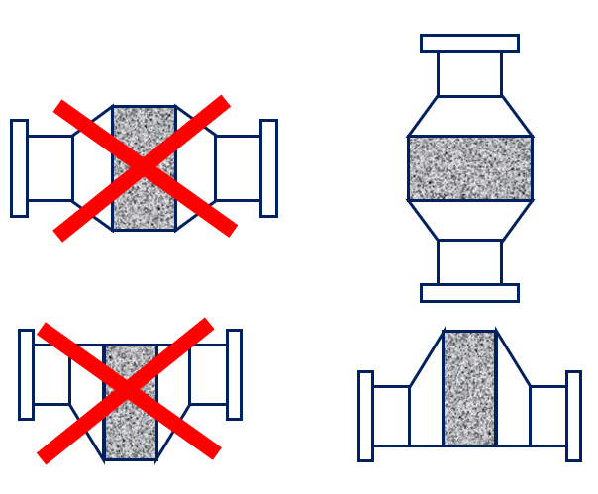

Figure 12‑1. Forbidden and recommended ways of installing a flame arrester in the NCG lines.

Matters to inspect:

1. The placement of the pipe drains so that condensate cannot accumulate in any part of the operation. Special attention must be paid to the operations during a shutdown and when non-condensable gases are being turned to the plant for burning.
2. The defrosting and sufficient size of the condensate removal to prevent blocking.
3. Condensate must not accumulate in the flame arrester or its devices.
4. Draining of vapour lines in the NCG system.
5. The position of the flexible joints (bellows, braided metal hose) to prevent condensate accumulation.

## Turpentine

The turpentine in the non-condensable gases of softwood pulp mills poses one of the most significant risks, and special attention must be paid to processing it.

A high turpentine content in non-condensable gases is hazardous, which is why the turpentine content is typically reduced through condensation. Despite condensation, terpenes always remain in a gas mix processed in gas form in the amount that corresponds to the partial pressure of the turpentines, see Appendix 3. Safety can be improved when such potentially terpene-heavy DNCG targets are condensed after the collection point or condensation. It is recommended that the diluted non-condensable gases with turpentine content be cooled to a temperature below 35°C. If the maximum temperature after the condensation is exceeded, the target must be automatically excluded from the collection.

The fraction cleaned in the stripping of foul condensate may include some residual turpentine if the foul condensate supply has a high turpentine content. The transfer of turpentine into the cleaner condensates via the foul condensate processing should be inspected since turpentine causes an odour nuisance among clean condensate fractions. The transfer of turpentine can be prevented through proper tank design and decanting the turpentine in the foul condensate storage tank.

One of the known risks involved in turpentine processing is the transfer of turpentine to a truck, during which air may enter the NCG system. It is recommended that attention be paid to the design and use of the transfer system so that safe operations can be ensured and odorous emissions prevented.

Matters to inspect:

1. Condensation of turpentine in the pipelines and ducts during shutdown, and safe startup of the plant after shutdown.
2. Potential turpentine leaks into the clean secondary condensates.
3. Safety as the temperature rises after the condensation of chip bin vent gas.

## Methanol

Non-condensable gases in methanol liquefication are collected, like other concentrated non-condensable gases, below the liquid surface of the collection system’s water trap vessel.

Special instructions for processing methanol must be followed due to the explosion hazard and toxicity.

## Startup of the evaporator

When starting up the evaporator, a typical risk involved in the NCG system is the potential foaming of black liquor, especially in softwood mills. Foaming liquor may end up in the NCG collection system.

When the evaporator startup begins, the evaporation units are full of air. If air discharge directly into the environment is not allowed due to potential odour nuisance, special attention must be paid to the transfer and burning of concentrated non-condensable gases in connection with the evaporator’s activation, since the concentrated non-condensable gases will be at an explosive range in such situations. When using an ejector to transfer gas, steam functions as an inert medium which reduces the proportion of air in the NCG mixture.

The composition of concentrated non-condensable gases may fluctuate when the evaporator is activated, which will cause problems for oxygen regulation at the auxiliary burner and cause the amount and quality of flammable substances to fluctuate. As a result, the burner may be extinguished, which may cause odour nuisance.

Matters to inspect:

1. Increasing the dry solid content of the weak black liquor at startup to prevent foaming.
2. Safe processing of concentrated non-condensable gases if the gases are in the explosive range when the evaporator is activated.

## Flame arresters

There are two types of flame arrester models: vertical and horizontal, see figure 12‑1. The flame arrester must be intended for non-condensable gases, and condensate accumulation in the arrester must be prevented.

The flame arrester must be inspected regularly, and the pressure difference caused by it should also be monitored to detect blocking. It must be possible to flush the CNCG line to the burner with steam to ensure safe maintenance work on the flame arrester.

## Flame controllers

When selecting the flame controller, attention should be paid to the auxiliary fuel to be used for burning since specific fuels require a flame controller at a specific wavelength range (ultraviolet or infrared).

## Matters to consider in secondary burning locations

When planning and building the NCG system, the automatic, safe and odourless transfer of non-condensable gases into a secondary burning location must be ensured. The NCG system must be treated as a whole, paying equal attention to the requirements set for the pipelines, devices and automation.

When designing the condensate lines for the secondary burning facilities, it must be ensured that the concentrated non-condensable gases cannot bypass the fire and quick shut-offs in other burners via the condensate lines.

A sufficiently high water trap must be reserved for the flare drains so that the flare cannot push combustion air into the NCG condensate collection system. The combustion air may create an explosive gas mixture in the pipeline for concentrated non-condensable gases and their condensates.

Matters to inspect:

1. The automation of NCG turning and operation even during disruptions, such as power outages or other energy outages.
2. Sufficient size of NCG systems’ condensate removal lines (≥DN50), regarding both the pipeline and the devices (burners, fans, etc.).
3. Height of the water traps.
4. Preconditions for quick starting the flare, see section 11.2.
5. The operation of the condensate system during both standby and running.
6. Protecting the NCG lines and NCG condensation lines in all conditions, such as preventing the drying of water traps and defrosting.

## Changes to the NCG system

When making changes related to the NCG systems, it must be ensured that the new and old systems form a safe and consistent system together. The system connections must be implemented so that connections to obsolete process areas do not remain in the old system, and that the respective systems for diluted and concentrated non-condensable gases are not connected to each other.

When planning the bottling of concentrated non-condensable gases, special attention must be paid to the suitability of older process equipment, in particular, for the requirements for bottling. Typical problematic places are water traps and tanks that are not designed for low or high pressure.

Matters to inspect:

1. Isolating devices and tanks that are to be removed from the NCG system.
2. Pipe routing and condensate collection.
3. Design values of tanks and their safety devices as a part of the new system.

# OTHER GUIDELINES AND REGULATIONS THAT INFLUENCE THE DESIGN

## Finnish legislation

The key Finnish laws and regulations applied to the processing of non-condensable gases are the following:

* Chemicals Act ([744/1989](https://www.finlex.fi/fi/laki/kaannokset/2013/en20130599_20130599.pdf))
* Decree on the Industrial Handling and Storage of Dangerous Chemicals ([59/1999](https://www.finlex.fi/fi/laki/ajantasa/2015/20150685))
* Decree of the Ministry of Social Affairs and Health on amending the decree of the Ministry of Social Affairs and Health on the grounds for classifying and labelling chemicals ([6/2010](https://www.finlex.fi/fi/laki/alkup/2010/20100006))

### Hazard and operability study (HAZOP)

The Chemicals Act defines hazardous gases and requires that a hazard and operability study (e.g. HAZOP) be carried out on the burning of non-condensable gases.

### Pipeline classification

The Chemicals Act and the Decree on the Industrial Handling and Storage of Dangerous Chemicals provide technical requirements for equipment and determine, among other things, how pipelines are classified, how regular inspections are carried out, and that concentrated non-condensable gases must be moved by using an ejector and not a fan or similar.

The EU’s new regulation on classification, labelling and packaging of substances and mixtures, [the CLP regulation (EC) No 1272/2008](https://eur-lex.europa.eu/legal-content/EN/TXT/HTML/?uri=CELEX:32008R1272), entered into force on 20 January 2009. The CLP regulation is valid as-is in all EU member states.

The decision of the Ministry of Social Affairs and Health on the grounds for classifying and labelling chemicals [26 September 2001/807](http://www.edilex.fi/tukes/fi/lainsaadanto/20010807/) provides a formula for determining flammability. It is based on the standard [Determination of fire potential and oxidizing ability for the selection of cylinder valve outlets ISO 10156](http://sales.sfs.fi/sfs/servlets/ProductServlet?action=showproduct&productid=237500) and its tables 1 and 2. Diluted non-condensable gases are classified as harmful gases, but not as explosive.

In practice, the separate burning of concentrated non-condensable gases is structured according to the requirements for natural gas. There are guidelines on natural gas that set strict requirements for valves and flushing, for example.

### Classification of explosive atmospheres

Explosive atmospheres are governed by [the EU ATEX directive, 2014/34/EU](https://eur-lex.europa.eu/legal-content/EN/TXT/?uri=CELEX%3A32014L0034). Instructions on the classification of explosive atmospheres are also provided in [standard EN 60079-10:1956](http://sales.sfs.fi/sfs/servlets/ProductServlet?action=showproduct&productid=236924). The classification for explosive atmospheres is applied to concentrated non-condensable gases. The atmosphere classifications and their impact zones are defined for potential leak locations. The systems built in the impact zone of a classified atmosphere must have components that comply with the classification. Class 1 means that the explosive gas is present occasionally, and class 2 means that the gas is not expected to be present in the space during normal use.

## European standards

The European standard on water-tube boilers and auxiliary installations ([EN 12952-8, Annex A.3.3](http://sales.sfs.fi/sfs/servlets/ProductServlet?action=showproduct&productid=145060)) sets some restrictions on the burning of non-condensable gases in a recovery boiler. Concentrated non-condensable gases may be burned in a recovery boiler if the steam generation is at least 50% of the boiler’s nominal load when processing black liquor.

The standard also requires that precautions be taken to prevent water solutions from entering the furnace along the gases or fuel, and that concentrated non-condensable gases not enter the air in the boiler building. The above does not apply to diluted non-condensable gases.

All NCG lines must have shut-off valves installed.

## Binding conclusions in EU BAT BREF

The EU has published BAT BREF documents to direct environmental regulations. The documents consist of two parts:

1. The directly binding conclusions are the *European Commission, Implementing decision (2014/687/EU), Pulp and Paper Conclusions*.
2. The full text, *European Commission, Integrated Pollution Prevention and Control (IPPC), Best Available Techniques (BAT) Reference Document for the Production of Pulp, Paper and Board* *2015*,   
   is intended as a guideline and does not legally bind the member states.

Based on overall considerations, the environmental authority in a member state may decide on the matters independently. However, if the decisions are more relaxed than the binding conclusions, the EU must be notified of them.

## Notes about the process-specific BAT conclusions

BAT 5 means that the NCG content must be taken into account when reusing odorous waters.

BAT 9, a and c

“*BAT is to carry out the monitoring and measurement of emissions to air, as indicated below, on a regular basis with the frequency indicated and according to EN standards.*

*If EN standards are not available, BAT is to use ISO, national or other international standards which ensure the provision of data of an equivalent scientific quality*.”

The NOx and SO2 levels of an NCG boiler intended for burning NCGs must be monitored periodically or continuously.

The H2S levels of an NCG boiler intended for burning NCGs must be monitored periodically or continuously.

Diffuse emissions (H2S) from different sources (e.g. the fibre line, tanks, chip bins, etc.) and residual weak gases must be monitored periodically.

BAT 20

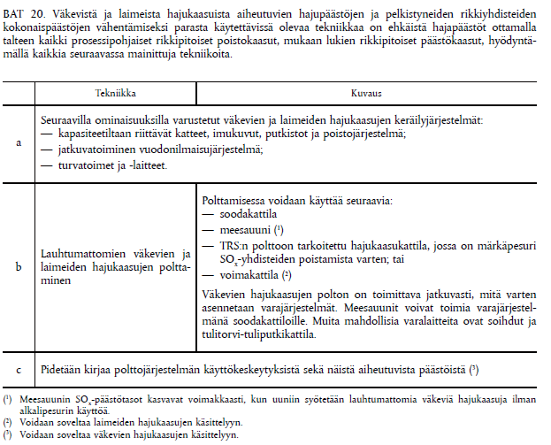

BAT 20 also mentions the following regarding uncollected sulphur compounds: “*BAT-associated emission level of total reduced sulphur (TRS) in residual weak gases emitted is 0.05 – 0.2 kg S/ADt*.”

BAT BREF states the following about the burning of NCG in a lime kiln:

*Reduction of emissions from a lime kiln*, SO2, BAT 24: “*In order to reduce SO2 emissions from a lime kiln, BAT is to apply one or a combination of the techniques given below.*”

1. Fuel selection/low-sulphur fuel
2. Limit incineration of sulphur-containing odorous strong gases in the lime kiln
3. Control of Na2S content in lime mud feed
4. Alkaline scrubber

Point b means that a large amount of concentrated non-condensable gases must not be continuously supplied to the lime kiln due to its limited ability to bind sulphur. The BAT document does not mention the burning of diluted non-condensable gases in a lime kiln.

*Reduction of emissions from a lime kiln*, TRS, BAT 25, table 7: “*For lime kilns burning strong gases (including methanol and turpentine), the upper end of the AEL range may be up to 40 mg/Nm3.”* Without the burning of non-condensable gases, the range is 1–10 mg/Nm3. As such, burning concentrated non-condensable gases in a lime kiln increases the TRS emissions.

*Reduction of emissions from a lime kiln*, NOx, BAT 26, lists the following techniques to reduce NOx emissions from a lime kiln:

1. Optimised combustion and combustion control
2. Good mixing of fuel and air
3. Low-NOX burner (burners that reduce the generation of nitrogen oxides)
4. Fuel selection/low-N fuel

The fuel mentioned in point d also encompasses the concentrated non-condensable gases led to the lime kiln and liquid methanol and turpentine. The conclusion states that the NOx emissions increase when these are burned in a lime kiln.

*Reduction of emissions from a burner for strong odorous gases (dedicated TRS burner)*, SO2 and TRS, BAT 28 states: “*In order to reduce SO2 emissions from the incineration of strong odorous gases in a dedicated TRS burner, BAT is to use an alkaline SO2 scrubber.”*

The BAT conclusion provides emission levels for a dedicated NCG boiler as shown in the table below.

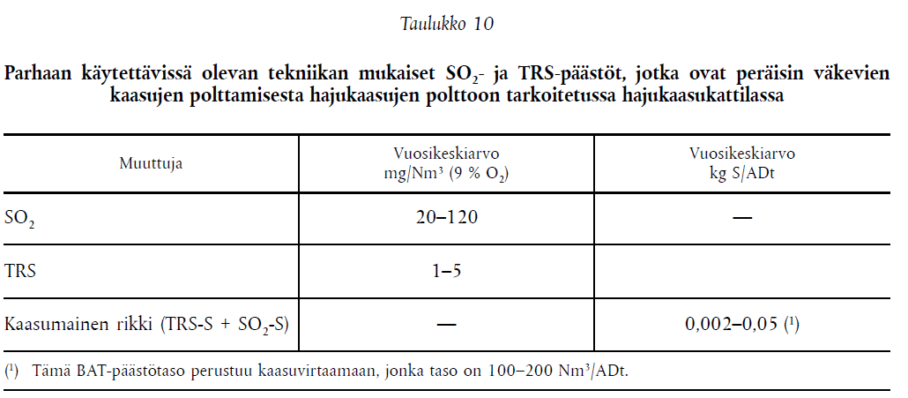

*Reduction of emissions from a burner for strong odorous gases (dedicated TRS burner)*, NOx, Bat 29 a–b states: “*In order to reduce NOX emissions from the incineration of strong odorous gases in a dedicated TRS burner, BAT is to use one or a combination of the techniques given below*.”

1. Burner/firing optimisation
2. Staged incineration

Regarding emissions from the NCG boiler, the conclusion provides the emission limits shown in the table below.

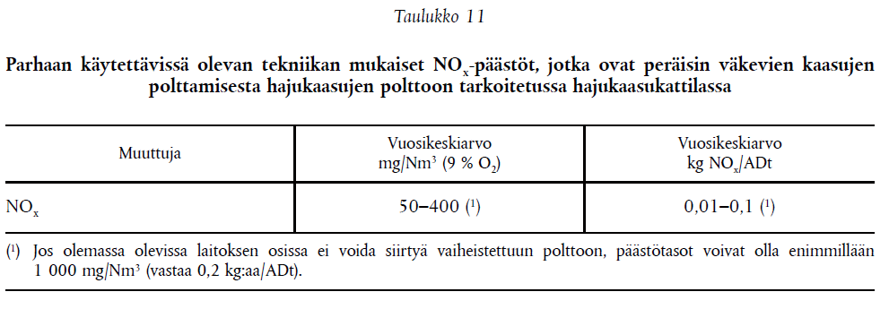

The BAT conclusions include a description of techniques for the prevention and control of emissions to air in section 8.7.1. The following sections are relevant for the processing of NCG:

1. The following general mentions are made about the burning of non-condensable gases: “Collected strong gases can be destroyed by burning them in the recovery boiler, in dedicated TRS burners, or in the lime kiln. Collected weak gases are suitable for burning in the recovery boiler, lime kiln, power boiler or in the TRS burner. Dissolving tank vent gases can be burnt in modern recovery boilers.”
2. Nitrogen oxides, NOx: “*The use of fuels with a low nitrogen content is applied to reduce the amount of NOx emissions from the oxidation of nitrogen contained in the fuel during combustion. The combustion of CNCG or biomass-based fuels increases NOx emissions compared to oil and natural gas, as CNCG and all wood-derived fuels contain more nitrogen than oil and natural gas. Due to higher combustion temperatures, gas firing leads to higher NOx levels than oil firing*.” Since concentrated non-condensable gases and liquid methanol contain a high amount of nitrogen compounds, burning them increases the NOx emissions.

## Existing guidelines

Sodahuskommittén from Sweden and BLRBAC from the US have prepared guidelines on the processing and burning of non-condensable gases. BLRBAC’s guidelines are extremely detailed and include specific technical descriptions of the solutions presented.

### Sodahuskommittén

Our sister organisation in Sweden, Sodahuskommittén, decided in December 2008 that, moving forward, it would only publish guidelines in Swedish and the guidelines would only be intended for its members. According to a survey commissioned by the committee, the committee’s responsibility for the guidelines extends quite far.

### BLRBAC

BLRBAC has prepared guidelines to minimise hazards, titled [*Recommended good practice for the thermal oxidation of waste streams in a black liquor recovery boiler*](http://blrbac.org/sites/default/files/Waste_Streams_October_2010.pdf), last updated in April 2017.

The document details flammable non-condensable gases and defines explosive limits for them. It also describes where non-condensable gases are collected and how they can be disposed of. It also provides instructions on burning methanol and turpentine. There are chapters dedicated e.g. to the processing of chip bin vent gas. The document also provides conditions for the dry solid content in black liquor at which non-condensable gases can be burned safely.

In the event of a problem, and especially when an emergency shutdown procedure (ESP) is initiated in practice, non-condensable gases must be immediately led elsewhere from the recovery boiler, similarly to other fuels.

The document also includes warnings about the toxicity and corrosion hazard of non-condensable gases, even though the burning of non-condensable gases has not been proven to corrode the pressurised vessel.

The document is extremely detailed and extensive, and it also provides logic conditions and examples of PI and locking diagrams for burning and collection systems. The excerpt below is BLRBAC’s presentation of logic conditions.

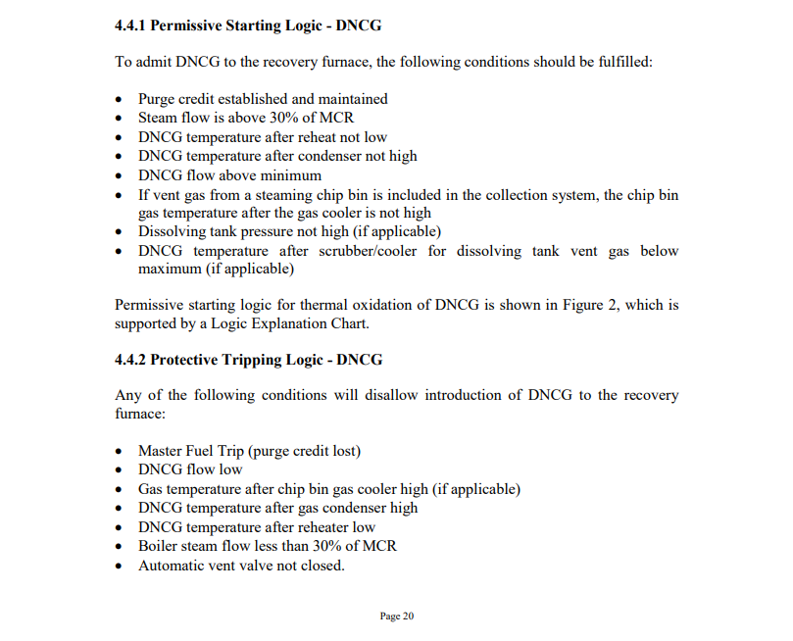

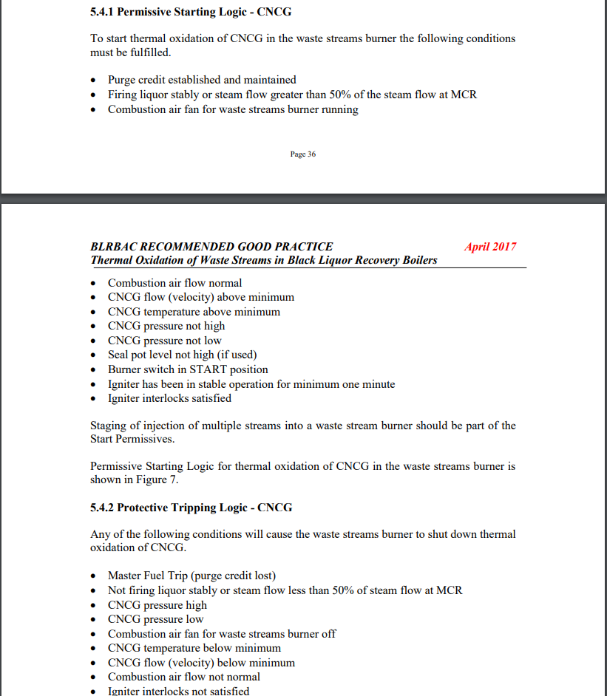

# DIFFERENCES FROM OTHER GUIDELINES

The Finnish Recovery Boiler Committee has aimed to follow the recommendations and guidelines prepared in some other countries regarding the burning of non-condensable gases in a recovery boiler. However, some parts differ from the other guidelines. Some of these differences are listed below.

## Differences compared to the BLRBAC guidelines

The guidelines of the Finnish Recovery Boiler Committee differ from those of the BLRBAC (<http://www.blrbac.org/>) for the following parts, among others:

* The BLRBAC guidelines feature a chapter dedicated to the collection and processing of chip bin vent gas. BLRBAC recommends using an LEL analyser if a fan is used to move the substances and expansion steam from the digester is brought into the chip bin.
* The Finnish Recovery Boiler Committee’s recommendations are different in terms of the processing of chip bin vent gas.
* The BLRBAC guidelines feature a chapter dedicated to the processing and burning of stripper off gases.
* The BLRBAC guidelines present examples of the PI and locking diagrams for NCG collection.
* The recommended relative humidity of diluted non-condensable gases and vent gas, after the condenser, is 50%, corresponding to a temperature of <43.3°C (110°F). Heating at least 22.2°C (40°F) above the condensation temperature.
* The burning of diluted non-condensable gases may start when the steam load in the boiler is over 30% of the boiler’s MCR.
* The burning of concentrated non-condensable gases may start when the steam load in the boiler is over 50% of the boiler’s MCR.
* The burning of methanol/turpentine while mixed into black liquor.

## Differences compared to the EN standard

The Finnish Recovery Boiler Committee’s guidelines are different from the standard EN 12952-8 for the following parts, among others:

* The standard demands that an impurity removal device (e.g. a filter net) is used on all fuels (including concentrated non-condensable gases) before the burner’s quick-closing valves.
* The standard states that concentrated non-condensable gases may be burned in a recovery boiler if the steam generation is at least 50% of the boiler’s nominal load when processing black liquor.

# EXAMPLES OF DAMAGE

The NCG line may involve a risk of explosion if the gas concentration is within the explosive range. The gas concentration must remain sufficiently high or low. Shutdown and startup situations, in particular, are problematic. Typically, the NCG explosions in recovery boilers have occurred in the DNCG systems.

Below are some examples of damage and dangers that the Finnish Recovery Boiler Committee is aware of. The damage is described so that readers get a concrete idea of the potential dangers involved in the processing or burning of non-condensable gases. Similar incidents have occurred at other mills than the ones mentioned here.

## Example 1:

An explosion occurred in a concrete stack of the mill, which damaged the steel pipe for diluted non-condensable gases throughout its length, parts of the lime kiln’s flue gas pipe, and a section of the pipe for concentrated non-condensable gases. The explosion in the stack was caused by the combined effect of multiple factors. The explosion was preceded by running operations that raised the concentration of the gas mixture up to the ignition and explosion range. The weather conditions at the time pushed the hot flue gases from the lime kiln into the diluted non-condensable gases, causing them to ignite.

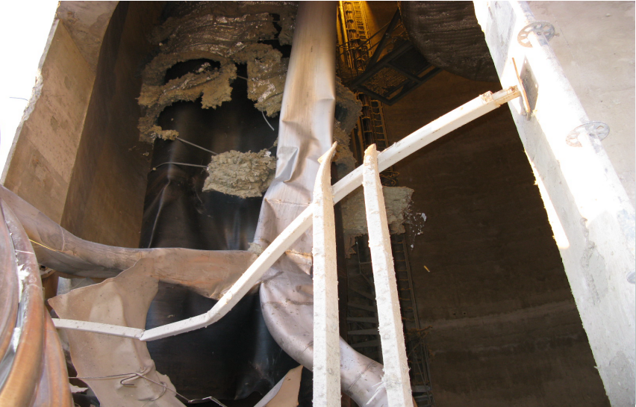

Figure 15‑1. Photo of the inner stack after the explosion.

Causes:

* The diluted non-condensable gases in the condenser had concentrated to explosive range during normal operation and shutdown.
* The gases from the strong liquor tank were led into the DNCG collection. Gases were powerfully discharged from the strong liquor tank 22 hours before the explosion.
* The NCG fan in the fibre lines had been stopped, which is why the non-condensable gases from the fibre lines could not dilute the content.
* The hot (ca. 260°C) flue gases from the lime kiln were mixed with the diluted non-condensable gases that were directly discharged due to weather conditions and exceeded the lower explosive limit. The DNCG bypass pipe and the lime kiln’s flue gas pipe were at the same level.

Follow-up measures after the explosion:

* The DNCG fan in the fibre lines should be kept running during the shutdown while leading diluting air to the fan’s suction side. This way, it can be ensured that the gas concentration remains as low as possible.
* The gases from the strong liquor tank are led to the concentrated NCG collection or condenser sequence, not to the diluted NCG collection.
* The temperature of the strong black liquor in the strong liquor tank is dropped to 117°C, and its dry solids to 67–69%, to prevent gas formation reactions during the shutdown.
* The recycling pump of the NCG scrubber will not be stopped during the shutdown.
* Clear instructions are provided for running diluted non-condensable gases during the shutdown.
* The scrubbing cycle liquids from the evaporator’s NCG scrubber are not pumped into the leak liquor tank from which the gases are sucked back to the DNCG collection.

Other recommendations:

* The concentration of methanol, TRS and turpentine should be charted in diluted non-condensable gases, liquors and condensates.
* Concentration and flow measuring should be added to the DNCG collection for monitoring purposes.
* A simulation should be prepared in order to reliably determine the amount of dilution air during different runs.
* The capacity of the closed DNCG collection in the evaporator should be increased, and the suction side should be equipped with dilution air intake.
* The lower sections of the DNCG bypass pipe should be redesigned.
* In this example, the mill should stop using the evaporator fan and direct the diluted non-condensable gases to a dedicated pipe on the suction side, so that they cannot concentrate to explosive range.
  + - * + Please note that, in general, it is recommended that the DNCG fans be kept on even during shutdowns to prevent concentration. If the NCG fan needs to be stopped for maintenance, the non-condensable gases should be directed straight outdoors, and dilution air should be added at the collection location, e.g. by opening the maintenance hatches of the relief and inward relief valves, to prevent concentration.
* For diluted non-condensable gas, a hazard and operability study (HAZOP) should be carried out in terms of gas concentration during normal use and shutdowns.

## Example 2:

An NCG explosion close to the NCG boiler’s burner in the DNCG collection pipeline.

Causes:

When the pulp mill was started up, the supply of chips to the digester stopped due to problems in the black liquor filters. After this, the surface of the chip bin was raised to the level of 95% and the chips were pre-steamed with live steam, at which point the chip bin’s temperature was at 90°C.

About 30 minutes after the stoppage, the chip supply to the digester was restarted. At this point, flash steam was also added to the chip bin since the CNCG system was unable to maintain a sufficient negative pressure in the NCG collection line leading up to the burning boiler. The pre-steamed chip bed was unable to condense and absorb the injected steam, which is why it slipped through the bed and rapidly increased the temperature in the upper section of the chip bin. From the chip bin, the steam leaked to the DNCG collection system.

The temperature locking system after the condenser for the chip bin vent gas reached the locking temperature of >55°C, at which point the gases were directed to the bypass pipe. Before this safety locking, gases leaked into the DNCG collection for about 40 seconds, which caused an explosion about 90 seconds from the opening of the flash steam valve. The explosion occurred close to the NCG boiler burner in the collection pipeline.

**Follow-up measures after the explosion:**

Before the mill was restarted, the following measures were taken:

* The opening speed of the flash steam valve was slowed down (5%/min on a range of 0–10%) so that only a controllable amount of flash steam can enter the chip bin during startup.
* The chip conveyor running into the bin must be kept running for at least five minutes before the flash steam valve into the chip bin can be opened. This way, it can be ensured that there are fresh chips in the bin to condense the flash steam.
* When the temperature in the chip bin rises above 90°C, the condenser water valve of the condenser will immediately open fully.

## Example 3:

When a pulp mill and recovery boiler were started up, a fire started in the NCG duct, which damaged the front wall of the recovery boiler and the duct for a length of two metres. The fire may have started from the boiler’s back fire that ignited the deposit accumulated at the bottom of the NCG duct. The deposit at the bottom of the NCG duct are usually from the tall oil plant.

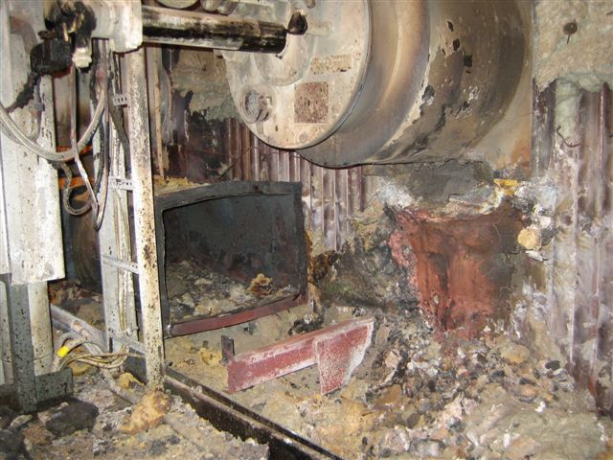

Figure 15‑2. Photo of the DNCG duct after the fire.

The materials and welding working group of the Finnish Recovery Boiler Committee compiled a list of matters to consider:

* The scrubbers’ smooth operation must be ensured to achieve good results. The liquid distribution, drop separation and post-scrubber temperature must be inspected at each scrubber.
* The dilution control in the DNCG system must be inspected.
* Drop separation must occur before the pre-heater.
* As stated in the burning guidelines, the composition of non-condensable gases must be measured regularly.
* The ducts must be inspected and cleaned regularly.
* A hazard and operability study (HAZOP) should be performed together with the NCG system provider whenever the system is changed.

Follow-up measures after the explosion:

* The DNCG fan was replaced.
* The pre-heating of air was enhanced by adding a dedicated heat exchanger for fresh air, which helped increase the temperature of the diluted non-condensable gases.
* The collection system’s capacity was increased.
* The locking systems related to burning were inspected.
* The dissolving tank vent gases were included in diluted non-condensable gases for burning.

## Example 4:

This example features two separate cases. The first explosion occurred in the DNCG duct at the recovery boiler, while the other explosion occurred in the strong liquor tank.

Causes:

A Brazilian mill experienced two explosions after startup. The first explosion was related to the chip bin, while the other was related to the pressurised strong liquor tank.

Presteaming steam was run into the chip bin during the mill’s shutdown, which is when concentrated non-condensable gases ended up in the DNCG collection through the chip bed, or, alternatively, methanol had concentrated into the bed and was released. No condensation was carried out for the presteaming steam; instead, it had to be run into the chip bin. The explosion occurred in the DNCG duct at the recovery boiler. The recovery boiler’s volume of secondary air had been reduced manually.

The second explosion was related to a pressurised strong liquor tank that exploded when its recycling pump was left running during the shutdown and NCG compounds started forming rapidly. The tank did not have a safety valve, and it was not connected to the CNCG collection system.

Follow-up measures after the explosion:

The explosion of the chip bin’s concentrated gases in the diluted collection system led to the mill investing in a reboiler for presteaming steam, with which chips are presteamed with pure steam. This improvement to the digester removed the problems related to the DNCG collection and processing system. Using the reboiler steam in the chip bin always keeps the concentration of diluted non-condensable gases at a low level. The acquisition of an auxiliary burning system was also considered due to problems with odours, but the reboiler removed the worst source of nuisance and a new burning system was not deemed necessary.

The strong liquor tanks were connected to the CNCG collection system, and a safety valve was installed in the tank.

## Example 5:

At a pulp mill’s startup, the chip bin released turpentine and NCG compounds that ignited explosively at the flare. The combustion wave moved backwards to the NCG fan where another explosion occurred.

Causes:

The explosion was a sum of multiple factors in the chip bin where controlling the exceptional conditions was not possible via the DNCG safety system. The safety system worked well in normal use, but exceptional situations involved a risk of the system not recognising the danger. In other tanks affected in the collection system, the changes in diluted non-condensable gases were slower, thanks to which the mill’s safety systems had sufficient time to react.

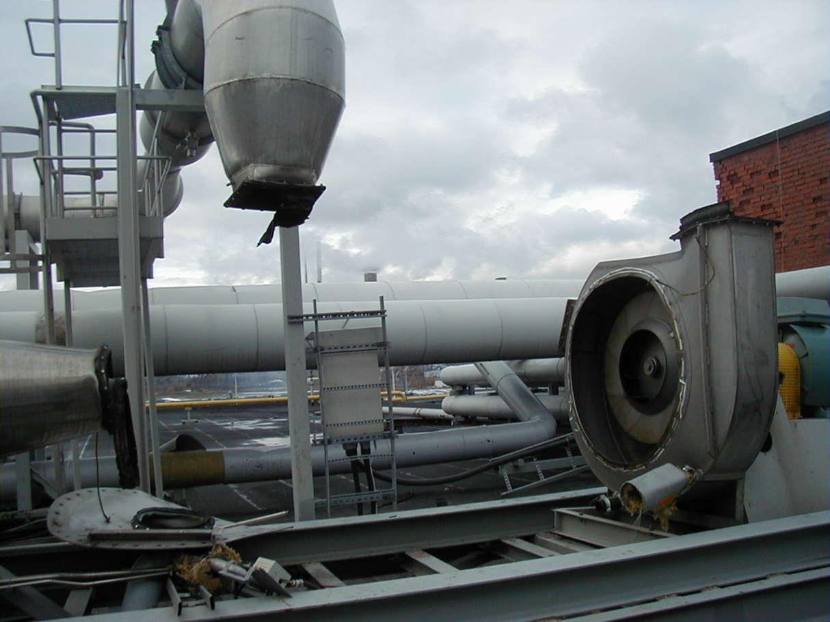 Figure 15‑3. DNCG fan after the explosion.

The explosion was affected by the following individual factors:

* The chips’ long presteaming in the chip bin (the low-pressure feeder being stuck).
* The higher-than-normal concentrations of TRS and VOC in the chip bin at startup.
* A delay in the temperature measurement in the vent gas line from the chip bin.
* A delay in the LEL analyser.
* The NCG scrubber mainly condensed steam, which caused the proportion of NCG to increase in the air. The LEL analyser was located before the condensation, which is why the concentration measured was lower.
* The failure of the dilution valve on the suction side of the DNCG collection fan.
* The automatic reopening of the DNCG collection valve for the digester based on the results of the LEL analyser.
* A throttling disc in the vent gas pipe for DNCG from the digester.
* The flare going out.

The amount of dilution air had been sufficient for normal operation. It was based on measurements carried out in 1998 and 2000. However, the measurements did not cover exceptional situations.

Dilution air is added to the DNCG collection and processing system at three points:

* The negative pressure created by the NCG fan sucks in dilution air from the various collection locations via the vent gas pipes for the chip bin and other tanks. However, the system will not work if it is pressurised as gas will only push out of it. In the case of the chip bin, a throttling disc had been added to the dilution air inlet.
* The LEL NCG analyser opens up the dilution valve on the suction side of the NCG fan if the concentration rises by more than 30% from the previous LEL.
* The diluted non-condensable gases are led to the flare where the required extra air dilutes the non-condensable gases.

Follow-up measures after the explosion:

* The operating method and monitoring of the chip bin will be developed.
* In connection with the changes, the DNCG processing and the related safety systems will be looked at as a whole.
* The sufficiency of dilution air during disruptions will be ensured.
* The safety system will be built based on the principles of safety automation.
* The monitoring of DNCG concentrations will be improved, and the locking thresholds will be verified (development and placement of the analyser; potential duplication).
* Exceptional situations will be identified, and instructions will be provided in order to prepare for them.
* Hazard identification and risk assessment will be carried out systematically.
* Monitoring will be made more consistent.

## Example 6:

An NCG explosion occurred in the tertiary air system of a recovery boiler. The explosion damaged the fan for transferring non-condensable gases, about 15 metres of gas ducts, nine openings next to the boiler, support structures of the ducts and fan, two heat exchangers, a droplet separator, two dampers, the spindle of the shut-off valve in the supply water line, some of the building’s windows, and a small number of automation devices.

Causes:

There were disturbances at the chip bin due to the chip conveyor stopping and presteaming steam ending up in the chip bin’s vent gas system. The vent gas from the chip bin had been connected to the DNCG collection system via the white liquor scrubber after the mill started operating. The connection was made because the chip bin was the single most significant source of odour nuisances in the mill. During the disturbance, the vent gas volume and concentration increased rapidly in the chip bin. As a result, strong gas containing turpentine, methanol and TRS ended up in the tertiary air system of the recovery boiler.

In the NCG measurements carried out after the explosion, it was determined that the vent gas gas in the chip bin exceeded the lower explosive limit, which is why the gas could be ignited by the flame that entered backwards from the recovery boiler, or by a spark caused by the fan. The propagation velocity of a turpentine flame is 150 m/s, while the velocity in the tertiary air openings is about 85 m/s.

The explosion did not cause personal injuries, but it would have been possible.

Follow-up measures after the explosion:

In the review conducted, it was recommended that the vent gas gas from the chip bin not be introduced to the DNCG collection system. However, the report also mentioned that if the mill operators wanted to bring the vent gas to the collection system because of the odour, the chip bin’s vent gas line should be equipped with a turpentine condenser and a scrubber in which the gas is cooled with cold water. It is also recommended that the lower explosive limit be measured and the chip bin vent gas be directed to a local bypass pipe in an emergency.

## Example 7:

In the DNCG burning line, the gas mixture concentrated excessively during startup after a shutdown, which resulted in an explosion.

It is likely that the gas mixture was in explosive range and travelled, via a partially opened shut-off valve and/or drain pipes, to the NCG openings at the back wall of the recovery boiler’s tertiary level at startup after a shutdown. The mixture ignited at the openings and proceeded via the NCG ducts to the front part of the heat exchanger where the explosion occurred.

Today, the mill keeps the NCG collection running even during shutdowns.

## Example 8:

If water is condensed in the NCG line leading to the recovery boiler, a risk of smeltwater explosion is present.

A severe explosion occurred in Brazil when a large amount of water ended up in the furnace via the NCG burner. The explosion resulted in the deaths of four people, and 13 people suffered injuries. A second, smaller smeltwater explosion occurred 15 minutes later.

The ultimate reason for the explosion was likely the water that ended up in the furnace and extinguished the char bed. Apparently, the water ended up in the recovery boiler from the NCG burning line when the automated system turned off the burner system and blew the gas line empty with gas, all while pushing the condensate in the line into the furnace.

Special attention should be paid to the draining, and it should be arranged extensively for the lines. The bypass pipe should be located as close to the boiler as possible for the line between the pipe and the recovery boiler construct to be as short as possible. For practical reasons, the bypass pipe is often close to the recovery boiler since the ejector is often located in or near the recovery boiler construct, and the pipe is always on the pressure side, after the ejector.

## Example 9:

It is vital that everyone working at or near NCG lines is aware of the risk of gas poisoning.

In the early 1980s, a mill suffered an accident where two recovery boiler operators were subjected to gas poisoning caused by non-condensable gases. The accident occurred when liquor was no longer running into the black liquor mixing tank since the vent gas pipe was blocked. There was a pressure transmitter for measuring the mixing tank’s surface, which showed an incorrect surface level due to the pressure rising. In a normal situation, the waste acid was led to the bottom of the mixing tank, about 2 metres below the liquor surface, so that hydrogen sulphide would not enter the room.

During the accident, the liquor surface dropped too low and the waste acid caused a reaction that released hydrogen sulphide. The pressure that increased due to the reaction shut down the black liquor valve, which caused the rapid generation of hydrogen sulphide. An operator was cleaning the vent gas line and inhaled the hydrogen sulphide that was released from the cleaning hatch. This person felt faint and went outdoors, after which they lost consciousness for a moment. Another operator came in to inspect the operation of the mixing tank and detected foam with black liquor bursting out from the lid of the inspection hatch on the mixing tank. They also felt faint and exited to the recovery boiler control room, informing the control room operator of the situation and momentarily losing consciousness afterwards. Both operators went to a hospital for an examination. After the incident, the pumping of excess waste acid into the mixing tank was stopped to eliminate risk factors.

## Example 10:

An explosion occurred in a pulp mill’s CNCG collection system after midnight. The night shift workers repaired one of the four broken bursting discs without problems, and the morning shift workers continued to work on replacing the bursting discs. When the bursting disc was being installed, concentrated non-condensable gases leaked into the indoor spaces. The workers were not wearing respirator protectors or multi-gas meters, and they were exposed to the concentrated non-condensable gases. One of the employees fell severely ill and was hospitalised. Two employees were examined at the hospital and two received first aid at the accident site.

The explosion that broke the bursting discs occurred when air entered the NCG system via a dried-up water trap, and the explosive mix of gas and air was likely ignited by a spark caused by static electricity. In the inspections carried out prior to the accident, defects had been detected in the grounding and equipotential bonding of the pipelines. In the past year, several explosions had occurred in the mill’s CNCG system. Most of the incidents had only broken the bursting discs that functioned as the high-pressure safeguards in the CNCG collection system, but one accident had also caused material damage.

When the bursting discs were being replaced, the steam valve of the ejector had been closed, and the gases were gravitationally directed to the roof via the bypass line. At the moment of the accident, the workers were about to replace one of the two bursting discs that had been broken in the pipeline between the fibre and liquor lines. The bursting disc to be replaced was on the side of the recovery boiler. When the workers installed the bursting disc to the discharge pipe and started to tighten the bolts, the gas flows were likely changed or accelerated in the pipe between the broken bursting discs. The non-condensable gases that entered the line from the digester and condenser started to flow towards the bypass line to the roof and discharged, through a gap in the bursting disc, into the pipe tunnel where the maintenance work was underway.

The non-condensable gases from the digester and evaporator can be directed outdoors through separate bypass lines during an emergency, but these measures had not been taken before the work on replacing the bursting discs started in the pipe tunnel.

In the post-accident investigation, defects were detected in both the condition of the CNCG collection system and in the operating methods related to maintenance work.

* The system in use had (too) many water traps and bursting discs as safety devices, which involves a high probability of air entering into the system.
* Defects were detected in maintenance, which increases the risk of leaks caused e.g. by corrosion.
* There were shortcomings in the working instructions and permits, even though the system included hazardous chemicals.

Actions to prevent similar accidents:

* The devices added to ensure process safety should be placed so that they can be inspected and repaired safely. It is recommended to install an appropriate indicator for the safety devices or connect the devices to an automation system to detect when they are activated.
* If the devices installed to ensure process safety are triggered, the reasons should always be inspected. Running against the safety devices should not be approved as a normal method of running the process.
* The risks involved in an ageing system should be assessed. Special care should be paid to the advance maintenance, inspections and replacement needs related to the devices that are critical for process safety.
* The mill operator should ensure that the employees are aware of the hazards involved in each workstation and tasks and know the safety and working instructions. The instructions should also cover operations in case of an emergency so that the process can be reverted to a safe state. The instructions that are relevant for safety should be discussed with the employees, and the compliance with the instructions should be monitored.
* When working shifts, sufficient information exchange between the shifts should be ensured. For maintenance carried out by operators, the suitable methods for shift changes and information exchange should be determined.
* For the operators who carry out maintenance work, a sufficient induction for the site and tasks, and the related hazards, should be offered before the work starts.
* Responsibilities and duties in the follow-up after a disruption (including startup and shutdown situations) should be defined accurately.
* The change management should also cover the safety assessment of minor changes. It should be verified regularly that risk analyses, instructions and PI diagrams are up-to-date.
* For equipment located in the worksites of multiple departments or units, the maintenance responsibilities should be defined clearly.
* The handling and storage of the chemicals formed in the process must comply with the regulations and instructions on the handling and storage of hazardous chemicals.
* Internal audits and inspections should also pay attention to the failure mechanisms of the systems that are relevant for process safety and the methods for remedying failures, including the responsibilities and tasks related to use and maintenance.

## Example 11:

The white liquor measuring tank located on the third floor of the pulp mill’s digester exploded. The metal tank, with a volume of 9 m3 and wall thickness of about 5 mm, ruptured, and the tank components spread to the other levels of the digester. Windows were broken on multiple floors of the digester. The explosion severed two black liquor pipes leading to the digester, which is when about 85 m3 of black liquor leaked into the mill’s sewers/leak liquor system. Because of the explosion, the non-condensable gases were led outside unprocessed for a few hours, which caused an odour nuisance in the mill area and its immediate vicinity. The explosion did not result in personal injuries. No one was inside the digester building at the time of the explosion, and the people outside were 50–200 metres away.

The measuring tank had been installed in the late 1970s to monitor the dosing of white liquor. Later, it had been used as a scrubber tank for the digester’s heat exchangers. The tank had been removed from use about 15 years before the accident. At this time, the tank had been emptied, but its pipelines had been left in their place.

Causes of the event:

* Turpentine-heavy gas entered the measuring tank from the evaporator’s vacuum tank. The overflow of the vacuum tank and the measuring tank were connected through a duct pipe.
* The overflow pipe and discharge line of the measuring tank ran into a shared duct pipe. The water trap was dry, and as such, it did not prevent the gases from rising to the measuring tank.
* In an inspection, damage was discovered in the suction pipe inside the vacuum tank. Due to the damage, the turpentine-heavy liquid was not removed from the tank as planned. Due to the pressure fluctuations in the NCG collection, the turpentine-heavy non-condensable gas entered the measuring tank via the duct pipe. The measuring tank and its pipelines were not grounded, which is why static electricity may have caused the explosion. The turpentine-heavy mixture of gas and air may also self-ignite in some concentrations.
* There was a DN250 vent gas pipe from the measuring tank to the digester roof, and the maintenance hatch on the measuring tank’s lid was not closed tightly.

Actions to prevent similar accidents:

* Obsolete pipelines and tanks should be permanently separated from the ongoing process. The pipelines should be cut off and blinded.
* The NCG system was originally constructed in the late 1980s, after which it has been modified and modernised several times. The documentation and risk assessment of the changes made were insufficient. The system description and the instructions for its use and maintenance should be kept up-to-date.
* For the shift managers and fibre line control room, temporary instructions have been prepared on the enhanced supervision of the NCG system. In the pulp mill’s morning meetings, the significance of NCG processing has been emphasised.
* The option to connect the explosion discs from the NCG collection pipeline to the automation system is being studied. If this was done, resolving problems should become quicker.
* The evaporator’s vacuum tank will be replaced completely during the next annual maintenance shutdown. The tank in question is not pressurised.

# CONCLUSION

The members of the Finnish Recovery Boiler Committee have wished to see a clear statement on the NCG collection and burning in pulp mills. The need for these guidelines arises from concerns about safety and the overall functionality of the processes in the field.

Based on their flammable or explosive range, non-condensable gases are divided into diluted gases, the concentration of which is below the explosive limit, and concentrated gases, the concentration of which is above the explosive limit.

The burning of concentrated non-condensable gases in a recovery boiler has gained wider interest only since the 1990s, whereas diluted non-condensable gases have been led into recovery boilers earlier.

When leading diluted non-condensable gases for burning, several problems have arisen. Like with other flue gases, the burning of concentrated non-condensable gases involves risks, which has evoked a need for these guidelines. There are different schools of thought related to NCG burning, which has caused confusion and much discussion.

Various instructions have been provided for the design and use of recovery boilers. The purpose of these guidelines is to allow safe NCG collection and burning in a recovery boiler.

# LITERATURE

Allen, Travis, 2001, NCG Handling, incineration concerns drive need for safe system design. Pulp&Paper, April 2001. pp. 39 – 41.

Black Liquor Recovery Boiler Advisory Committee, Recommended good practice for the thermal oxidation of waste streams in a black liquor recovery boiler. February 2012.

Burgess, Tom and Young, Randy, The explosive nature of noncondensable gases. Proc. 1992 Tappi Environmental Conf., pp. 81 – 95.

Compilation of ’Air Toxic’ Emission Data for Boilers, Pulp Mills and Bleach Plants; NCASI Technical bulletin no. 650, June 1993.

Drew, John, Russel, James and Bajak, Henry W., Sulfate turpentine recovery. Pulp Chemicals Association, New York 1971, 147 p.

Gas book. 2007. Honeywell Analytics Inc.

Grace, T. M., Klabin / Monte Alegre recovery boiler explosion. Föredrag vid Sodahuskonferensen ’99, ÅF-IPK AB 1999.

Huuska, T., Presentation at the *Konemestaripäivät* trade fair 2000. Report of the Finnish Recovery Boiler Committee 1/2000.

Hokynar, S., Odorous gases generated in the production of kraft pulp and their explosion limits. Helsinki University of Technology, Master’s thesis, 1999.

HTP-ARVOT 2020: Haitallisiksi tunnetut pitoisuudet. Sosiaali- ja terveysministeriön julkaisuja 2020:24. (‘TLVs 2020: threshold limit values. Publications of the Ministy of Social Affairs and Health 2020:24’). <http://urn.fi/URN:ISBN:978-952-00-5658-2> Referenced 9 July 2021.

ISO 10156:1996 Ed.2, TC58/SC2: Gases and mixtures – Determination of fire potential and oxidizing ability for the selection of cylinder valve outlets. [http://sales.sfs.fi/servlets/ProductServlet?action=showproduct&productid=237500](http://sales.sfs.fi/servlets/ProductServlet?action=showproduct&amp;amp;productid=237500)

Archive data from Jaakko Pöyry Oy.

Janka, K., Haaga, K., Tamminen, A. and Wallin, E., Advanced Recovery Boilers Reduce Odor Gases Cost-Efficiently; SPCI 1999 s.531-535.

Karjunen, T., Kaasuräjähdykset soodakattiloissa vesivuotojen aikana. (‘Gas explosions in recovery boilers during water leaks’). Report of the Finnish Recovery Boiler Committee 7/1999.

Kankkonen, S., Pekkanen, M., Soodakattilassa poltettavat ainevirrat. (‘Material flows burned in recovery boilers’). Report of the Finnish Recovery Boiler Committee 2/2000.

Lautkaski, Risto, 2010, Reappraisal of the role of turpentine vapor in noncondensible gas explosions. Tappi Journal, Vol. 7, No. 4, April 2010, pp. 6–11.

Modernin sulfaattisellutehtaan haihtuvat kaasumaiset yhdisteet, Osaprojekti 1 Haihtuvien kaasumaisten yhdisteitten määrittäminen. (‘Volatile gaseous compounds in a modern kraft mill, Sub-project 1, Defining volatile gaseous compounds’). Final report. VTT departments of Chemical Technology, Environmental Technology. 45 p.

Mäntyniemi, Jussi, Isoniemi, Markku and Harila, Pauli, Biosludge and NCG incineration in a recovery boiler. 1995 International Chemical Recovery Conference. pp. B57 – B61.

OVA-ohje: Tärpätti. (‘Guidelines on hazardous substances: turpentine’). 28 August 2013. Finnish Institute of Occupational Health. http://www.ttl.fi/ova/tarpatti.pdf.

Pekkanen M, Nieminen R, Lehtinen T. Hajukaasujen polttosuosituksen päivitykseen liittyvä selvitys. (‘Study on an update to the guidelines for burning non-condensable gases’). Report of the Finnish Recovery Boiler Committee 7/2010.

PSAVI/7988/2019. Environmental and water management permit, Kemi. 2019. Regional State Administrative Agency for Northern Finland. <https://ylupa.avi.fi/fi-FI/asia/1694991> Referenced 9 July 2021.

Rantanen, Asmo, 1987, Soodakattilan liuotinhöngän koostumuksen ja käsittelymenetelmien tutkiminen (‘Studying the consistency and processing methods of recovery boiler dissolving tank vent gases’). Master’s thesis, Lappeenranta University of Technology, School of Energy Systems, Lappeenranta, 114 p.

Decision of the Ministry of Social Affairs and Health (979/1997) on the grounds for classifying and labelling chemicals.

Decision of the Ministry of Social Affairs and Health (1058/1999) on amending the Decision of the Ministry of Social Affairs and Health on the grounds for classifying and labelling chemicals.

Decree of the Ministry of Social Affairs and Health on amending the decree of the Ministry of Social Affairs and Health on the grounds for classifying and labelling chemicals (6/2010), 11 January 2010.

Safety requirements for chemical piping 2017. Finnish Safety and Chemicals Agency (Tukes), 2017.

Työpaikan ilman epäpuhtauksien enimmäispitoisuudet (enimmäispitoisuusohjeet). (‘Maximum concentrations of impurities in workplaces (guidelines on maximum concentrations)’). Sosiaali- ja terveysministeriön vahvistamat teknilliset turvallisuusohjeet N.o 11. (‘Technical safety guidelines verified by the Ministry of Social Affairs and Health, No. 11’). Ministry of Social Affairs and Health 1972.

Venermo, Mikko, Upgrading of the odour control system of a kraft pulp mill by pre-evaporating the black liquor. Master’s thesis, Helsinki University of Technology, Espoo. 94 p, 1992.

APPENDIX 1

Example of calculating fire power

EXAMPLE OF CALCULATING FIRE POWER

To consistently calculate a minimum load for the burning of non-condensable gases, this document shows two ways of calculating it. In the first one, the load is tied to the steam flow, and in the other, to the liquor flow. The unit for firing power is the net heat for the steam generation divided by the base squares of the furnace.

|  |  |  |  |  |  |
| --- | --- | --- | --- | --- | --- |
|  | 100 | % |  | 43 | % |
| Boiler base area | 100 | m2 |  | 100 | m2 |
|  |  |  |  |  |  |
| Steam generation | 80 | kg/s |  | 34.3 | kg/s |
| Live steam pressure | 80 | bar |  | 80 | bar |
| Live steam temperature | 480 | oC |  | 480 | oC |
| Live steam enthalpy | 3,349.5 | KJ/kg |  | 3,349.5 | kJ/kg |
| Feed water pressure | 100 | bar |  | 100 | bar |
| Feed water temperature | 115 | oC |  | 115 | oC |
| Feed water enthalpy | 489.6 | kJ/kg |  | 489.6 | kJ/kg |
| Cylinder pressure | 90 | bar |  | 90 | bar |
| Sootblowing steam enthalpy | 2,942.9 | kJ/kg |  | 2,942.9 | kJ/kg |
| Vent gas enthalpy | 1,363.7 | kJ/kg |  | 1,363.7 | kJ/kg |
| Vent gas | 1.5 | % |  | 1.5 | % |
| Sootblowing | 2.0 | % |  | 2.0 | % |
| Heat into the steam | 2.922 | MJ/kg |  | 2.922 | MJ/kg |
|  | 233.8 | MW |  | 100.2 | MW |
| Net heat per base area | 2.34 | MW/m2 |  | 1.00 | MW/m2 |
|  |  |  |  |  |  |
| OR |  |  |  |  |  |
|  | 100 | % |  | 43 | % |
| Black liquor flow | 2,200 | ADt/24 h |  | 943 | ADt/24 h |
|  | 25.5 | kg dry solids/s |  | 10.9 | kg dry solids/s |
| Net heat (from the balance) | 9,200 | kJ/kg dry solids |  | 9,200 | kJ/kg dry solids |
|  | 234.3 | MW |  | 100.4 | MW |
| Net heat per base area | 2.34 | MW/m2 |  | 1.00 | MW/m2 |

APPENDIX 2

LEL vs temperature graph for alpha pinene in air

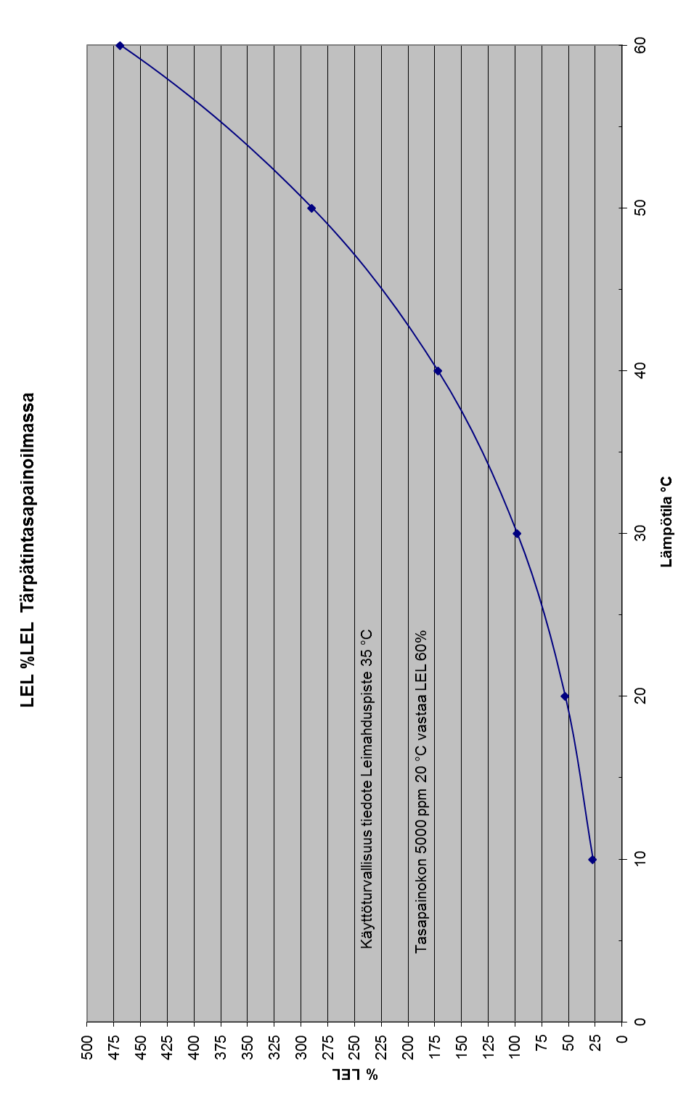

APPENDIX 3

Partial pressure of turpentine components



Partial vapor pressure of turpentine components, Drew et al., 1971

APPENDIX 4

LEL vs temperature graph for methanol in air

